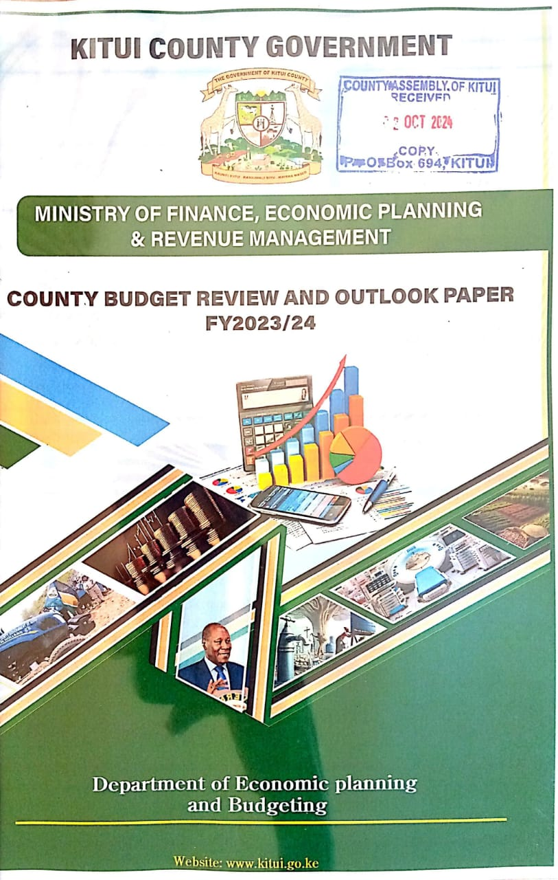
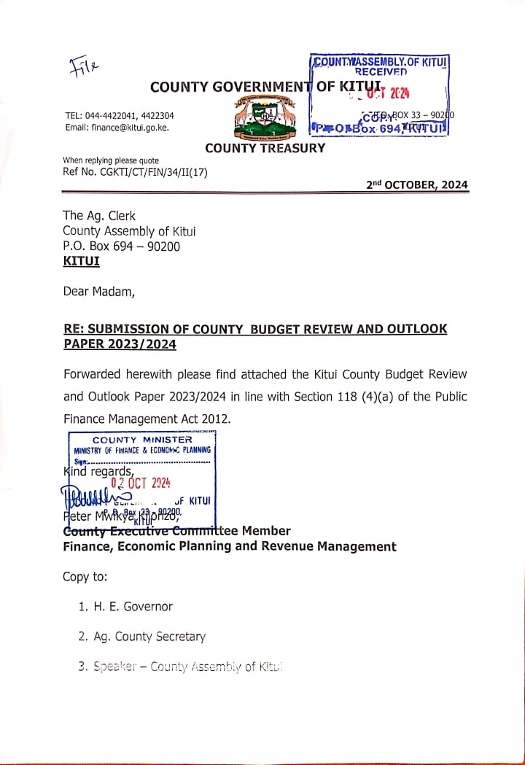
FOREWORD

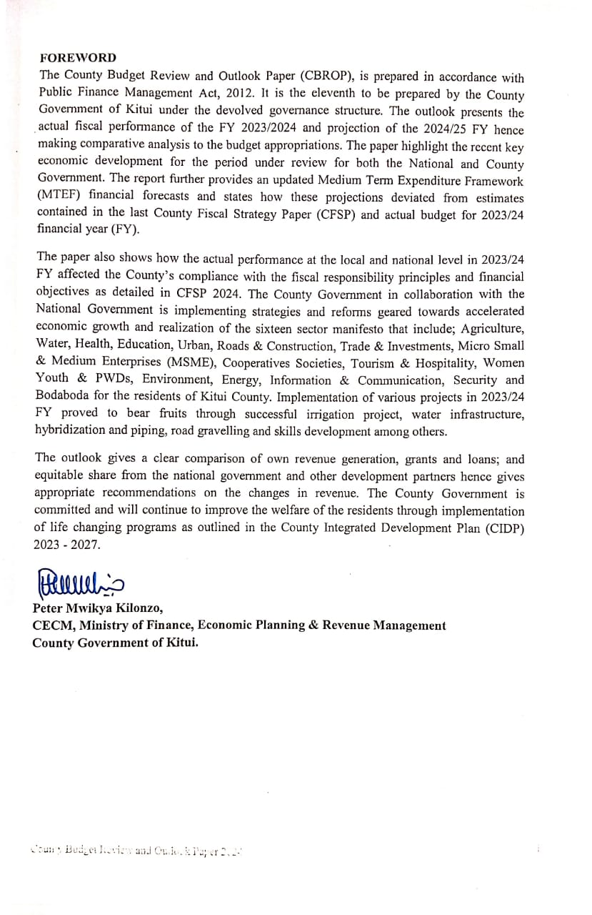

ACKNOWLEDGEMENT
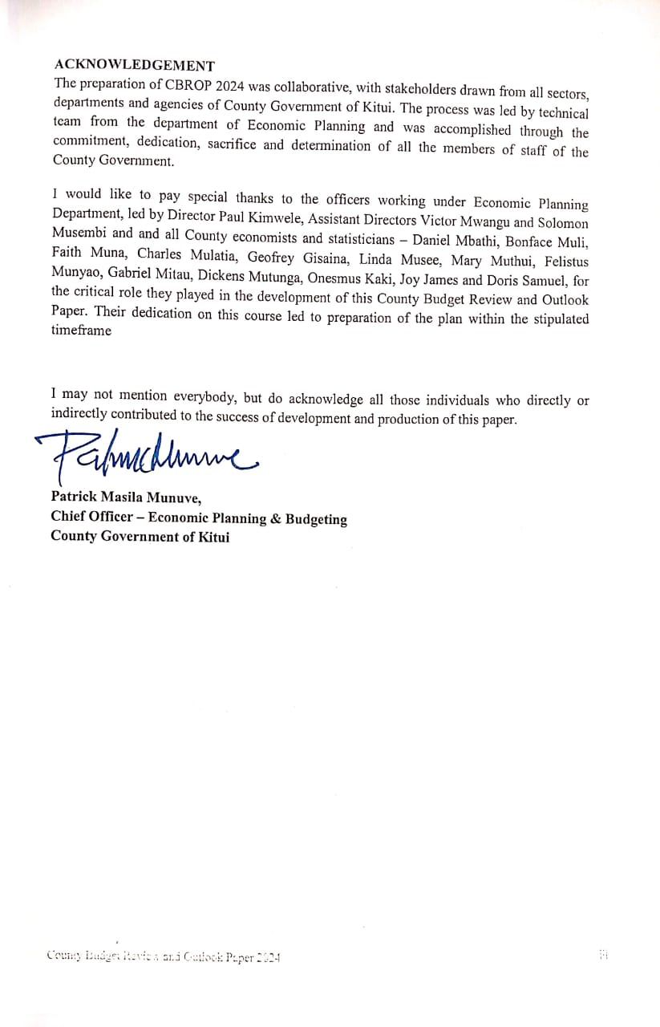
- Table of Contents
FOREWORD i
ACKNOWLEDGEMENT iv
EXECUTIVE SUMMARY 1
I. INTRODUCTION 2
A. Objective of the County Budget Review and Outlook Paper (CBROP) 2024 2
II. REVIEW OF FISCAL PERFORMANCE IN FY 2023/24 3
B. Overview 3
C. 2023/24 Fiscal Performance 3
Revenue 4
a. Equitable Share and Grants 4
b. Grants 5
c. Own Source Revenue Generated 6
Expenditure 10
D. Implications of FY 2023/24 fiscal performance on fiscal responsibility principles and financial objectives contained in the 2023 CFSP. 20
III. RECENT ECONOMIC DEVELOPMENTS AND OUTLOOK 23
Recent Economic Development 23
World Economic Outlook 23
Kenya’s Economic Performance and Outlook 24
Inflation Developments 27
Monetary and Credit Developments 29
Interest Rates Developments 30
External Sector Developments 32
Foreign Exchange Reserves 33
Exchange Rate Developments 33
Capital Markets Developments 34
County level 35
Kenya’s Macroeconomic Outlook 37
Monetary Policy Management 38
County Economic Outlook 40
Risks to the economic outlook 44
IV. RESOURCE ALLOCATION FRAMEWORK 46
Adjustments to 2024/25 Budget 46
Medium Term Expenditure Framework 47
Budget Framework 2023/2024 48
V. CONCLUSION AND WAY FORWARD 52
ANNEXURES 54
Expenditure Analysis by Project/ Programme 54
3711: Office of the Governor 54
3728: Office of the Deputy Governor 56
3729: Ministry of Water & Irrigation 59
3730: Ministry of Education, Training & Skills Development 60
3731: Ministry of Roads, Public Works & Transport 62
3716: Ministry of Health and Sanitation 67
3732: Ministry of Trade, Industry, MSMEs, Innovation & Cooperatives 73
3733: Ministry of Energy, Environment, Forestry, Natural & Mineral Resources 75
3734: Ministry of Culture, Gender, Youth, ICT, Sports & Social Services 83
3735: Ministry of Finance, Economic Planning & Revenue Management 86
3736: Ministry of Agriculture & Livestock 87
3737: Ministry of Lands, Housing and Urban Development 89
3722 County Public Service Board 91
3723 County Assembly 91
3724: Kitui Municipality 94
3725: Mwingi Municipality 99

List of Tables
Table 1: Revenue and Expenditure Summary for 2022/23 -2023/24FY 3
Table 2: Schedule of Disbursement of Equitable Share in FY 2023/24 5
Table 3: Grants performance in FY 2023/24 5
Table 4: Grants Performance in FY 2023/24 5
Table 5: Own Source Revenue Generated by Ministry for the Period ending 30th June 2024 7
Table 6: Own Source Revenue Generated by Revenue Streams for the period ending 30th June, 2024 7
Table 7: Budget Absorption rate against the FY 2023/24 budget 12
Table 8: Recurrent expenditure in the FY 2023/24 12
Table 9: Development Expenditure in the FY 2023/24 13
Table 10: FY 2023/24 Expenditure by Entity 15
Table 11: Ministry/ Spending Entity Expenditure for the Period Ending 30th June 2024 (Kshs) 16
Table 12: CFSP Allocation versus Budget Allocation for FY 2023/24 20
Table 13: Global Economic Performance 24
Table 14: Sectoral GDP Performance 25
Table 15: Money and Credit Developments (12 Months to June 2024, Ksh billion) 29
Table 16: Balance of Payments (USD Million) 32
Table 17: Kenya’s Macroeconomic Indicators and Projections 39
Table 18: Actual Revenue for 2020/21 – 2023/24 & Revenue Estimates for 2024/25 to 2026/27 FY 49
Table 19: Medium Term Expenditure Framework (MTEF) Actuals 2023/2024-2024/2025 FY & Projection up to 2026/2027 FY 52

List of Figures
Figure 1: Pie Chart of Budgeted Revenue by Source 10
Figure 2: Bar graph of budgeted vs Actual Revenue by Source 10
Figure 3: Annual Real GDP Growth Rates, percent 27
Figure 4: Inflation Rate, Percent 28
Figure 5: Private Sector Credit 30
Figure 6: Short Term Interest Rates, Percent 31
Figure 7: Commercial Bank Rates, Percent 31
Figure 8: Foreign Exchange Reserves (USD Million) 33
Figure 9: Kenya Shillings Exchange Rate 34
Figure 10: Performance of the Nairobi Securities Exchange 35
Figure 11: Kitui County Gross County Product (Kshs Mns) 40

ABBREVIATIONS
ADP Annual Development Plan
ADSE Anglican Development Services Eastern
ASDSP Agricultural Sector Development Support Program
CBROP County Budget Review and Outlook Paper
CFSP County Fiscal Strategy Paper
CHPs Community Health Promoters
CIDP County Integrated Development Plan
CLIDP Community Level Infrastructure Development Projects
CMMB Catholic Medical Mission Board
COFOG Classification of Functions of Government
COVID 19 Corona Virus Disease
CT Computed Tomography
ECDE Early Childhood Development Education
FY Financial Year
GCP Gross County Product
GDP Gross Domestic Product
HDU High Dependency Unit
ICU Intensive Care Unit
IFMIS Integrated Financial Management Information System
KCRH Kitui County Referral Hospital
KDSP Kenya Devolution Support Programme
KSHS Kenya Shilling
MCH Maternal and Child Health
MSME Micro Small and Medium Enterprises
MTEF Medium Term Expenditure Framework
MTP Medium Term Plan
NBU New - born Unit
O&M Operation and Maintenance
OPD Out Patient Department
PE Personnel Emolument
PFMA Public Finance Management Act
PO Producer Organizations
SDL State Department for livestock
SEKEB South Eastern Kenyan Economic Block
SIVAP Small Irrigation Value Addition Project
TIMPs Technology, Innovations and Management Practices
VTC Vocational Training Centre
WBR World Bicycle Relief

Legal Basis for the Publication of the County Budget Review and Outlook Paper
The County Budget Review and Outlook Paper is published in accordance with Section 118 of the Public Finance Management Act, 2012. The law states that:

- A County Treasury shall –
  - prepare a County Budget Review and Outlook Paper in respect of the county for each financial year; and
  - Submit the paper to the County Executive Committee by 30th September of that year.

- In preparing the county Budget Review and Outlook Paper, the County Treasury shall specify –
  - details of the actual fiscal performance in the previous year compared to the budget appropriation for that year;
  - updated economic and financial forecasts with sufficient information to show changes from the most recent County Fiscal Strategy Paper;
  - information on –
    - any changes in the forecasts compared with the County Fiscal Strategy Paper;
    - how actual financial performance for the previous financial year may have affected compliance with fiscal responsibility principle, or the financial objective in the County Fiscal Strategy Paper for that year; and

  - Reasons for the deviations from the financial objectives in the County Fiscal Strategy Paper together with proposal to address the deviations and estimated time for doing so.

- The County Executive Committee shall consider the County Budget Review Paper with a view to approving it, with or without amendments, within fourteen day after its submission.

- Not later than seven days after the County Budget Review and Outlook Paper is approved by the County Executive Committee, the County Treasury shall –

- Arrange for the Paper to be laid before the County Assembly; and

- As soon as practicable after having done so, publish and publicise the Paper.

Fiscal Responsibility Principles for the County Governments
In line with the Constitution, the Public Finance Management (PFM) Act, 2012, sets out the fiscal responsibility principles to ensure prudent and transparent management of public resources. The PFM Act, 2012, (Section 107) states that:
- A County Treasury shall manage its public finances in accordance with the principles of fiscal responsibility set out in subsection (2), and shall not exceed the limits stated in the regulations.
- In managing the county government’s public finances, the County Treasury shall enforce the following fiscal responsibility principles- (a) the county government’s recurrent expenditure shall not exceed the county government’s total revenue; (b) over the medium term a minimum of thirty percent of the county government’s budget shall be allocated to the development expenditure; (c) the county government’s expenditure on wages and benefits for its public officers shall not exceed a percentage of the county government’s total revenue as prescribed by the County Executive member for finance in regulations and approved by the County Assembly; (d)over the medium term, the government’s borrowings shall be used only for the purpose of financing development expenditure and not for recurrent expenditure; (e) the county debt shall be maintained at a sustainable level as approved by county assembly; (f) the fiscal risks shall be managed prudently; and (g) a reasonable degree of predictability with respect to the level of tax rates and tax bases shall be maintained, taking into account any tax reforms that may be made in the future.
- For the purposes of subsection (2) (d), short-term borrowing shall be restricted to management of cash flows and shall not exceed five percent of the most recent audited county government revenue.
- Every county government shall ensure that its level of debt at any particular time does not exceed a percentage of its annual revenue specified in respect of each financial year by a resolution of the county assembly.
- The regulations may add to the list of fiscal responsibility principles set out in subsection (2).

EXECUTIVE SUMMARY
The core purpose of the 2024 CBROP is to provide a review of the previous fiscal performance and how this impacts the financial objectives and fiscal responsibility principles. These are set out in the last County Fiscal Strategy Paper (CFSP), which provides the basis for the revision of the current budget in the context of supplementary estimates and informs the choice of broad fiscal parameters underpinning the next budget and medium-term expenditure framework.
Analysis of the 2023/24 FY fiscal performance shows an increase in absorption rate of development funds from 84.10% to 87.12%. There was a great improvement in the performance in revenue collection owing to setting realistic historical target, strict enforcement and favourable economic activities in the county.
Kenya’s economic performance is projected to remain stable over the medium term. Growth is expected to moderate from 5.6 percent in 2023 to a forecast of 5.2 percent in 2024 and 5.4 percent in 2025. The growth in 2024 and 2025 will benefit from the enhanced agricultural productivity and a resilient services sector. The rebound in Kenya's agricultural sector is expected to be largely driven by favourable weather conditions and productivity-enhancing government interventions.
The departments need to rationalise their budget to align resources availability to needs, allocating funds to high impact projects. The Ministry of Finance, Economic Planning & Revenue Management plans to fully automate its revenue collection to improve revenue collection. The County Government managed to collect Kshs. 517,049,815 from own source revenue reflecting 88.38% of the targeted amount of Kshs. 585,000,000. This represents an 11.3% increase from 2022/23 FY performance whereby Kshs. 464,354,468 was collected. The increase was majorly attributed to the realistic target setting, strict enforcement and favourable economic activities in the County.
On the expenditure side, the County Government continued to rationalize expenditures to improve efficiency and reduce wastage. In the medium term, expenditure management is expected to improve given the various budget rationalisation reforms undertaken and because of tightening of the fiscal framework to create room for more productive expenditures.
Global economy has stabilized with global growth projected at 3.2 percent in 2024 and 3.3 percent in 2025 from 3.3 percent in 2023. The outlook reflects economic recovery in China, Euro area and UK, despite a slowdown in activity in the USA and Japan. The main risks to the global growth outlook relate to further escalation of geopolitical tensions, interest rates remaining higher-for-even-longer in advanced economies, and policy uncertainty attributed to changes of Government in some major economies. Global inflation has moderated, with central banks in some major economies lowering interest rates. International oil prices have moderated, but the risk premium from the Middle East conflict has increased following the recent escalation.

I. INTRODUCTION

A. Objective of the County Budget Review and Outlook Paper (CBROP) 2024
- The main objective of the 2024 County Budget Review and Outlook Paper (CBROP) is to review the fiscal performance for 2023/24 FY and how this impacts the financial objectives and fiscal responsibility principles set out in the last County Fiscal Strategy Paper 2023/24 released in February 2023. The paper further outlines the expenditure and revenue in 2023/24 FY providing budgeting basis in the current financial year of 2024/25 and medium term expenditure.
- The CBROP, like the CFSP links policy, planning and the budgeting through reviewing the performance of the government in line with the budget and the laid down policies as tied to the broad priorities. These policies include the Kenya Vision 2030 and its Medium Term Plans I, II, III & IV (MTP I, II, III &IV), the County Integrated Development Plan (CIDP (2023-2027) and all other national and county policies relevant to planning.
- The report rolls out the implementation of the development projects initiated in 2023/24 financial year, and continues to address the “Kitui Promise” under the sixteen sector manifesto priority areas. These sectors include Agriculture, Water, Health, Education, Urban, Roads & Construction, Trade & Investments, Micro Small & Medium Enterprises (MSME), Cooperatives Societies, Tourism & Hospitality, Women Youth & PWDs, Environment, Energy, Information & Communication, Security and Bodaboda.
- The rest of the paper is organised as follows: Section II provides a review of the fiscal performance in FY 2023/24 and its implications on the financial objectives set out in 2023/2024. This is followed by brief highlights of the recent economic developments and updated revenue and expenditure in section III. Section IV provides the resources allocation framework, while Section V gives the development projects implemented in 2023/2024 FY.

II. REVIEW OF FISCAL PERFORMANCE IN FY 2023/24

B. Overview
- The fiscal performance shows an increase in absorption rate from 84.1% in FY 2022/23 to 87.12% absorption in FY 2023/24, and revenue side where revenue collection improved by 11.3% from Kshs. 464,354,468 in FY 2022/23 to Kshs. 517,049,815 in FY 2023/24.
- The total revenue generated by the county over the period was Kshs, 517,049,815 up from Kshs 464,354,468 collected during FY 2022/2023 amounting to an 11.35% increase. The table 5 shows performance of revenue collection per ministry in the period under review. The county achieved 88.38% of the set revenue target amounting to Kshs. 585,000,000. The NHIF arrears amounting to Kshs. 121,742,201 was not remitted to the Ministry of Health and Sanitation by close of FY 2023/24. This means that inclusive of the NHIF arrears and Revenue from Public Health, the County achieved Kshs. 646,067,266 on own source revenue.

C. 2023/24 Fiscal Performance
- The table below presents the fiscal performance for the FY 2022/23 and FY 2023/24 together with the deviations from the original budget estimates of FY 2023/24.
Table 1: Revenue and Expenditure Summary for 2022/23 -2023/24FY
 | 2022/23 |  | 2023/24 |  | Deviations (Actual/Target FY2023/24) | Percentage Deviation (2023-24/2022-23)
 | Actual | Target | Actual | Target | (%) | %
A. TOTAL REVENUE AND GRANT
1. Revenue | 11,976,326,523 | 11,931,972,056 | 12,492,382,697 | 13,426,691,833 | -7.0% | 4.3%
Equitable Share | 10,393,970,413 | 10,393,970,413 | 9,963,127,985 | 10,829,486,936 | -8.0% | -4.1%
Other Revenues | 1,582,356,110 | 1,538,001,643 | 2,529,254,712 | 2,597,204,897 | -2.6% | 59.8%
Locally Generated Revenue | 464,354,467 | 420,000,000 | 517,049,816 | 585,000,000 | -11.6% | 11.3%
Unspent Balances b/fwd. | 1,118,001,643 | 1,118,001,643 | 2,012,204,897 | 2,012,204,897 | 0.0% | 80.0%
2. Grants
HSSF/HSPS - (DANIDA/IDA) | 28,405,688 | 28,405,688 | 16,112,250 | 16,112,250 | 0.0% | -43.3%
Urban Institutional Grant (KUSP) | 2,339,915 | 2,339,915 |  |  |  | -100.0%
Agriculture Sector Development Support Programme (ASDSP) | 11,636,683 | 11,636,683 | 1,792,965 | 1,292,965 | 38.7% | -84.6%
World Bank loan for National Agricultural and Rural Inclusive Growth Project | 227,100,709 | 169,475,223 | 4,261,826 | 5,000,000 | -14.8% | -98.1%
World Bank (Emergency Locust Response Project (ELRP)) | 68,522,528 | 70,223,000 | 132,498,510 | 133,683,244 | -0.9% | 93.4%
IDA(World bank)Credit National Agricultural Value Chain Development Project(NAVCDP) | 67,192,729 | 70,000,000 | 199,781,563 | 200,000,000 | -0.1% | 197.3%
World bank Credit to Finance Locally -Led Climate Action Program (FLLoCA) | 11,000,000 | 22,000,000 | 216,807,064 | 216,807,064 | 0.0% | 1871.0%
Court fines |  |  |  | 50,000 | -100.0%
Mineral royalties |  |  |  | 336,118 | -100.0%
Livestock Value Chain Support Projects |  |  |  | 14,323,680 | -100.0%
De-Risking and Value Enhancement (DRIVE) |  |  |  | 63,341,980 | -100.0%
Fertilizer Subsidy |  |  |  | 179,499,580 | -100.0%
Total Grants | 416,198,252 | 374,080,509 | 571,254,178 | 830,446,881 | -31.2% | 37.3%
Total | 12,392,524,775 | 12,306,052,565 | 13,063,636,876 | 14,257,138,714 | -8.4% | 5.4%
B. EXPENDITURE
1. Recurrent | 8,209,066,423 | 8,662,902,604 | 8,590,482,401 | 8,881,658,967 | -3.3% | 4.6%
Salaries and Wages | 4,727,336,691 | 4,787,527,652 | 5,363,094,440 | 5,394,680,360 | -0.6% | 13.4%
O&M/Others | 3,481,729,732 | 3,875,374,952 | 3,227,387,961 | 3,486,978,607 | -7.4% | -7.3%
2. Development | 3,227,387,961 | 3,643,149,961 | 3,830,886,978 | 5,375,479,746 | -28.7% | 18.7%
Total | 11,436,454,384 | 12,306,052,565 | 12,421,369,379 | 14,257,138,713 | -12.9% | 8.6%
C. SURPLUS/ (DEFICIT) | 956,070,391 |  | 642,267,497
Source: Ministry of Finance, Economic Planning & Revenue Management
Notes
- Equitable share: This is the amount of funds the county government expected to receive from the national government, as shared out using the Commission on Revenue Allocation formula, which was not disbursed in full for the review period.

Revenue
    - Equitable Share and Grants
The total disbursement to the county revenue fund account during the financial year 2023/2024 was Kshs 9,963,127,985, representing 92% of the total equitable share the county expected to receive from National Treasury. The amount disbursed reduced by 4.15% from previous financial year of 2022/23 FY which was Kshs. 10,393,970,413. A disbursement of Kshs 866,358,951 for FY 2023/24 was received in the month of July 2024. Therefore, this will be revoted in FY 2024/25 during supplementary appropriation.

Over the same period, the county expected to receive grants totalling to Kshs 830,446,881 from international donors (World Bank, SWEDEN and DANIDA) and conditional grants from the National Government. However, the County Government received grants totalling to Kshs. 571,254,178 during the period under review as shown in Table 2.

Cumulatively, the amount of grants budgeted during the year was Kshs. 830,446,881. This includes the revote amount of Kshs. 291,399,610, which is part of Kshs 2,012,204,897 revote that was brought forward (see table 4). Nevertheless, only Kshs 571,254,178 was received as grants, representing 68.75% of the total budgeted grants leaving a balance of Kshs 259,679,693 which may or may not be received depending with the discretion of the respective donor organization. Table 2 shows schedule of disbursement of equitable share under the review period.
Table 2: Schedule of Disbursement of Equitable Share in FY 2023/24
Month | Date received | Amount
July | 28-Jul-23 | 920,506,390
August | 25-Oct-23 | 866,358,955
September | 24-Nov-23 | 920,506,390
October | 20-Dec-23 | 866,358,955
November | 25-Jan-24 | 920,506,390
December | 20-Feb-24 | 866,358,955
January | 27-Mar-24 | 920,506,390
February | 24-Apr-24 | 920,506,390
March | 23-May-24 | 866,358,955
April | 20-Jun-24 | 974,653,825
May | 26-Jun-24 | 920,506,390
 | TOTAL | 9,963,127,985
Source: Ministry of Finance, Economic Planning & Revenue Management

Grants
In addition, the County Government received grants totalling to Kshs. 571,254,178 during the period under review. The breakdown for the grants was as follows: -
Table 3: Grants performance in FY 2023/24
Source | Date received | Amount
Agriculture Sector Development Support Programme (ASDSP) | 6-Oct-23 | 500,000
Agriculture Sector Development Support Programme (ASDSP) | 27-Mar-24 | 1,292,965
Agriculture Sector Development Support Programme (ASDSP) | Sub Totals | 1,792,965
HSSF/HSPS - (DANIDA/IDA) | 21-Jun-24 | 16,112,250
HSSF/HSPS - (DANIDA/IDA) | Sub Totals | 16,112,250
World bank Credit to Finance Locally -Led Climate Action Program (FLLoCA) | 2-Apr-24 | 102,903,532
 | 25-Jun-24 | 102,903,532
 | 5-Jul-24 | 11,000,000
 | Sub Totals | 216,807,064
World Bank (Emergency Locust Response Project (ELRP)) | 5-Apr-24 | 95,513,836
World Bank (Emergency Locust Response Project (ELRP)) | 25-Jun-24 | 36,984,674
World Bank (Emergency Locust Response Project (ELRP)) | Sub Totals | 132,498,510
World Bank loan for National Agricultural and Rural Inclusive Growth Project (NARIGP) | 20-Mar-24 | 4,261,826
 | Sub Totals | 4,261,826
IDA(World bank)Credit National Agricultural Value Chain Development Project(NAVCDP) | 20-Mar-24 | 195,087,953
 | 25-Jun-24 | 4,693,610
 | Sub Totals | 199,781,563
 | Totals | 571,254,178
Source: Ministry of Finance, Economic Planning & Revenue Management
Table 4: Grants Performance in FY 2023/24
Source | Amount Approved in CARA | Grant Revote from FY 2022/23 | Cumulative Grant Amount FY 2023/24 | Receipts in the FY 2023/24 | Outstanding Balance not Received
Agriculture Sector Development Support Programme (ASDSP) | 1,292,965 | 486,990 | 1,779,955 | 1,792,965 | -13,010
World bank Credit to Finance Locally -Led Climate Action Program (FLLoCA) | 216,807,064 | 11,019,260 | 227,826,324 | 227,826,324 | 0
KDSP - World Bank |  | 139,956,716 | 139,956,716 | 139,956,716 | 0
World Bank loan for National Agricultural and Rural Inclusive Growth Project (NARIGP) | 5,000,000 | 38,669,471 | 43,669,471 | 42,931,297 | 738,174
World Bank (Emergency Locust Response Project (ELRP)) | 133,683,244 | 25,146,724 | 158,829,968 | 157,645,234 | 1,184,734
IDA(World bank)Credit National Agricultural Value Chain Development Project(NAVCDP) | 200,000,000 | 67,192,729 | 267,192,729 | 266,974,292 | 218,437
HSSF/HSPS - (DANIDA/IDA) | 16,112,250 |  | 16,112,250 | 16,112,250 | 0
Court fines | 50,000 |  | 50,000 | - | 50,000
Mineral royalties | 336,118 |  | 336,118 | - | 336,118
Livestock Value Chain Support Projects | 14,323,680 |  | 14,323,680 | - | 14,323,680
De-Risking and Value Enhancement (DRIVE) | 63,341,980 |  | 63,341,980 | - | 63,341,980
Fertilizer Subsidy | 179,499,580 |  | 179,499,580 | - | 179,499,580
Road Maintenance Fuel Levy |  | 8,927,720 | 8,927,720 | 8,927,720 | 0
Total | 830,446,881 | 291,399,610 | 1,121,846,491 | 862,166,798 | 259,679,693
Source: Ministry of Finance, Economic Planning & Revenue Management
The County received grants amounting to Kshs. 571,254,178 for the period under review registering a deficit of Kshs 259,679,693 above the total cumulative grants.

Own Source Revenue Generated
- The total revenue generated by the county over the period was Kshs, 517,049,815 up from Kshs 464,354,468 collected during FY 2022/2023 amounting to an 11.35% increase. The table 5 shows performance of revenue collection per ministry in the period under review. The county achieved 88.38% of the set revenue target amounting to Kshs. 585,000,000. The NHIF arrears amounting to Kshs. 121,742,201 was not remitted to the Ministry of Health and Sanitation by close of FY 2023/24. This means that inclusive of the NHIF arrears and Revenue from Public Health, the County achieved Kshs. 646,067,266 on own source revenue.

Table 5: Own Source Revenue Generated by Ministry for the Period ending 30th June 2024
Spending Entity | Annual Target | Annual Realization | Percentage Realized
Office of the Governor | 14,468,391 | 22,476,805 | 155.35%
Office of the Deputy Governor | 107,171 |  | 0.00%
Ministry of Water & Irrigation | 2,163,121 | 1,017,000 | 47.02%
Ministry of Education, Training & Skills Development | 107,173 | - | 0.00%
Ministry of Roads, Public Works & Transport | 3,457,410 | 3,289,568 | 95.15%
Ministry of Health & Sanitation | 350,500,826 | 272,308,709 | 77.69%
Ministry of Trade, Industry, MSMEs, Innovation & Cooperatives | 3,268,785 | 861,124 | 26.34%
Ministry of Energy, Environment, Forestry, Natural & Mineral Resources | 6,182,327 | 573,500 | 9.28%
Ministry of Culture, Gender, Youth, ICT, Sports & Social Services | 214,347 | 251,480 | 117.32%
Ministry of Finance, Economic Planning & Revenue Management | 87,798,589 | 94,151,509 | 107.24%
Ministry of Agriculture & Livestock | 10,484,458 | 14,434,340 | 137.67%
Ministry of Lands, Housing and Urban Development | 26,070,796 | 25,791,050 | 98.93%
Kitui Municipality | 53,160,532 | 53,227,811 | 100.13%
Mwingi Municipality | 27,016,074 | 28,666,919 | 106.11%
Totals | 585,000,000 | 517,049,815 | 88.38%
NHIF Arrears |  | 121,742,201
Revenue From Public Health not Swipped into CRF by close of FY 2023/24 |  | 7,275,250
Total Collection inclusive of NHIF arrears and Revenue from Public Health |  | 646,067,266
Source: Ministry of Finance, Economic Planning & Revenue Management
Office of the Governor performed well in the collection of revenue with a 155.35 percent collecting Kshs 22,476,805 against a target of Kshs 14,468,391. The performance under the Office of the Governor was driven by Alcoholic Drinks License (liquor license). Ministry of Agriculture & Livestock was the second-best performing entity with increased collection in Agriculture show and trade exhibition and Training/Learning Centre (ATC) Fee. Table 6 gives reasons for underperformance or over performance of each revenue stream.
Table 6: Own Source Revenue Generated by Revenue Streams for the period ending 30th June, 2024
No | Revenue Stream | Annual Targeted Revenue (Kshs) 2022/23 | Actual Revenue 2022/23 | Annual Targeted Revenue (Kshs) 2023/24 | Actual Revenue 2023/24 | Variance | Remarks
1 | Receipts from Sale of Agricultural Goods (Sell of seedlings from ATC) |  |  | 671,222 | 1,015,530 | 344,308 | Target Achieved
2 | Borehole Drilling | 3,012,040 |  | 2,156,369 | 1,011,000 | -1,145,369 | Machinery Breakdown
3 | Engineering and Works Levy | 188,650 |  | 6,752 | 6,000 | -752 | Minimal Soil Analysis Tests
4 | Ploughing | 52,296 | 41,000 | 46,142 | 157,650 | 111,508 | Target Achieved
5 | Training/Learning Centre Fee | 2,027,413 | 4,418,250 | 5,627,014 | 7,622,608 | 1,995,594 | Target Achieved
6 | Agricultural show |  |  | 2,813,506 | 3,982,200 | 1,168,694 | Target Achieved
7 | Slaughter Houses Inspection Fee | 29,000 | 40,225 | 45,270 | 19,400 | -25,870 | Enhacned inspection of slaughter houses
8 | Meat Inspection/ Veterinary Services | 342,301 | 775,910 | 873,211 | 1,030,312 | 157,101 | Target Achieved
9 | Certificate to Transport/Movement permits | 253,335 | 351,920 | 401,000 | 601,340 | 200,340 | Target Achieved
10 | Dispatch note& Flayer License | 15,500 | 10,700 | 7,091 | 12,300 | 5,209 | Target Achieved
11 | Sand approval fee, pollution &penalties | 2,183,168 | 525,200 | 6,182,327 | 566,500 | -5,615,827 | Implementation of sand management act will lead to improved performance
12 | Ministry of Health and Sanitation | 220,367,881 | 278,937,695 | 350,500,826 | 272,308,709 | -78,192,117 | The Ministry didn’t achieve their target fully due to NHIF arrears amounting to Kshs. 121,742,201
13 | Ministry of Culture, Gender, Youth, ICT, Sports & Social Services | 79,718 | 111,000 | 214,347 | 251,480 | 37,133 | Target Achieved
14 | Land rates | 15,889,581 | 11,599,653 | 15,912,597 | 12,776,097 | -3,136,500 | Target will be realised once valuation roll is implemented
15 | Penalties &penalties | 25,000 | 116,290 | 126,068 | 192,240 | 66,172 | Target Achieved
16 | Land Administration Fees | 11,318,385 | 8,393,476 | 12,862,327 | 13,215,053 | 352,726 | Target Achieved
17 | Alcoholic Drinks License | 10,106,642 | 12,461,000 | 14,468,391 | 22,476,805 | 8,008,414 | Target Achieved
18 | Inspection of Schools and ECD centres |  |  | 107,173 | 0 | -107,173 | The revenue stream was proposed but not yet implemented
19 | Sale of Goods eg cabros,interlocking bricks | 6,676,524 | 21,014 |  |  | 0
20 | Weights and measures | 533,838 | 560,431 | 750,213 | 485,330 | -264,883 | Need for Enhanced enforcement and continued inspection
21 | Other county investments-Crusher | 1,451,965 |  | 1,607,598 | 0 | -1,607,598 | At time of target setting the County Crusher was anticipated to generate revenue but the investment has since been proposed for Community ownership through Cooperative
22 | Cooperative Audit |  |  | 375,107 | 375,794 | 687 | Target Achieved
23 | Hire of Machines in Trade Department |  |  | 535,867 | 1,226,368 | 690,501 | Target Achieved
24 | Game reserves and park fees |  |  | 107,171 |  | -107,171 | The revenue stream was proposed but not yet implemented
25 | Livestock Transportation | 376,820 | 35,343 |  |  | 0
26 | Single Business Permits | 68,984,258 | 70,024,710 | 83,056,943 | 86,654,680 | 3,597,737 | Target Achieved
27 | House and Stalls Rents | 1,999,800 | 2,805,640 | 3,010,359 | 2,917,240 | -93,119 | Some stalls have remained un-occupied due to high cost of living
28 | Market Fees | 10,941,907 | 14,853,052 | 16,060,908 | 15,129,916 | -930,992 | Enhanced enforcement of markets & stock fees
29 | Cess | 5,656,840 | 6,913,075 | 9,913,071 | 15,576,016 | 5,662,945 | Target has been achieved
30 | Sign Board & Advertising | 28,534,716 | 22,912,545 | 25,430,931 | 21,979,450 | -3,451,481 | Reduced Advertising due to low business resulting from high cost of living
31 | Transportation Fees | 13,416,550 | 11,342,130 | 12,768,772 | 15,671,600 | 2,902,828 | Target Achieved
32 | Slaughter Fees | 3,064,210 | 1,816,130 | 1,946,406 | 2,598,455 | 652,049 | Target Achieved
33 | Burial Fees | 17,400 | 15,200 | 16,290 | 17,900 | 1,610 | Its an act of God
34 | Parking fees | 12,447,962 | 15,256,278 | 16,380,733 | 17,166,243 | 785,510 | Target Achieved
35 | Sale & search of assets | 6,300 | 16,600 | 17,996 | 5,600 | -12,396 | Number of Records searched
 | TOTAL OWN SOURCE REVENUE | 420,000,000 | 464,354,467 | 585,000,000 | 517,049,816 | -67,950,184
 | NHIF Arrears |  |  |  | 121,742,201
 | Revenue From Public Health not Swipped into CRF by close of FY 2023/24 |  |  |  | 7,275,250
 | Total Collection inclusive of NHIF arrears and Unswipped Revenue from Public Health |  |  |  | 646,067,267
Source: Ministry of Finance, Economic Planning & Revenue Management

Figure 1: Pie Chart of Budgeted Revenue by Source
Figure 2: Bar graph of budgeted vs Actual Revenue by Source
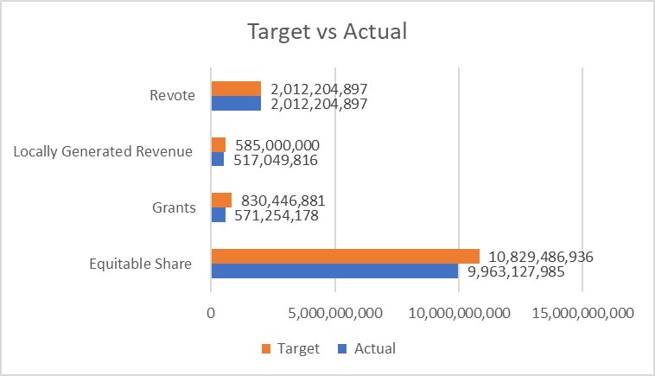

Expenditure
- During FY 2023/2024, the approved budget for the county was Kshs. 14,257,138,714 comprising of 62.3% recurrent (Kshs 8,881,658,968) and 37.7% development (Kshs 5,375,479,746). This represents 7.7% above recommended ceiling for funds allocation to development expenditure. This was driven by revote of Kshs 2,012,204,897 which was mainly development in nature. Additionally, timely planning and procurement of programmes, training and capacity building of contractors to improve their efficiency and timely payments led to increased absorption in development.
- Total expenditure for the year ending 30th June 2024 amounted to Kshs 12,421,369,379; representing gross absorption of 87.12%, up from 84.1% in 2022/23 FY, of this expenditure, recurrent expenditure was Kshs 8,590,482,401 (69.2%) while development expenditure amounted to Kshs 3,830,886,978 (30.8%).
- Analysis of recurrent expenditure shows that Personnel Emoluments (PE) - Kshs. 5,363,094,440 (43.2%) and Operations, and Maintenance (O&M) – Kshs. 3,227,387,961 (26.0%) of the total expenditure, compared to 41.3% and 30.4% respectively in the previous financial year. This reveals an upward trend for PE and reduced O&M expenses. The reduction on O&M was due to rationalization and adoption of austerity measures, reliance on our decentralized units already in the wards to carry out roles or duties where headquarter staff would have been required to travel to the wards. The saving on O&M was reallocated to development expenditure.
- The increment in PE is driven by implementation of new scheme of service for ECDE Teachers amounting to an increment of Kshs 304,602,781. In FY 2023/2024, there were additional increments in statutory deductions i.e. Housing Levy, NSSF, annual salary increments for all cadres and promotion of doctors. This impacted PE by an addition of Kshs 208.4 million per annum. This had an overall annual impact of PE increment of Kshs 513 million.
- Personnel emoluments at 43.2% exceeded the 35% threshold as stipulated in the PFM Act, 2012 Section 107 2(c) as well as Regulations 25 1(a) & (b) of PFM Regulation, 2015 Counties. The county government is working towards harmonising the findings of human resource audit conducted in FY 2023/24 by amicably reducing recruitments in the forthcoming years as well as maximize the available workforce for efficient service delivery. Development expenditure was above the minimum threshold leading to an accelerated absorption within the review period.
- The overall expenditure significantly increased by 8.6% from Kshs 11,436,454,384 in the financial year 2022/23 to Kshs 12,421,369,379 in 2023/24 FY. The proportion of actual development expenditure to the total expenditure increased from 28.2 % in 2022/23 to 30.8% in 2023/24 FY. However, recurrent expenditure decreased from 71.8% to 69.2% in 2023/24 financial year.
- Within the financial year 2023/24, the actual expenditure on the recurrent budget realised the highest level of utilisation at 96.7% up from 94.7% in the previous year. Development budget expenditure was 71.2% in 2023/24 up from 58.8% in 2022/23. The utilisation rate in both development and recurrent expenditures resulted from timely implementation of procurement plans as well as payment for processed claims for staff and merchants (overall absorption rate rising to 87.12% (see table 7), which was higher compared to 84.10% realised in the previous period).
- Table 10 presents analysis of the total expenditure by county spending entities giving the overall absorption rate. Amounts in the variance column indicate the deviation from the planned target expenditures.
- The amount of Kshs 1,835,769,335 indicated in table 11 as not having been absorbed included funds budgeted as equitable share of Kshs. 866,358,951 that were not disbursed during the review period, unrealised local revenue that was never collected of Kshs. 67,950,184 and an additional amount of Kshs 259,679,693 that were grants not received amongst other monies.
- The development expenditure for the period 2023/24 FY was Kshs 3,830,886,978 (30.8%) compared to Kshs 3,227,387,961 (28.2%) spent in the 2022/223 financial year. This represents a growth of 2.6 percentage points in the financial year 2023/24 above the amount absorbed on development budget in the previous year. With this increased level of development, the county programmes have been noticed across all the 40 wards and 247 villages and positive feedback passed by Kitui residents.
Table 7: Budget Absorption rate against the FY 2023/24 budget
County Ministry | Total Budget Estimates | Actual Expenditure | % Absorption rate
Office of the Governor | 2,561,198,253 | 2,321,543,440 | 90.64
Office of the Deputy Governor | 235,259,259 | 222,030,920 | 94.38
Ministry of Water & Irrigation | 905,527,831 | 769,253,389 | 84.95
Ministry of Education, Training & Skills Development | 1,048,077,114 | 1,010,931,780 | 96.46
Ministry of Roads, Public Works & Transport | 699,593,517 | 674,193,144 | 96.37
Ministry of Health & Sanitation | 3,717,865,328 | 3,674,930,239 | 98.85
Ministry of Trade, Industry, MSMEs, Innovation & Cooperatives | 480,571,418 | 340,726,878 | 70.90
Ministry of Energy, Environment, Forestry, Natural & Mineral Resources | 461,386,010 | 229,433,109 | 49.73
Ministry of Culture, Gender, Youth, ICT, Sports & Social Services | 235,575,222 | 214,083,099 | 90.88
Ministry of Finance, Economic Planning & Revenue Management | 657,695,933 | 609,075,873 | 92.61
Ministry of Agriculture & Livestock | 1,266,506,286 | 853,285,822 | 67.37
Ministry of Lands, Housing and Urban Development | 209,087,968 | 147,877,241 | 70.72
County Public Service Board | 79,333,803 | 61,518,926 | 77.54
County Assembly Service Board | 1,409,872,841 | 1,022,961,294 | 72.56
Kitui Municipality | 192,453,208 | 176,914,566 | 91.93
Mwingi Municipality | 97,134,723 | 92,609,659 | 95.34
Totals | 14,257,138,714 | 12,421,369,379 | 87.12
Source: Ministry of Finance, Economic Planning & Revenue Management
Table 8: Recurrent expenditure in the FY 2023/24
Spending Entity | Recurrent Budget | Total Recurrent Expenditure | Variance
Office of the Governor | 1,275,451,666 | 1,275,401,152 | 50,514
Office of the Deputy Governor | 185,320,858 | 174,694,296 | 10,626,562
Ministry of Water & Irrigation | 115,780,706 | 105,171,729 | 10,608,977
Ministry of Education, Training & Skills Development | 854,332,520 | 851,057,470 | 3,275,050
Ministry of Roads, Public Works & Transport | 194,720,047 | 184,177,202 | 10,542,845
Ministry of Health & Sanitation | 3,467,530,515 | 3,454,500,875 | 13,029,640
Ministry of Trade, Industry, MSMEs, Innovation & Cooperatives | 188,423,831 | 180,675,973 | 7,747,858
Ministry of Energy, Environment, Forestry, Natural & Mineral Resources | 91,613,716 | 91,318,800 | 294,916
Ministry of Culture, Gender, Youth, ICT, Sports & Social Services | 112,494,780 | 103,244,185 | 9,250,595
Ministry of Finance, Economic Planning & Revenue Management | 517,739,217 | 507,488,138 | 10,251,079
Ministry of Agriculture & Livestock | 361,569,752 | 356,924,477 | 4,645,275
Ministry of Lands, Housing and Urban Development | 113,857,558 | 96,445,604 | 17,411,954
County Public Service Board | 64,333,803 | 61,518,926 | 2,814,877
County Assembly Service Board | 1,180,814,288 | 996,761,294 | 184,052,994
Kitui Municipality | 92,555,842 | 90,486,843 | 2,068,999
Mwingi Municipality | 65,119,869 | 60,615,437 | 4,504,432
Totals | 8,881,658,968 | 8,590,482,401 | 291,176,567

Source: Ministry of Finance, Economic Planning & Revenue Management
Table 9: Development Expenditure in the FY 2023/24
Spending Entity | Development Budget | Total Development Expenditure | Variance
Office of the Governor | 1,285,746,587 | 1,046,142,288 | 239,604,299
Office of the Deputy Governor | 49,938,401 | 47,336,624 | 2,601,777
Ministry of Water & Irrigation | 789,747,125 | 664,081,660 | 125,665,465
Ministry of Education, Training & Skills Development | 193,744,594 | 159,874,310 | 33,870,284
Ministry of Roads, Public Works & Transport | 504,873,470 | 490,015,942 | 4,857,528
Ministry of Health & Sanitation | 250,334,813 | 220,429,364 | 29,905,449
Ministry of Trade, Industry, MSMEs, Innovation & Cooperatives | 292,147,587 | 160,050,905 | 132,096,682
Ministry of Energy, Environment, Forestry, Natural & Mineral Resources | 369,772,294 | 138,114,309 | 231,657,985
Ministry of Culture, Gender, Youth, ICT, Sports & Social Services | 123,080,442 | 110,838,914 | 12,241,528
Ministry of Finance, Economic Planning & Revenue Management | 139,956,716 | 101,587,735 | 38,368,981
Ministry of Agriculture & Livestock | 904,936,534 | 496,361,345 | 408,575,189
Ministry of Lands, Housing and Urban Development | 95,230,410 | 51,431,637 | 43,798,773
County Public Service Board | 15,000,000 | 0 | 15,000,000
County Assembly Service Board | 229,058,553 | 26,200,000 | 202,858,553
Kitui Municipality | 99,897,366 | 86,427,723 | 13,469,643
Mwingi Municipality | 32,014,854 | 31,994,222 | 20,632
Totals | 5,375,479,746 | 3,830,886,978 | 1,544,592,768
Source: Ministry of Finance, Economic Planning & Revenue Management
Table 10: FY 2023/24 Expenditure by Entity
Spending Entity | Personnel Emoluments | % | Operations and Maintenance | % | Development | % | Grand Total
Office of the Governor | 544,724,352 | 23.46 | 730,676,800 | 31.47 | 1,046,142,288 | 45.06 | 2,321,543,440
Office of the Deputy Governor | 88,975,644 | 40.07 | 85,718,652 | 38.61 | 47,336,624 | 21.32 | 222,030,920
Ministry of Water & Irrigation | 58,194,462 | 7.57 | 46,977,267 | 6.11 | 664,081,660 | 86.33 | 769,253,389
Ministry of Education, Training & Skills Development | 784,880,264 | 77.64 | 66,177,206 | 6.55 | 159,874,310 | 15.81 | 1,010,931,780
Ministry of Roads, Public Works & Transport | 100,303,247 | 14.88 | 83,873,955 | 12.44 | 490,015,942 | 72.68 | 674,193,144
Ministry of Health & Sanitation | 2,491,308,236 | 67.79 | 963,192,639 | 26.21 | 220,429,364 | 6.00 | 3,674,930,239
Ministry of Trade, Industry, MSMEs, Innovation & Cooperatives | 77,077,073 | 22.62 | 103,598,900 | 30.41 | 160,050,905 | 46.97 | 340,726,878
Ministry of Energy, Environment, Forestry, Natural & Mineral Resources | 48,151,071 | 20.99 | 43,167,729 | 18.81 | 138,114,309 | 60.20 | 229,433,109
Ministry of Culture, Gender, Youth, ICT, Sports & Social Services | 22,123,636 | 10.33 | 81,120,549 | 37.89 | 110,838,914 | 51.77 | 214,083,099
Ministry of Finance, Economic Planning & Revenue Management | 323,172,807 | 53.06 | 184,315,331 | 30.26 | 101,587,735 | 16.68 | 609,075,873
Ministry of Agriculture & Livestock | 265,231,905 | 31.08 | 91,692,572 | 10.75 | 496,361,345 | 58.17 | 853,285,822
Ministry of Lands, Housing and Urban Development | 42,657,104 | 28.85 | 53,788,500 | 36.37 | 51,431,637 | 34.78 | 147,877,241
County Public Service Board | 31,847,496 | 51.77 | 29,671,430 | 48.23 | 0 | - | 61,518,926
County Assembly Service Board | 425,874,109 | 41.63 | 570,887,185 | 55.81 | 26,200,000 | 2.56 | 1,022,961,294
Kitui Municipality | 29,366,000 | 16.60 | 61,120,843 | 34.55 | 86,427,723 | 48.85 | 176,914,566
Mwingi Municipality | 29,207,034 | 31.54 | 31,408,403 | 33.91 | 31,994,222 | 34.55 | 92,609,659
Totals | 5,363,094,440 | 43.18 | 3,227,387,961 | 25.98 | 3,830,886,978 | 30.84 | 12,421,369,379
Source: Ministry of Finance, Economic Planning & Revenue Management
Table 11: Ministry/ Spending Entity Expenditure for the Period Ending 30th June 2024 (Kshs)
Spending Entity | Recurrent |  | Variance | Absorption Rate | Development |  | Variance | Absorption Rate | Total |  | Variance | Absorption Rate
Spending Entity | Actual | Target | Variance | Absorption Rate | Actual | Target | Variance | Absorption Rate | Actual | Target | Variance | Absorption Rate
Office of the Governor | 1,275,401,152 | 1,275,451,666 | 50,514 | 100.00% | 1,046,142,288 | 1,285,746,587 | 239,604,299 | 81.36% | 2,321,543,440 | 2,561,198,253 | 239,654,813 | 90.64%
Office of the Deputy Governor | 174,694,296 | 185,320,858 | 10,626,562 | 94.27% | 47,336,624 | 49,938,401 | 2,601,777 | 94.79% | 222,030,920 | 235,259,259 | 13,228,339 | 94.38%
Ministry of Water & Irrigation | 105,171,729 | 115,780,706 | 10,608,977 | 90.84% | 664,081,660 | 789,747,125 | 125,665,465 | 84.09% | 769,253,389 | 905,527,831 | 136,274,442 | 84.95%
Ministry of Education, Training & Skills Development | 851,057,470 | 854,332,520 | 3,275,050 | 99.62% | 159,874,310 | 193,744,594 | 33,870,284 | 82.52% | 1,010,931,780 | 1,048,077,114 | 37,145,334 | 96.46%
Ministry of Roads, Public Works & Transport | 184,177,202 | 194,720,047 | 10,542,845 | 94.59% | 490,015,942 | 504,873,470 | 14,857,528 | 97.06% | 674,193,144 | 699,593,517 | 25,400,373 | 96.37%
Ministry of Health & Sanitation | 3,454,500,875 | 3,467,530,515 | 13,029,640 | 99.62% | 220,429,364 | 250,334,813 | 29,905,449 | 88.05% | 3,674,930,239 | 3,717,865,328 | 42,935,089 | 98.85%
Ministry of Trade, Industry, MSMEs, Innovation & Cooperatives | 180,675,973 | 188,423,831 | 7,747,858 | 95.89% | 160,050,905 | 292,147,587 | 132,096,682 | 54.78% | 340,726,878 | 480,571,418 | 139,844,540 | 70.90%
Ministry of Energy, Environment, Forestry, Natural & Mineral Resources | 91,318,800 | 91,613,716 | 294,916 | 99.68% | 138,114,309 | 369,772,294 | 231,657,985 | 37.35% | 229,433,109 | 461,386,010 | 231,952,901 | 49.73%
Ministry of Culture, Gender, Youth, ICT, Sports & Social Services | 103,244,185 | 112,494,780 | 9,250,595 | 91.78% | 110,838,914 | 123,080,442 | 12,241,528 | 90.05% | 214,083,099 | 235,575,222 | 21,492,123 | 90.88%
Ministry of Finance, Economic Planning & Revenue Management | 507,488,138 | 517,739,217 | 10,251,079 | 98.02% | 101,587,735 | 139,956,716 | 38,368,981 | 72.59% | 609,075,873 | 657,695,933 | 48,620,060 | 92.61%
Ministry of Agriculture & Livestock | 356,924,477 | 361,569,752 | 4,645,275 | 98.72% | 496,361,345 | 904,936,534 | 408,575,189 | 54.85% | 853,285,822 | 1,266,506,286 | 413,220,464 | 67.37%
Ministry of Lands, Housing and Urban Development | 96,445,604 | 113,857,558 | 17,411,954 | 84.71% | 51,431,637 | 95,230,410 | 43,798,773 | 54.01% | 147,877,241 | 209,087,968 | 61,210,727 | 70.72%
County Public Service Board | 61,518,926 | 64,333,803 | 2,814,877 | 95.62% | 0 | 15,000,000 | 15,000,000 | 0.00% | 61,518,926 | 79,333,803 | 17,814,877 | 77.54%
County Assembly Service Board | 996,761,294 | 1,180,814,288 | 184,052,994 | 84.41% | 26,200,000 | 229,058,553 | 202,858,553 | 11.44% | 1,022,961,294 | 1,409,872,841 | 386,911,547 | 72.56%
Kitui Municipality | 90,486,843 | 92,555,842 | 2,068,999 | 97.76% | 86,427,723 | 99,897,366 | 13,469,643 | 86.52% | 176,914,566 | 192,453,208 | 15,538,642 | 91.93%
Mwingi Municipality | 60,615,437 | 65,119,869 | 4,504,432 | 93.08% | 31,994,222 | 32,014,854 | 20,632 | 99.94% | 92,609,659 | 97,134,723 | 4,525,064 | 95.34%
Totals | 8,590,482,401 | 8,881,658,968 | 291,176,567 | 96.72% | 3,830,886,978 | 5,375,479,746 | 1,544,592,768 | 71.27% | 12,421,369,379 | 14,257,138,714 | 1,835,769,335 | 87.12%
Source: Ministry of Finance, Economic Planning & Revenue Management

Notes on Absorption of Development Budget
The overall absorption across ministries was affected by the reason that the County did not receive June 2024 disbursement from the exchequer amounting to Kshs 866,358,951.
The Office of the Governor absorbed 81.36% of the allocated development funds as a result of timely procurement of CLIDP projects as well as allocation for construction of police stations.
The Office of the Deputy Governor achieved 94.79% absorption on development budget owing to timely implementation of the procurement plan. The budgeted projects were procured in good time. These included construction of Snake Cages at Mutomo Reptile Park, Renovation of Masyungwa Entrance Gate, installation of Benches and waste Bins at Kalundu Eco-Park, Solarisation of Kalalani Borehole, completion of snake pit at Mutomo Reptile Park, Renovation of gate at Mutomo reptile park, Construction of 4-Pit latrine at Mutomo reptile park and Drilling and equipping of Borehole at Kaningo in Mwingi National Reserve
The Ministry of Water & Irrigation absorbed 84.09% of allocated development funds owing to timely implementation of their procurement plan, particularly construction for water structures, subsidies for water service providers (KITWASCO and KIMWASCO), irrigation clusters and construction of sand dams.
The County Ministry of Education, Training & Skills Development achieved 82.52% due to timely procurement of ECDE classroom and VTCs construction & renovations. Notwithstanding, few projects were not paid due to delayed disbursement of funds.
The Ministry of Roads, Public Works & Transport achieved 97.06% absorption on development budget as a result of timely implementation of the procurement plan. Key projects implement in FY 2023/24 included spot improvement of various roads across the county, construction and repair of drifts as well as construction of modern boda boda sheds.
The County Ministry of Health & Sanitation absorbed 88.05% of its development funds resulting from timely procurement of construction works in various health facilities. However, the allocation the construction of South Eastern renal centre at Kitui County Referral Hospital did not kick off affecting the overall development absorption.
The Ministry of Trade, Industry, MSMEs, Innovation & Cooperatives achieved 54.78% of their development budget during the period under review. The national government did not transmit their matching fund for County Aggregation and Industrial Park (CAIP) and a result the procurement on budgetary allocation did not kick off.
The County Ministry of Energy, Environment, Forestry, Natural & Mineral Resources absorption was 37.35%. The low absorption was because FLoCCA grant resources were received at a time when the financial year was about to close and therefore funds could not be fully absorbed due to IFMIs challenges.
The Ministry of Culture, Gender, Youth, ICT, Sports & Social Services absorbed 90.05% of the allocated development funds. This was the result of timely procurement and payment of development of 13 playground in various wards.
The Ministry of Finance, Economic Planning & Revenue Management achieved 72.59% absorption on development allocation. This resulted from reduced absorption in KDSP I conditional grant from World Bank.
The County Ministry of Agriculture & Livestock absorbed 54.85% of development allocation resulting from delayed disbursement of grants by donors, that is, NARIGP, ELRP and NAVCD.
The Ministry of Lands, Housing and Urban Development absorbed 54.01% of their development budget by the end of the financial year. This absorption was mainly affected by non-payment of allocated works as well an incomplete procurement process for purchase of land in Tharaka Ward whose delay was due to land acquisition procedure (identification, valuation, survey, ownership confirmation etc) which had to be undertaken before payments are made. Further, there was delayed procurement of Land Information Management System (LIMS).
County Public Service Board did not achieve their target as a result of delay in procurement of the contractor for the construction of office block.
The poor absorption of 11.44% on development allocation for the County Assembly Service Board was as a result of delay in sourcing for the contractor for construction of Speaker’s residence and Assembly’s office block.
Kitui Municipality achieved 86.52% of their development funds. This was attributed to timely procurement of the budgeted development projects.
The Mwingi Municipality achieved 99.94% as a result of timely procurement of the budgeted development projects.

D. Implications of FY 2023/24 fiscal performance on fiscal responsibility principles and financial objectives contained in the 2023 CFSP.
- The performance of FY 2023/2024 budget estimates was aligned to the financial objectives set out in the 2023 CFSP and the budget for FY 2023/24. However:
  - The accelerated absorption rate recorded in 2023/24 FY is likely to inform the reallocation of funds during supplementary budget. However, this will have to be done within the broader priorities set out in the FY 2024/25 CFSP and all other medium-term policies; and
  - Funds not spent in the previous year (i.e. FY 2023/24) whether recurrent or development will be reallocated/ revoted to cater for outstanding commitments for both recurrent and development in current year (FY 2024/25).
- Deviations from CFSP arose from emerging priorities such as settlement of pending bills, desiltation of sand dams and alignment of the approved budget with the actual balances that were brought forward. The equitable share for the review period was slightly adjusted to 10,829,486,936 from 10,822,198,611 recorded in the CFSP 2024. Targeted revenue was adjusted from 450M to 585M due to a positive trend from the previous financial year and as the County geared for automation of own source revenue. On the other hand, the targeted grants for the year under review increased from 374M to 830M. However, there were balances brought forward from FY 2022/23 amounting to 2.012B inclusive of grants. These necessitated ministerial alignments amongst other emerging issues geared towards improving service delivery. These changes were reflected in the succeeding supplementary budgets undertaken within the review period.
Table 12: CFSP Allocation versus Budget Allocation for FY 2023/24
Vote | Spending Entity | Budget Allocation 2023/24 | CFSP Estimates 2023/24 | Variance | Remarks
3711 | Office of the Governor | 2,561,198,253 | 1,984,644,129 | 576,554,124 | Increase in revote balances
3728 | Office of the Deputy Governor | 235,259,259 | 190,357,186 | 44,902,073 | Increase in revote balances
3729 | Ministry of Water & Irrigation | 905,527,831 | 585,959,519 | 319,568,312 | Increase in revote balances
3730 | Ministry of Education, Training & Skills Development | 1,048,077,114 | 898,981,726 | 149,095,388 | Increase in revote balances
3731 | Ministry of Roads, Public Works & Transport | 699,593,517 | 722,559,699 | -22,966,182 | The reduction resulted from alignment of County Government's Priorities, Programmes and Projects
3716 | Ministry of Health & Sanitation | 3,717,865,328 | 3,621,709,875 | 96,155,453 | Increase in revote balances and adjusted allocation for conditional grants
3732 | Ministry of Trade, Industry, MSMEs, Innovation & Cooperatives | 480,571,418 | 415,902,998 | 64,668,420 | Increase in revote balances
3733 | Ministry of Energy, Environment, Forestry, Natural & Mineral Resources | 461,386,010 | 248,649,157 | 212,736,853 | Increase in revote balances and adjusted allocation for conditional grants
3734 | Ministry of Culture, Gender, Youth, ICT, Sports & Social Services | 235,575,222 | 193,203,936 | 42,371,286 | Increase in revote balances
3735 | Ministry of Finance, Economic Planning & Revenue Management | 657,695,933 | 571,122,273 | 86,573,660 | Increase in revote balances
3736 | Ministry of Agriculture & Livestock | 1,266,506,286 | 803,447,720 | 463,058,566 | Increase in revote balances and adjusted allocation for conditional grants
3737 | Ministry of Lands, Housing and Urban Development | 209,087,968 | 152,988,034 | 56,099,934 | Increase in revote balances
3722 | County Public Service Board | 79,333,803 | 81,252,043 | -1,918,240 | The decrease resulted from alignment of County Priorities, Programmes and Projects and balances brought forward from FY 2022/23
3723 | County Assembly Service Board | 1,409,872,841 | 909,689,957 | 500,182,884 | Increase in revote balances
3724 | Kitui Municipality | 192,453,208 | 178,448,399 | 14,004,809 | Increase in revote balances
3725 | Mwingi Municipality | 97,134,723 | 87,362,469 | 9,772,254 | Increase in revote balances
 | Total Voted Expenditure Kshs | 14,257,138,714 | 11,646,279,120 | 2,610,859,594 | The overall increase was facilitated by inclusion of revote, increase in equitable share, increase in grants amounts and increase in revenue targets

Source | Budget 2023/24 | CFSP 2023/24 | Variance
Revenue | 585,000,000 | 450,000,000 | 135,000,000
Grants | 830,446,881 | 374,080,509 | 456,366,372
Equitable Share | 10,829,486,936 | 10,822,198,611 | 7,288,325
Revote | 2,012,204,897 |  | 2,012,204,897
Total Deviation | 14,257,138,713 | 11,646,279,120 | 2,610,859,593
Source: Ministry of Finance, Economic Planning & Revenue Management

- The projected own source revenue of Kshs. 600,000,000 as per the Approved FY 2024/25 Budget Estimates has been reviewed upwards to Kshs. 825,277,630 in the FY 2024/25 supplementary budgets I to be submitted to the County Assembly in due course. The revised target has been necessitated by the planned implementation of own source revenue enhancement strategies such as; increased own source revenue at our health facilities due to implementation of Facilities Improvement Financing Act, 2023, implementation of the Kitui County River Basin Sand Utilization and Conservation Act, 2023, implementation of new rates as per the valuation roll, full automation of all revenue streams and Enforcement of Finance Act 2024.
- The county economy is based on the Agriculture sector; several measures to boost the food security were put in place during the period under review. These measures included the drilling of boreholes, construction and desilting of earth dams to increase the availability of water, pest and vector control, bee keeping and honey production and the irrigation project.

III. RECENT ECONOMIC DEVELOPMENTS AND OUTLOOK

Recent Economic Development

World Economic Outlook
- The whole world continues to grapple with a highly challenging economic downturn caused mainly by the effects of wars between Ukraine and Russia, the ranging Israel-Hamas-Hezbollah war in the Middle East, and the volatile situation in Sudan Dafur and Somalia, among many other hotspots. The outcome of the forthcoming November 2nd, 2024 US elections is keenly being followed in many regions and countries in the world including by our own country Kenya. This is because the outcome has the potential for creating positive or negative impacts in the global financial markets and economy.
- Global economy has stabilized with global growth projected at 3.2 percent in 2024 and 3.3 percent in 2025 from 3.3 percent in 2023 (Table 13). The outlook reflects economic recovery in China, Euro area and UK, despite a slowdown in activity in the USA and Japan. The main risks to the global growth outlook relate to further escalation of geopolitical tensions, interest rates remaining higher-for-even-longer in advanced economies, and policy uncertainty attributed to changes of Government in some major economies. Global inflation has moderated, with central banks in some major economies lowering interest rates. International oil prices have moderated, but the risk premium from the Middle East conflict has increased following the recent escalation.
- Global economic output showed resilience in the first half of 2024, with modest growth anticipated in 2024 and 2025, mainly due to improving economic activities in the United States, China, and India. Global growth was estimated at 3.3 percent for 2023 is projected to continue at the same pace in 2024 and 2025. However, the divergence in output across the countries at the beginning of the year narrowed partly attributed to waning cyclical factors and a better alignment of growth with the potential. Even though global headline inflation concerns are diminishing, core inflation remains persistently high. Financial market conditions have remained stable throughout 2024, reflecting improved global investor sentiment and a softening of labor markets. However, the outlook faces significant downside risks, including escalating conflicts in the Middle East, uncertainties around the US elections, and consistently high interest rates in advanced economies.

Table 13: Global Economic Performance
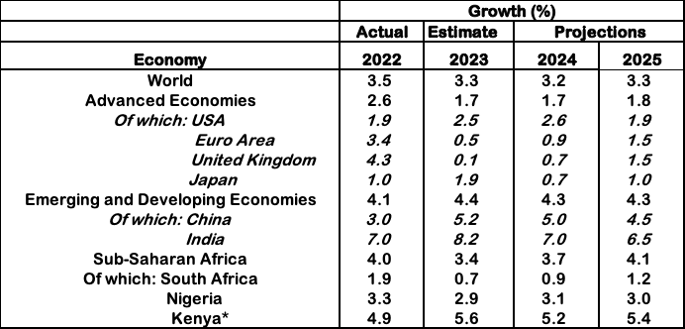
Source: IMF World Economic Outlook, July 2024. *National Treasury Projection
- Growth in the advanced economies is projected to remain stable at 1.7 percent in 2024 and 1.8 percent in 2025. Growth in the US has been revised downwards by 0.1 percentage points from the World Economic Outlook (WEO) April projections as consumption moderated and the labor market eased. Growth prospects for the Euro area were revised upwards by 0.1 percentage points following strong momentum in the services sector and higher than expected net exports in the first half of the year. The Euro area and the UK are projected to grow by 0.9 percent and 0.7 percent, respectively in 2024. In the emerging market and developing economies, growth is projected at 4.3 percent in 2024 and 2025, reflecting stronger activity in Asia particularly China and India. In Sub-Saharan Africa (SSA), economic growth is projected to rise from an estimated 3.4 percent in 2023 to 3.7 percent in 2024 and 4.1 percent in 2025. Growth has been revised downwards by 0.1 percentage points in the April WEO attributed to a weaker growth outlook in Nigeria on account of weaker than expected activity in the first quarter of 2024. Nigeria and South Africa are expected to grow by 3.1 percent and 0.9 percent in 2024, respectively.
- Global financial conditions remained accommodative boosted by positive corporate valuations. Global headline inflation is expected to fall to 5.9 percent and 4.4 percent in 2024 and 2025, respectively. which is a slower pace due to higher-than-average inflation in services prices. World trade growth is expected to increase 3.1 percent and 3.4 percent in 2024 and 2025, respectively. Annual average oil prices and non-fuel commodity prices are projected to increase by 0.8 percent and 5.0 percent in 2024, respectively.

Kenya’s Economic Performance and Outlook
- The Kenyan economy is currently unwinding from the effects of negative and persistent global and domestic shocks that had pushed the economy to its lowest activity level. These shocks included COVID-19 pandemic and its ensuing effects, conflict in Eastern Europe and Middle East that led to global supply chain disruptions and the adverse effects of climate change from the prolonged drought in 2021 to the floods in the first half of 2024. These shocks escalated the cost of essential household commodities including fuel prices, and led to a rapid depreciation of the Kenya Shilling exchange rate, pilling pressure on public debt.
- Various government interventions, structural reforms and policies have supported economic recovery. The economy grew by 5.6 percent in 2023 from 4.9 percent in 2022, a demonstration of resilience and the beginning of economic recovery. The growth was largely driven by a strong rebound in the agricultural subsector, which benefited from favorable weather conditions after two years of severe droughts and the robust performance of the services sector. The performance of the industrial sector, particularly manufacturing which has remained subdued. This growth momentum has continued in 2024 with the economy expanding by 5.0 percent in the first quarter compared to a growth of 5.5 percent in the corresponding quarter in 2023.
- The primary sector grew by 5.0 percent in the first quarter of 2024 compared to a growth of 5.3 percent in the first quarter of 2023. This was as a result of the robust growth in the agriculture, forestry and fishing sub-sector despite a contraction in the mining and quarrying sub sector. Activities in the agriculture, forestry and fishing sub-sector expanded by 6.1 percent in the first quarter of 2024 compared to a growth of 6.4 percent in a similar quarter in 2023 (Table 14). The performance was evident in the significant increase in production of tea, milk and sugarcane during the quarter under review. Mining and Quarrying sub-sector contracted by
14.8 percent in the first quarter of 2024 compared to a contraction of 11.0 percent over the same period in 2023. This was due to a decline in production of most minerals such as titanium, soda ash and gemstone.

Table 14: Sectoral GDP Performance

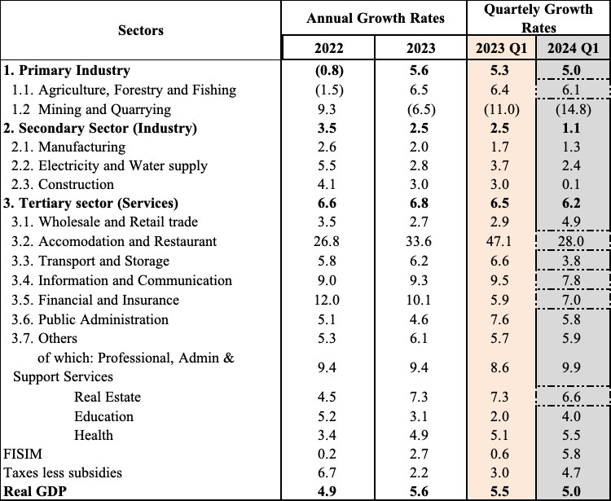
Source of Data: Kenya National Bureau of Statistics
- Industrial sector performance remained subdued, with growth of the sector slowing down to 1.1 percent in the first quarter of 2024 from a growth of 2.5 percent in a similar quarter of 2023. This was mainly on account of a slowdown in activities in all its sub-sectors i.e. the manufacturing, electricity& water supply and construction subsectors.
- The Manufacturing sub-sector grew by 1.3 percent in the first quarter of 2024 compared to 1.7 percent growth in the corresponding quarter of 2023. In the manufacture of food products, growth was supported by tea and dairy processing inspite of the decline in the production of soft drink. In addition, the production of cement declined in the review period. The Electricity and water supply sub-sector also recorded a decelerated growth of 2.4 percent in the first quarter of 2024 compared to a growth of 3.7 percent in the corresponding quarter of 2023 supported by an increase in hydroelectric power generation and a decrease in thermal power generation . . Activities in the construction sub-sector similarly registered a decelerated growth of 0.1 percent compared to 3.0 percent growth recorded in the first quarter of 2023. The slowdown in the construction sub-sector was reflected in the decline in the volume of cement consumption and imported bitumen. However, the volume of iron and steel imported increased during the review period.
- The activities in the services sector continued to sustain strong growth momentum in the first quarter of 2024 and grew by 6.2 percent compared to a growth of 6.5 percent in a similar period in 2023. The performance was largely characterized by significant growths in accommodation and food service, financial and insurance, information and communication, real estate, and wholesale and retail trade sub-sectors. Accommodation and food service activities reflected post COVID recovery inspite of the lingering effects of the pandemic. Consequently, the sub-sector grew by 28.0 percent in the first quarter of 2024 compared to a growth of 47.1 percent recorded in the corresponding quarter of 2023.
- Financial and insurance sub-sector sector grew by 7.0 percent in the first quarter of 2024 compared to 5.9 percent in the corresponding quarter of 2023 on account of increased profitability of the subsector. The information and communication subsector grew by 7.8 percent compared to a growth of 9.5 percent, over the same period supported by increased voice traffic, internet use and mobile money despite a decline in the use of domestic Short Messaging Services (SMSs). Activities in Transportation and Storage sub-sector slowed down to record a growth of 3.8 percent in the first quarter of 2024 compared to a growth of 6.6 percent in a corresponding period in 2023. The growth in the sub-sector was mainly supported by increased activities in Port throughput and an increase in the number of international passenger arrivals and departures.
- Available economic indicators for the first half of 2024 point to mixed performance in the economy reflecting sustained performance in agriculture, improved exports and services sector and subdued industrial sector.. In view of this and other consideration including domestic and external factors, economic growth is projected at 5.2 per cent in 2024 and 5.4 per cent from earlier projections of 5.5 per cent, respectively. This projections are underpinned by broad- based private sector growth and ongoing Government interventions and strategies under the Bottom Up Economic Transformation Agenda (BETA). Additionally, implementation of prudent fiscal and monetary policies will continue to support economic activity (Figure 3).
Figure 3: Annual Real GDP Growth Rates, percent
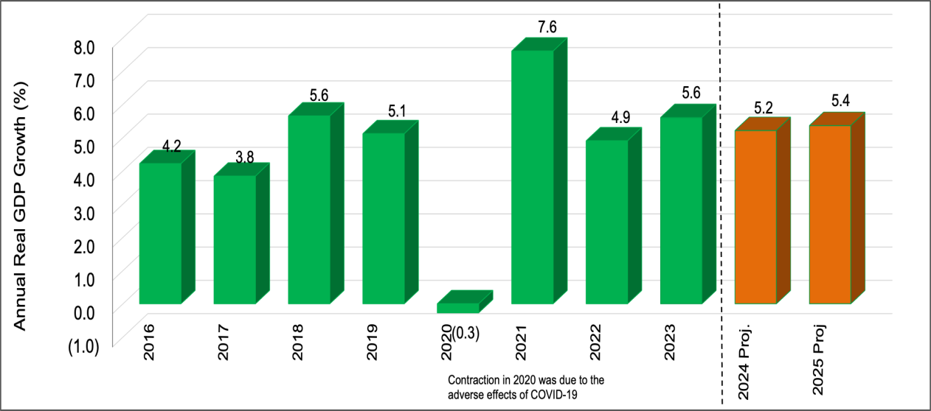
Source of Data: Kenya National Bureau of Statistics

Inflation Developments
- The overall year-on year inflation is within the Government target range of 5±2.5 percent largely driven by easing food and fuel prices. Overall inflation remained stable at 4.4 percent and 4.3 percent in August and July 2024, respectively , thereby remaining below the mid-point of the target for three consecutive months.. This is a drop from 6.7 percent in August 2023, and a peak of 9.6 percent in October 2022 (Figure 4). Favourable weather conditions coupled with targeted government interventions have partly led to the reduction in the cost of food production thereby lowering food inflation. Other factors expected to support low inflation include the pass-through effects of the strengthening exchange rate, decreases in electricity and pump prices and the CBK monetary policy stance.
- To anchor inflation expectations and address exchange rate pressures, the Central Bank of Kenya through the Monetary Policy Committee (MPC) tightened the monetary policy by raising the Central Bank Rate (CBR) from 10.5 percent in July 2023 to 13.0 percent in February 2024. However, in the MPC meeting held on August 6, 2024, the Committee decided to lower the CBR to 12.75 per cent as the previous measures had contributed to lowering overall inflation to below the mid-point of the target range, stabilized the exchange rate, and anchored inflationary expectations.
- Food inflation remained a key driver of overall year-on-year inflation though it declined to 5.3 percent in August 2024 from 7.5 percent in August 2023. The easing of food prices was supported by increased food supply arising from favorable weather conditions, continued Government interventions particularly through subsidized fertilizer, and the general easing of international food prices. Prices of most vegetable food items increased in the month of August 2024 compared to the same period in 2023 while those of non-vegetable food items declined during the same period.
- Fuel inflation declined to 4.7 percent in August 2024 from 14.2 percent in August 2023. The decline largely reflecting the easing global oil prices and appreciation of the Kenya Shilling’s which resulted in a downward adjustment of pump prices; and lower electricity prices. Core (non-food non-fuel) inflation has remained low and stable reflecting the impact of tight monetary policy and muted demand pressures.
Figure 4: Inflation Rate, Percent
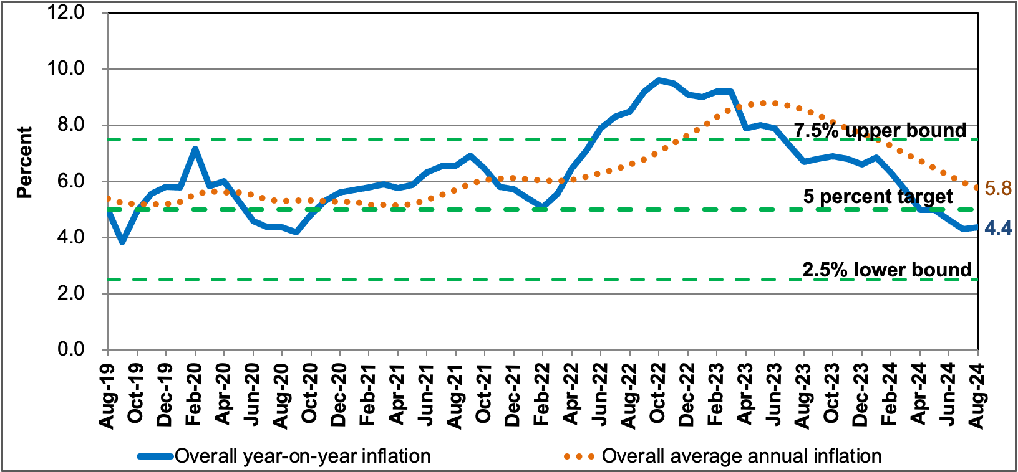
Source of Data: Kenya National Bureau of Statistics

Monetary and Credit Developments
- Broad money supply, M3, grew by 6.0 percent in the year to June 2024 compared to a growth of 13.4 percent in the year to June 2023 (Table 15). The slowdown in growth of M3 was due to a decline in the growth of Net Domestic Assets (NDA) particularly the domestic credit. The primary source of the growth in M3 was an improvement in the Net Foreign Assets (NFA) of the banking system. The NFA of the banking system in the year to June 2024 expanded by 53.2 percent compared to a growth of 29.5 percent in the year to June 2023. The increase in Net Foreign Assets, mainly reflected an increase in commercial banks’ Foreign Assets.
- Net Domestic Assets (NDA) contracted by 0.2 percent in the year to June 2024, compared to a growth of 11.5 percent over a similar period in 2023. The slowdown in growth of the NDA reflects a decline in growth of the domestic credit to both the Government and the private sector. The domestic credit extended by the banking system to the Government decreased to a growth of 7.9 percent in the year to June 2024 compared to a growth of 13.0 percent in the year to June 2023. Lending to other public sectors grew by 1.5 percent compared to a contraction of 0.5 percent over the same period.
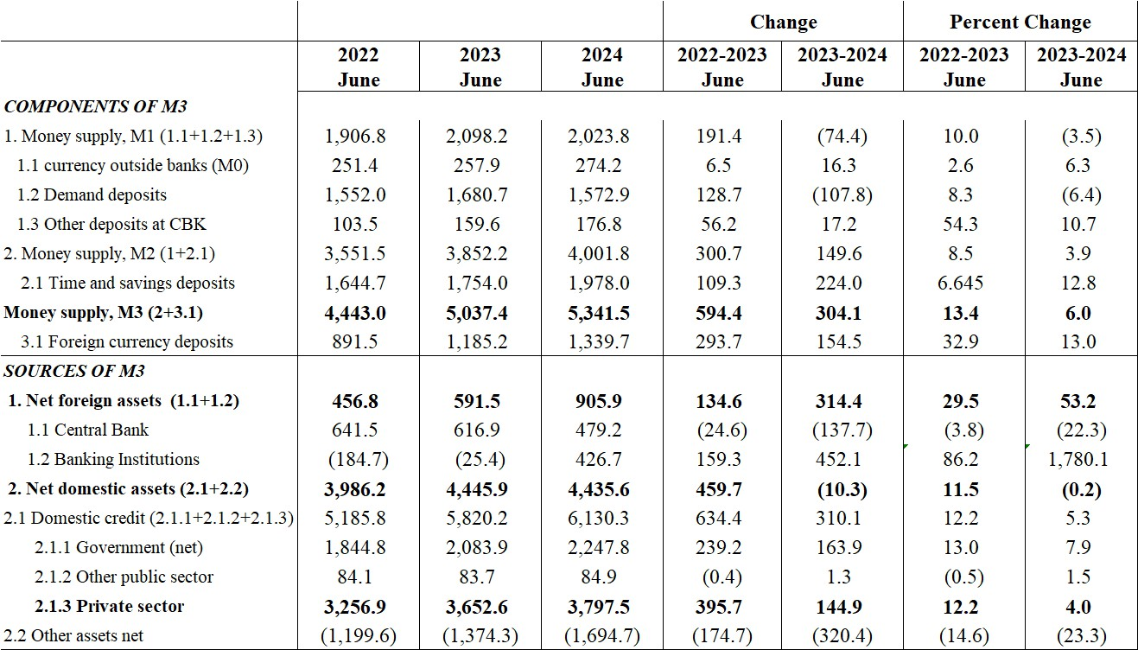
Table 15: Money and Credit Developments (12 Months to June 2024, Ksh billion)
Source of Data: Central Bank of Kenya

- Growth in private sector credit from the banking system slowed to 4.0 percent in the year to June 2024 compared to a growth of 12.2 percent in the year to June 2023, reflecting the impact of exchange rate appreciation on foreign currency denominated loans and monetary policy tightening. Reduced credit growth was observed in manufacturing, trade (exports) and building and construction. These are some of the sectors with significant foreign currency denominated loans
- The Monthly (month on month) credit flows to the private sector have slowed down since December 2023 following the monetary policy action of increasing the central bank rate to manage inflation expectation which resulted in the increased cost of credit (Figure 5). Sustained demand particularly for working capital due to resilient economic activity, the implementation of the Credit Guarantee Scheme for the vulnerable MSMEs and the projected economic growth for 2024 will continue to support private sector credit uptake.

Figure 5: Private Sector Credit
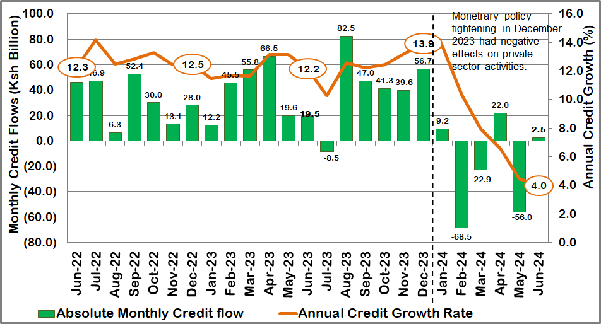
Source of Data: Central Bank of Kenya

Interest Rates Developments
- Interest rates in the year to August 2024 increased reflecting the tight monetary policy stance. The interbank rate increased to 12.97 percent in August 2024 compared to 10.48 percent in August 2023 and has remained within the prescribed corridor around the CBR (set at CBR± 150 basis points) (Figure 6). The 91-day Treasury Bills rate increased to 15.8 percent in August 2024 compared to 13.3 percent in August 2023 while the 182-day Treasury Bills rate also increased to 16.7 percent from 13.2 percent over the same period. The 364-day Treasury Bills rate increased to 16.9 percent in August 2024 from 13.6 percent in August 2023. This has increased the cost of borrowing by Government from the domestic market.

Figure 6: Short Term Interest Rates, Percent
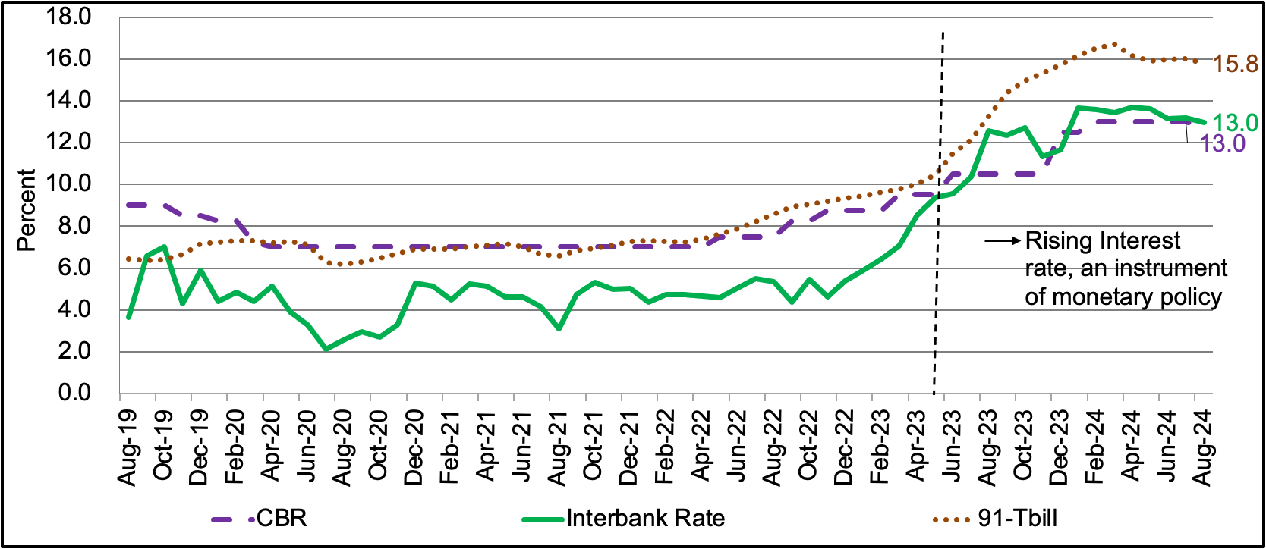
Source of Data: Central Bank of Kenya
- Commercial banks average lending and deposit rates increased in the year to July 2024 in tandem with the tightening of the monetary policy stance thereby reflecting high cost of investable funds. The average lending rate increased to 16.8 percent in July 2024 from 13.8 percent in July 2023 while the average deposit rate increased to 11.3 percent from 8.4 percent over the same period. Consequently, the average interest rate spread decreased to 5.6 percent in July 2024 from 5.4 percent in July 2023 (Figure 7).
Figure 7: Commercial Bank Rates, Percent
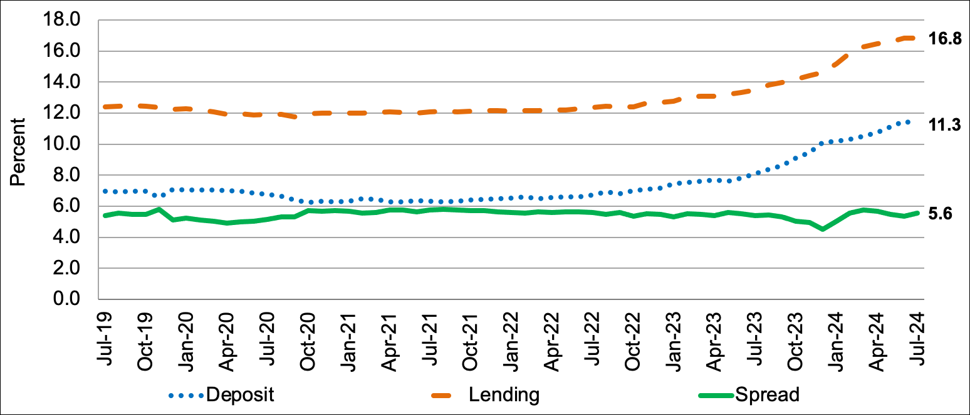
Source of Data: Central Bank of Kenya

External Sector Developments
- The current account deficit narrowed to USD 4,091.3 million (3.2 percent of GDP) in June 2024 compared to USD 4,840.9 million (4.5 percent of GDP) in June 2023 reflecting lower imports, strong performance of export of goods and services as well as increased remittances (Table 16). Goods exports increased by 5.0 percent in the 12 months to June 2024 compared to a similar period in 2023, reflecting increased exports of agricultural commodities and re- exports. Goods imports declined by 3.3 percent in the 12 months to June 2024 compared to a similar period of 2023, reflecting lower imports across all categories, except sugar, machinery and transport equipment, crude materials, and miscellaneous manufactures. In this respect, the balance in the merchandise account improved by USD 961.1 million to a deficit of USD 9,887.8 million in June 2024. Remittances increased by 12.9 percent to USD 4,536 million in the 12 months to June 2024 compared to USD 4,017 million in a similar period in 2023. Tourist arrivals improved by 27.2 percent in the 12 months to June 2024 compared to a similar period in 2023
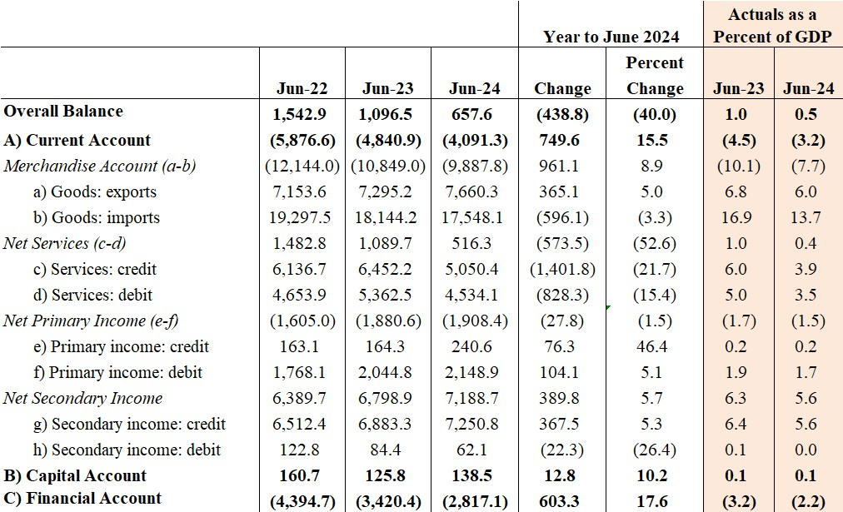
Table 16: Balance of Payments (USD Million)
Source of Data: Central Bank of Kenya
- The capital account balance improved by USD 12.8 million to register a surplus of USD 138.5 million in June 2024 compared to a surplus of USD 125.8 million in the same period in 2023. Net financial inflows declined to USD 2,817.1 million in June 2024 compared to USD 3,420.4 million in June 2023 reflecting a slowdown in inflows to the government and other sectors. However, portfolio investments and financial derivatives registered a net outflow during the period partly due to Kenya’s limited access to international financial markets owing to elevated borrowing costs.
- The overall balance of payments position slowed down to a surplus of USD 657.6 million (0.5 percent of GDP) in June 2024 from a surplus of USD 1,096.5 million (1.0 percent of GDP) in June 2023.

Foreign Exchange Reserves
- The banking system’s foreign exchange holdings remained strong at USD 16,438.0 million in June 2024, an improvement from USD 13,165.6 million in June 2023. The official foreign exchange reserves held by the Central Bank stood at USD 8,462.7 million compared to USD 8,036.7 million over the same period in 2023 (Figure 8). Commercial banks holdings increased to USD 7,975.3 million in June 2024 from USD 5,128.8 million in June 2023.
- The CBK foreign exchange reserves remained adequate. Official foreign exchange reserves stood at USD 7,349 million (3.8 months of import cover as at end August 2024) and continue to provide adequate buffer against short-term shocks in the foreign exchange market.
Figure 8: Foreign Exchange Reserves (USD Million)
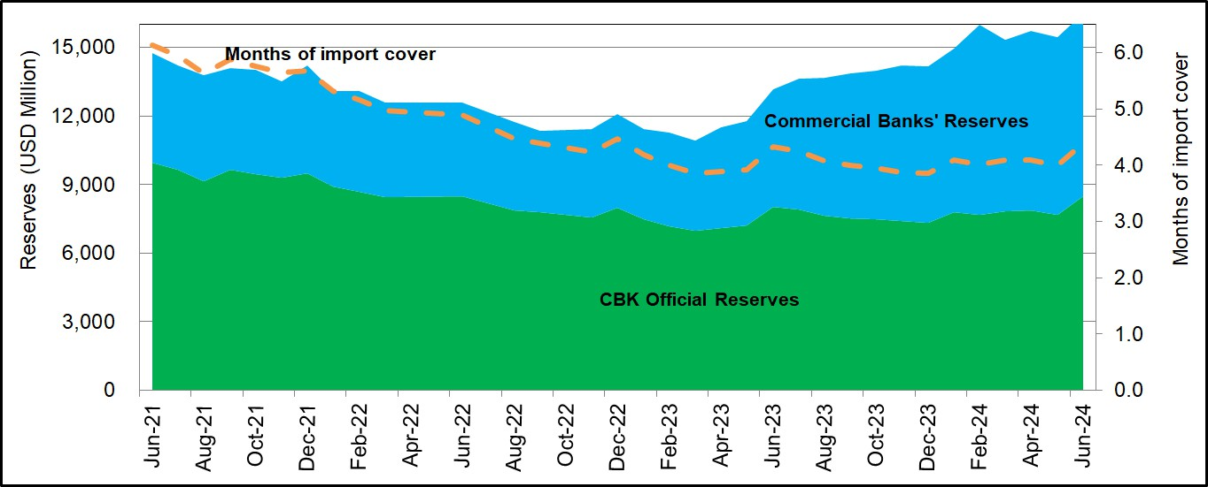
Source of Data: Central Bank of Kenya

Exchange Rate Developments
- The foreign exchange market remained stable in the first half of 2024 despite increased global uncertainties, effects of a stronger U.S. Dollar and geopolitical tensions in the Middle East. The Kenya Shilling exchange rate was weaker at the turn of the year but strengthened against the U.S. Dollar from mid-February 2024 through August 2024. It strengthened by 10.15 per cent, 8.55 per cent and 9.55 per cent against the US Dollar, Sterling Pound, and the Euro, respectively in August 2024 compared to a similar period in 2023. It exchanged at an average of Ksh 129.32 per US dollar in August 2024 compared with Ksh 143.93 per US dollar in August 2023. Similarly, the Kenya Shilling underperformed in all EAC regional currencies over the period under consideration. The foreign exchange market was mainly supported by inflows from agricultural exports, remittances and portfolio investors while demand was driven by pickup in economic activities specifically in the manufacturing, wholesale, and retail sectors (Figure 9).
- Through the repayment of the 2024 Eurobond, the Government successfully lowered investor uncertainty and improved the financial markets perception. The appreciation and stability of the exchange rate has created confidence and triggered inflows of foreign direct investment and attracted investors to the Nairobi Securities Exchange. This appreciation has helped to reduce debt service costs, improve performance of domestic borrowing and stabilize interest rates.
Figure 9: Kenya Shillings Exchange Rate
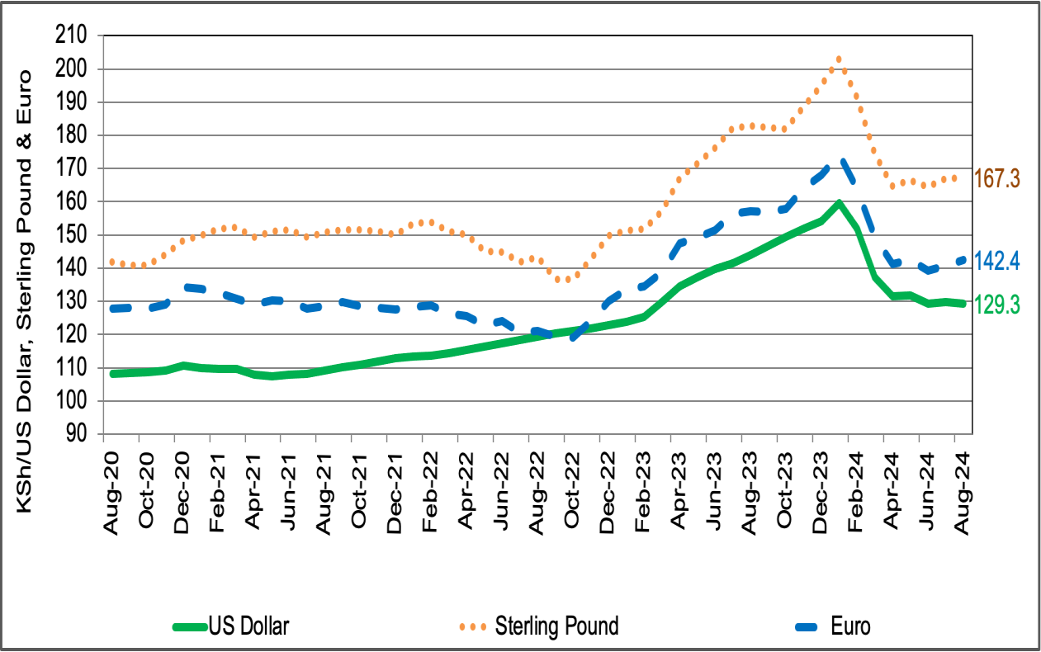
Source of Data: Central Bank of Kenya

Capital Markets Developments
- Economic recovery, appreciation of the Kenya Shilling against major international currencies and macroeconomic stability have created confidence and triggered inflows of foreign direct investment and attracted investors to the Nairobi Securities Exchange. The NSE 20 Share Index improved to 1,678 points in August 2024 compared to 1,540 points in August 2023 while market capitalization also improved to Ksh 1,620 billion from Ksh 1,545 billion over the same period (Figure 10).

Figure 10: Performance of the Nairobi Securities Exchange
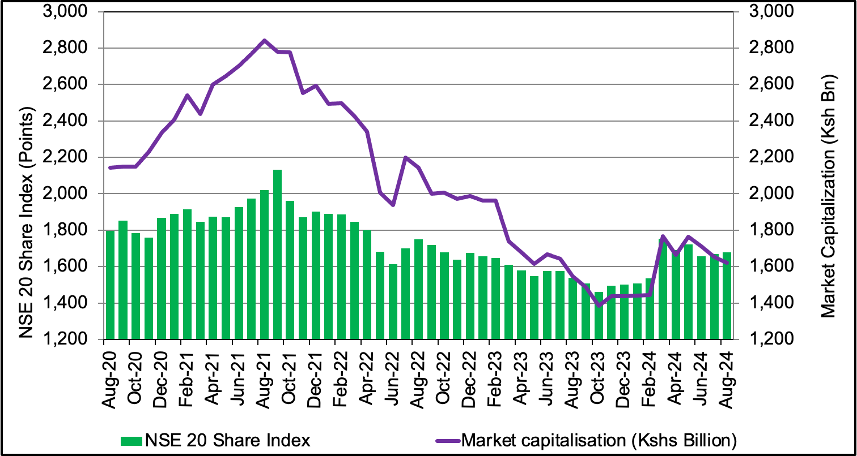
Source of Data: Nairobi Securities Exchange

County level
- As we all know, our nation is experiencing a turbulent economic environment characterized by a myriad of challenges including the after-effects of the recent Gen Z demonstrations, political realignments where some sections of the opposition parties joined the Government in what is being referred as Government for National Unity, rejection of the Finance Bill 2024, and subsequent budget cuts for both the National and County Governments.
- Notwithstanding this, we are full aware that our counties are tasked with delivering crucial services, yet we are often constrained by limited own-source revenues. The dependence on National Government transfers, coupled with an inelastic local revenue collection base, has created challenging fiscal situation. This lack of sustainable funding weakens our ability to plan for the future, stifling innovation, growth and attainment of the county development agenda.
- Moreover, the ongoing public debt crisis has forced many of us to re-evaluate our financial priorities. In this regard, let me reiterate that we must be responsible stewards of the resources entrusted to us, ensuring that every shilling is spent prudently to the benefit of our people.

- In the period 2023/2024 FY, the National government had several planned projects/programmes at County level, which had great impacts in the Kitui County economy.
- The County Government of Kitui commissioned the “Kitui County Transition Roadmap to a Sustainable HIV/TB program 2023-2027”. HIV prevalence has stabilized over the years owing to the concerted efforts between the county government and her implementing partners. This prevalence rate had declined from 3.8% in 2021 to 3.1% in 2024. The Kitui County Transition Roadmap to sustainable HIV/TB program forms a sustainable plan from USA Government funding to a Kitui County led owned and funded HIV/TV program.
- The Department for livestock (SDL) launched the De-risking, Inclusion and Value enhancement (DRIVE) Project in the county. The Government agency leading the DRIVE project implementation in Kenya has collaborated with ZEP-RE (PTA Reinsurance Company) and Kenya Development Corporation (KDC) through subsidiary agreements for implementation of component 1 and 2 respectively of the DRIVE project in 21 ASAL counties, including Kitui.
- The County Government of Kitui developed irrigation infrastructure for 9 micro-irrigation schemes in collaboration with the Small Irrigation Value Addition Project (SIVAP) in 4 Wards (Kauwi, Nguutani, Kyome/Thaana and Mutonguni) benefitting 460 farmers to increase food production. Three Sustainable Land Management (SLM) sites developed in Itulu in Kisasi, Katwenye in Kyuso and Syokaai in Nuu Wards through construction of 101.5Km of terraces as well as 42 farm ponds and supply of 2,690 agroforestry seedlings, benefitting 1,350 farmers. The County Government supported 320 farmers in five apiculture and honey producer organizations in five Wards - Tharaka, Mwingi Central, Kiomo/Kyethani, Mutitu/Kaliku and Athi - with 1,200 modern beehives.
- The County Government of Kitui in partnership with the National Government Ministry of Mining has gazetted artisanal mining committee, which shall be responsible in advising the Cabinet Secretary in issuing artisanal mining permits in Kitui. A report on mineral resources in the country has identified about 970 mineral occurrences that will be subjected to a fact-finding process.
- The County Government launched the Plug Mtaani Vijana 2 Invest initiative - a business idea competition designed to nurture young entrepreneurs by providing them with soft skills and business plan development training in the country. The National Government unveiled The Vijana 2 Invest program in partnership with counties to foster the spirit of innovation, resilience and determination among the youth in Kenya.
- The National Government issued over 10,000 title deeds to residents of Thagicu, Mwingi North. This gave the residents legal rights to become landowners. In addition, H.E Dr William Samoei Ruto opened the police border hospital at the Kanyonyoo Border Police base, which is expected to benefit the entire Ukambani community.
- The County Governments of Kitui, Makueni and Machakos, in their summit meeting, tasked the National Government to expedite completion of the Thwake Multipurpose Dam. The completion of the project will herald a new beginning for water and food security in the region as well as for electricity generation. In Kitui County, the leaders revealed that the County Government has already secured 30 acres of land as part of its contribution to the implementation of the High Grand Falls Dam, which shall serve the SEKEB Bloc and beyond.

Kenya’s Macroeconomic Outlook
- Kenya’s economic performance is projected to remain stable over the medium term. Growth is expected to moderate from 5.6 percent in 2023 to a forecast of 5.2 percent in 2024 and 5.4 percent in 2025. The growth in 2024 and 2025 will benefit from the enhanced agricultural productivity and a resilient services sector. The rebound in Kenya's agricultural sector is expected to be largely driven by favourable weather conditions and productivity-enhancing government interventions.
- The industrial sector will see growth primarily in manufacturing largely reflecting reduction in costs of production and easing of exchange rate pressures; and in construction partly attributed to increased public spending on affordable housing. The services sector is expected to remain resilient, with ICT reforms boosting growth in financial services, health, and public administration. However, increased uncertainties in both the external and domestic environments, such as the escalation of geopolitical tensions and potential disruptions in supply chain networks, could negatively impact commodity markets and slow down this potential growth.
- On the demand side, aggregate domestic demand is expected to remain resilient even as public sector consolidates with the private sector playing a stronger role in Kenya’s medium- term recovery. Bumper agricultural harvests, moderate inflation, a recovery in employment, and modest growth of credit to private sector will support growth in private consumption. Moreover, remittance inflows to Kenya are projected to remain resilient, providing further support to household incomes. Private consumption is expected to complement moderate government consumption in the context of fiscal consolidation.
- Private investment will be supported by measures aimed at improving competitiveness, inclusivity, market efficiency, positive business sentiment, access to the international market, and projected FDI inflows. Investment will also benefit from an increased focus on Public Private Partnerships (PPPs), following the near completion of the harmonization of the Public Investment Policy, which will align PPP and Public Investment Management frameworks. In the medium term, the Government targets PPP investments in key economic sectors to complement its development agenda. These sectors include Agriculture, Roads and Transport, Urban Development and Housing, Energy, Water, Information, Communication Technologies (ICT), and Health. The PPPs are also expected to partly fill the investment financing gap in the wake of ongoing fiscal consolidation efforts which would reduce government domestic borrowing and lower yields on government securities.
- Government consumption and investments are expected to slowdown in 2024 and 2025 due to the ongoing growth friendly fiscal consolidation efforts. However, the development will be complimented with private sector investments in commercially viable development projects. Growth over the medium term will also be driven by sustained Government investments in the Bottom Up Economic Transformation Agenda. Particularly, investments in the nine priority value chains (Leather, Cotton, Dairy, Edible Oils, Tea, Rice, Blue economy, Natural Resources (including Minerals and Forestry), and Building Materials). Government interventions towards climate change adaptation and mitigation measures that include rehabilitation of wetlands and reforestation are expected to support growth over the medium term.
- Kenya’s external position is expected to remain supportive of macroeconomic stability. Overall, the current account deficit is expected to be stable in the medium term. Exports are expected to recover, both from improvements in the global and regional trade outlook, and domestic conditions. Exports are expected to benefit from the ongoing implementation of trade agreements such as regional economic communities and the AfCFTA. Increased remittance inflows and tourism receipts are expected to further provide foreign exchange buffer. Imports are expected to grow as domestic demand recovers, particularly of raw materials, fuels, and intermediate goods, consistent with investment growth and the stability in the foreign exchange market.

Monetary Policy Management
- The monetary policy stance over the medium term will aim at achieving and maintaining overall inflation within the target range of 5±2.5 percent while maintaining a competitive exchange rate and stable interest rates. The flexible margin of 2.5 percent on either side of the inflation target is to cater for effects of external and domestic shocks and recurrence of extreme weather events that not only affect economic activities but also pose major fiscal risk. Maintaining the inflation rate at this level will help preserve macroeconomic stability and reduce undesirable fluctuations in economic performance. The targeted inflation will be supported by muted demand pressures consistent with prudent monetary policy and easing of domestic and global food and oil prices coupled with Government measures to lower cost of production.
- The ongoing implementation of reforms to modernize Monetary Policy Framework and Operations continues to enhance monetary policy transmission and improve distribution of liquidity in the interbank market. In particular, the introduction of the interest rate corridor, currently set at CBR ± 250 basis points, has ensured that the interbank rate (operating target), closely tracks the CBR. The reduction of the applicable interest rate to the Discount Window from the current 600 basis points above CBR to 400 basis points above CBR has improved access to the Window. In addition, the width of the interest rate corridor was narrowed to ± 150 basis points in June 2024, and the discount window lowered from 400 basis points above CBR to 300 basis points to further enhance efficiency in the interbank market and strengthen alignment of the policy rate with the interbank rate. The Central Bank of Kenya has recently undertaken the following major reforms in the operation of the interbank foreign exchange market:
- Introduction of electronic matching systems (EMS) in the interbank market;
- Requirement of maximum spread of 20 cents on indicative quotes in the interbank market removed; and
- The CBK published exchange rate is now a weighted average rate of all interbank transactions executed the previous day. Previously, the published rate was based on the indicative rate provided by selected major players in the interbank market.
- Additionally, the implementation of the DhowCSD, an upgraded Central Securities Depository infrastructure, has greatly enhanced efficiency in investment in Government Securities. The DhowCSD also continues to improve the functioning of the interbank market by facilitating collateralized lending amongst commercial banks and further reducing segmentation in the interbank market.
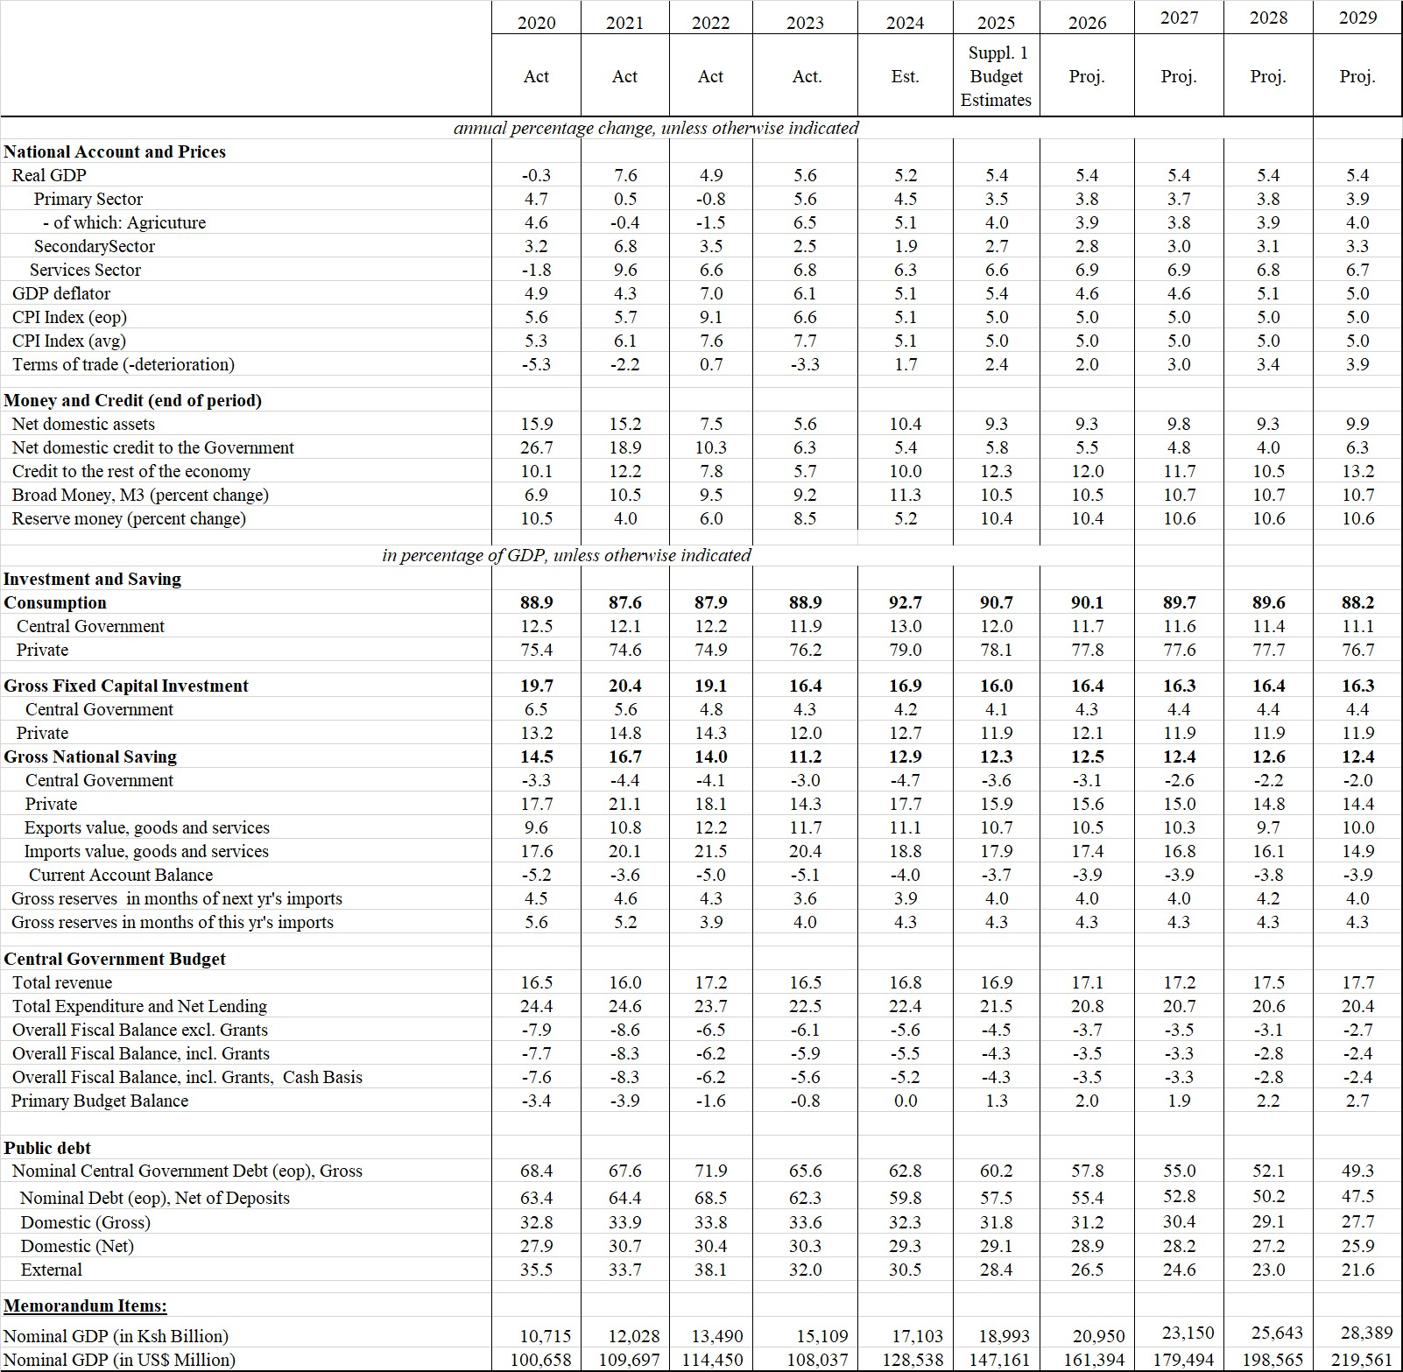
Table 17: Kenya’s Macroeconomic Indicators and Projections

Source: The National Treasury

County Economic Outlook
- According to 2023 Gross County Product, Kitui County’s Gross County Product (GCP) slightly accelerated from Kshs 143,268 Million in 2021 to Kshs 161,668 Million in 2022 representing a 12.8 percentage increase. Kitui County’s contribution remained constant at 1.3 with a five-year average of 1.4. The local revenue under the review period increased by 11.3% in relation to the previous 2022/2023 FY.
Figure 11: Kitui County Gross County Product (Kshs Mns)
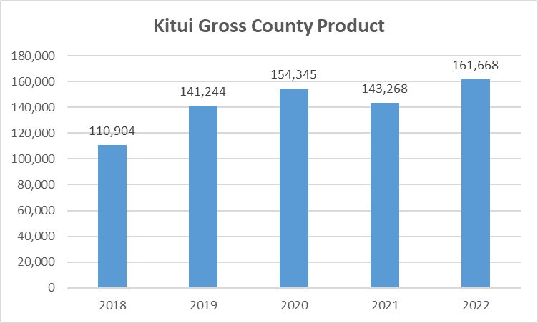
Source: Kenya National Bureau of Statistics, 2024
- During the FY 2023/24, we made tremendous the following achievements under various sectors:
- On Finance, we have grown our Own Source Revenue by 79% from Kshs 361M in FY 2021/22 to Kshs 646M in FY 2023/24.
- Food Security is one of the main pillars in our County Development Agenda. To boost food production, we developed irrigation infrastructure for 9 micro-irrigation schemes in collaboration with the Small Irrigation Value Addition Project (SIVAP) in 4 Wards (Kauwi, Nguutani, Kyome/Thaana and Mutonguni) benefitting 460 farmers. Further, we developed Three Sustainable Land Management (SLM) sites in Itulu in Kisasi, Katwenye in Kyuso and Syokaai in Nuu Wards through construction of 101.5KM of terraces as well as 42 farm ponds and supplied 2,690 agroforestry seedlings benefitting 1,350 farmers. In addition, we implemented subsidized tractor ploughing services in all the 40 Wards. To boost beekeeping, we have supported 320 farmers in five apiculture and honey producer organizations in five Wards - Tharaka, Mwingi Central, Kiomo/Kyethani, Mutitu/Kaliku and Athi - with 1,200 modern beehives.
- To enhance water access, we constructed eight (8) sumpwells in Kalwa (Ngomeni), Kanzinwa (Mumoni), Tyaa (Mwingi Central), Ndiang’u (Matinyani), Yambuu (Mulango), Kwa Wewa (Chuluni), Imuumba (Voo/Kyamatu) and Kalambani in Mutha ward serving an estimated 31,500 residents. Further, we desilted 15 medium-sized earth dams which benefitted over 22,500 residents.
- In addition, we supported our two water service providers (WSPs) – i.e., Kitui Water and Sanitation Company (KITWASCO) and Kiambere-Mwingi Water and Sanitation (KIMWASCO) through provision of subsidies towards part payment of electricity bills at a cost of Ksh. 113,869,278. Furthermore, the County Government is working towards weaning off the WSPs from continued dependence on the County Government to meet their operational costs. This will enable the county government to redirect these resources towards development of more water infrastructure, especially in the most undeserved areas of the vast county. To achieve the foregoing goal, the county government has implemented several strategies such as putting in place new board of directors for Kitwasco to enhance governance, trained to inculcate public service ethos, widened and deepened revenue base by increasing connections from 9,000 towards 15,000 connections, adoption of increased use of technology through use of digital prepaid and postpaid meters to reduce non-revenue water (NRW), reviewed tariff to ensure full cost recovery in water pricing, diversifying revenue sources to minimise dependence on the Masinga intake and hybridization of water schemes to reduce their costs of operation, among others.
- On Health and Sanitation, we recruited and trained 2,470 Community Health Promoters, which translates to 10 CHPs in each of the 247 County villages. The County Government has been providing a monthly stipend of Kshs 5,500 to each Community Health Promoter, co-funded by the County Government of Kitui (Kshs 3,000) and the National Government (Kshs 2,500).
- Our Government in partnership with Catholic Medical Mission Board (CMMB) officials distributed over 370 bicycles donated by World Bicycle Relief (WBR) to Community Health Promoters (CHPs) drawn from Mwingi North and Mwingi Central to help in their outreach work at the grassroots. This initiative has advanced promotive and preventive healthcare services.
- In order to offer affordable and reliable diagnostic services to our people, we reinstated the Computed Tomography (CT) Scan services at the Kitui County Referral Hospital. In addition, to improve the supply of oxygen in our facilities, in partnership with USAID, we installed and commissioned an Oxygen Plant including 300 gas cylinders at the Mwingi Level IV Hospital serving 58,493 people within Mwingi and adjoining areas.
- We have completed and renovated stalled maternity units in various health facilities such as Kyuso Sub-County Hospital, Ikanga, Nguni and Malalani Health Centres and established three New Born Units (NBUs) at Ikanga, Ikutha and Tseikuru Sub-County hospitals increasing the number to seven.
- In addition, the County Government operationalized Mutomo Sub-County Hospital’s Maternal and Child Health (MCH) Unit and completed the maternity theatre and Outpatient Block to serve 12,549 people. In Yatta Health Centre the County Government has constructed two wards (female and male) and maternity theatre. The Yatta Health Centre mortuary has also been operationalized.
- To improve diagnostic services, we have completed X-ray departments at Tseikuru and Kauwi Sub-County Hospitals and equipped laboratory units in Ikutha, Tseikuru, Migwani and Mutitu Sub-County Hospitals with hematology, biochemistry and electrolyte analyzers. In addition, we have constructed maternity theatres in Mutitu, Kanyangi, Mutomo, Kanziku and Yatta health facilities to enhance maternal services.
- To improve access and quality of care in health facilities, we have initiated upgrading of Yatta, Sosoma, Kanziko, Mbitini and Waita health centres, Tiva and Endau dispensaries to level 3B. In addition, new facilities have been constructed at Kanguu, Kitoo, Kyandui and Kyamatu.
- Under Trade, we constructed a total of 36 markets in various wards. Further, we completed installation of markets lights in 14 wards.
- To ensure appropriately nurtured and skilled human capital, we have established a new Vocational Training Centre (VTC) at Mwakini/Katothya in Yatta/Kwa Vonza ward. Further, we have completed the stalled Information Communication Technology (ICT) Workshop at Mutonguni VTC as well as the twin workshop and toilet blocks at Syou VTC in Endau/Malalani Ward.
- In addition, we have improved infrastructure/facelifted VTCs, where 3 new modern workshops in Mutomo (Mutomo ward), Ngwani (Ikanga/Kyatune ward) and Kyambiti (Mulango ward) VTCs. Further, we facelifted four (4) workshops in Ngomeni, Katse, Ithiani and Mui VTCs and renovated burnt dormitory at Mutonguni VTC. We constructed and fully equipped 3 ICT classrooms at Ikutha, Kauwi and Mwingi Baptist VTCs.
- On Early Childhood Development Education, we developed a scheme of service for ECDE teachers that saw 1688 ECDE teachers transit from casual to permanent and pensionable terms of employment. This act boosted their morale, improved their livelihoods and spurred, local rural economies as they paid for their goods and services. In addition, we constructed 40 ECDE classrooms in each of the 40 wards as well as installed a 10,000 litres capacity water tanks benefitting 1,200 ECDE learners.
- Planned Urban Development remains key in my development agenda. On this, we installed and repaired 274 streetlights across 23 urban areas spread across 21 wards. This has helped in extending working hours, enhancing security as well as enhancing urban aesthetics for the residents. In addition, we supported land adjudication in Mwakini Settlement Scheme where 2,113 parcels have already been demarcated for titling out of the projected 3,500 parcels.
- To live with our strategy that the future is urban, we have installed 123 posts Integrated Solar Streetlights in Kitui Municipality and repaired 136 posts of streetlights within Township ward, Museve, Mulutu, Matinyani and Wikililye shopping centers.
- Under Mwingi Municipality, we constructed 2,950M2 of Cabro paving in Mwingi Town along Total petrol station. As concerns security, a total of 167 street light poles were repaired along Muithi Museo to Stock Yard and ACK Church to Slaughter Road junction. In addition, five high electric powered masts were repaired.
- To improve the road network, we have graded a total of 1,730.10kms of roads across the County benefiting 25,000 users/day including:- Nzambani Police Station – Kangwa Shopping Centre Road in Nzambani Ward, Mutune Shopping Centre – Mutendea Primary School Road in Kyangwithya East Ward, Kwa Mbuvi- Mwangeni Centre in Athi Ward, Ithiani -Ngoleni -Wayani Road in Kyangwithya West Ward, Kwa Nyunyi – Mukelesu Primary School- Kwa Kilui Junction in Yatta/Kwavonza Ward, Ikutha – Kasaala Road in Ikutha Ward, improvement of Majengo (Spot Light Hotel) – Unyaa in Township/Kyangwithya West Wards among others.
- A total of 274.20KMS of roads have been opened and/or widened across the County in which 600 users/day benefit including Karangeni-Kanyengya-Nthangani Road in Tharaka Ward, Membau–Mbakoni-Yolomuni Road in Athi Ward, Kanyongonyo–Kangukangu Road in Kanyangi Ward, Kwa Kyenza-Kithome Nziana through Ngethwa River-Kunikila Primary School in Matinyani Ward, Wanzua – Kangau Primary School Road in Kyangwithya East Ward, Ithiiani-Ngoleni- Wayani Road in Kyangwithya West Ward, Kithambangii – Kavisi Primary School Road in Mulango Ward among others. We gravelled 9.7 kms of roads across Kitui including Spot improvement of Thaana Nzau – Kithyoko River Road in Kyome/Thaana Ward, Kinakoni – Kiangini – Kivwauni Road in Voo/Kyamatu Ward, Kyatune – Kyaaka Road in Ikanga/Kyatune Ward, Road to Mwitasyano Water intake project in Yatta/Kwa Vonza Ward, Mwingi Town in Both Kivou and Mwingi Central Wards besides upgrading 0.55kms of roads to paved standards i.e. Kitui ASK Exit road and walk ways in Kyangwithya West Ward.
- A total of 125 Meters (7No. Drifts) of drifts have been constructed including the Katse Drift along Katse-Musosya Road in Mumoni Ward, Syombuku – Kwa Isika Road in Nzambani Ward, Nzia zuni Drift in Kyangwithya West Ward, Masungwa River Drift in Kyuso Ward, Twili River Drift in Kanziko/Simisi Ward, Mutwang’ombe Market Protection works in Waita Ward, River Muna Protection works in Tseikuru Ward.
- To enhance the skills and capacity of contractors in public procurement processes and give them a competitive edge in tendering and contract management, we collaborated with the National Construction Authority (NCA) to train and capacity-build 4,000 contractors from all the 40 Wards.
- Employing over 20,000 youth in Kitui, the Boda Boda Sector is one of the fastest growing sectors in the County. We have mapped Boda Boda operators and sensitized them on road safety and the need to form at least one Savings and Credit Cooperative Society (SACCO) in each of the 40 Wards as well as construction of 28no. modern Boda Boda sheds in all the Wards within the County.
- On environment, we have made significant milestones towards full operationalization of the Kitui County River Basins Sand Utilization and Conservation Act, 2024. So far we have conducted ward elections, inducted and trained the interim caretaker committees. We are currently working with department of Social Protection and Cooperatives to establish/register site based sand community groups and River-Basin based cooperative societies. The established cooperatives will nominate one representative and constitute the Kitui County Sand Utilization and Conservation Committee to start licensing by end of October, 2024. The Act has, among other benefits, provided for a legislative framework for environmental conservation and restoration of river basin ecosystems. I wish to thank the County Assembly for their cooperation, dedication and commitment in bringing this Act into reality.
- Further, we have hybridized/solarized six (6) boreholes in Matinyani, Kakeani-Mutonguni, Kyume-Mui, Ikanga, Katse town and Ngungi-Zombe benefiting over 20,000 people with reliable and cheap water supply.
- In an effort to expand mobile telephony network, we have partnered with Safaricom Limited to put up three new Base Transceiver Stations (BTS) at Kalulini, Kwa vonza and Kiangu and optimized network in other eight BTS stations (Mosa Market, Muthue, Kyoani, Ndatani, Ikanga, Kaseve, Mutomo and Zombe) to connect over 50,000 people with 2G/3G/4G Network.
- In addition, we constructed 13 Community Playgrounds in 13 Various Wards providing over 10,000 youth with an opportunity to nurture their talents.
- Peace and Security is a key enabler in the achievement of our development agenda. In order to offer a long-lasting solution to the insecurity challenges along our North and Eastern borders, we have collaborated with the National Government in order to establish eight (8) police stations to enhance security patrols in Kanziku/Simisi, Mutha, Voo/Kyamatu, Endau/Malalani, Nuu, Nguni, Ngomeni and Tseikuru Wards. This collaboration is in line with Article 189 (1) (b) of the Constitution of Kenya (CoK) 2010 that allows the two levels of government to assist, support, consult, appropriate and implement the legislation of the other level of government. Currently, two police stations i.e. Mandongoi in Ngomeni and Kona Kaliti in Mutha are complete, while Twambui in Endau/Malalani and Imuumba in Voo/Kyamatu are ongoing. We will construct four Police Stations in Kanziku/Simisi, Nuu, Nguni and Tseikuru Wards.
- The above could not be achieved without qualified and competent staff who are sufficiently empowered through strategic and continuous capacity building as well as engagement and retention of visionary leadership and governance. Cognizant to the fact that what gets measured gets done, we have implemented performance contracting in all our ministries.

Risks to the economic outlook
- Kenya’s growth outlook portrays a stable macroeconomic environment in the medium term. However, there are downside risks to this macroeconomic outlook emanating from domestic as well as external sources. External risks include further escalation of geopolitical tensions – particularly the wars in the Middle East and Ukraine; potential worsening of supply disruptions due to the shipping crisis in the Red Sea and Suez Canal, which could result in higher import and production costs; and uncertainty about the evolution of international oil prices. Internally, extreme weather (drought or floods) could weaken agricultural output, lead to destruction of capital, increase food insecurity and lead to a surge in cases of water-borne diseases.
- Lower than anticipated global economic growth and particularly in major exports destination could reduce Kenya’s exports, tourism receipts, and remittances growth, while increase in global fuel prices could increase Kenya’s imports bill. Tight global financial conditions arising from lower-than-expected return of global inflation to target levels could aggravate Kenya’s vulnerabilities towards meeting external financing requirements. However, the government’s commitment to fiscal consolidation and prioritizing concessional borrowing is expected to mitigate this risk.
- The upside risk to the domestic economy relate to fast-tracked implementation of structural reforms under BETA and the Fourth Medium-Term Plan (MTP) IV. Early normalization in global financing conditions and lower international fuel and food prices would strengthen Kenya’s external balances. Faster than projected rebound in economic activities that would result in higher Government revenues providing fiscal space that would support fiscal Consolidation. Continued coordination between monetary and fiscal policies are expected to result to a stable macroeconomic condition which is a necessary condition for investment and savings thereby promoting economic growth.
- The Government continues to monitor the domestic and external environment and will take appropriate policy measures to safeguard the economy against the adverse effects of the risks if they were to materialize.
- At the county level, we anticipate several risks which might affect future economic outlook. This includes; insecurity in the eight wards bordering Tana River County, unreliable rainfall and delayed exchequer disbursement.

IV. RESOURCE ALLOCATION FRAMEWORK

Adjustments to 2024/25 Budget
- Kenya’s economic performance is projected to remain stable over the medium term. Growth is expected to moderate from 5.6 percent in 2023 to a forecast of 5.2 percent in 2024 and 5.4 percent in 2025. The growth in 2024 and 2025 will benefit from the enhanced agricultural productivity and a resilient services sector. The rebound in Kenya's agricultural sector is expected to be largely driven by favourable weather conditions and productivity-enhancing government interventions.
- The industrial sector will see growth primarily in manufacturing largely reflecting reduction in costs of production and easing of exchange rate pressures; and in construction partly attributed to increased public spending on affordable housing. The services sector is expected to remain resilient, with ICT reforms boosting growth in financial services, health, and public administration. However, increased uncertainties in both the external and domestic environments, such as the escalation of geopolitical tensions and potential disruptions in supply chain networks, could negatively impact commodity markets and slow down this potential growth.
- In the county level, though the level of absorption of 87.12% in 2023/2024 reflects an increase from previous year’s budget, a strategy is being drafted to ensure that steady performance is supported while rolling over to 2024/25 financial year and aim on 90%+ budget absorption.
- The project implementation status by the ministries clearly indicates the need for the departments to maximise the available resources on need based planning which will ensure the key projects are implemented. These projects will have great impact on socio-economic well-being of Kitui residents. These will ensure priority projects are given top priority in allocation of meagre resources.
- In order to achieve the revenue target of Kshs. 600M set out in the 2024/25 budget, the revenue department of the County Ministry of Finance, Economic Planning and Revenue Management will continue to implement the automation of revenue to improve revenue collection. The supervision of revenue collection is essential to seal off all possible revenue leakages and loss through non-collection.
- The County Government continued to rationalize expenditures to improve efficiency and reduce wastage of the resources’. Within the medium term, the ministries will have measures on expenditure control in order to regulate any increase in pending bills. Finally, the PFM Act, 2012 is expected to guide and accelerate reforms in expenditure management system necessary for the efficient utilisation of resources hence debt management.

Medium Term Expenditure Framework
- In the 2024/2025 FY, the MTEF budgeting will consider allocation of the resources to key priority sectors in order to offer service delivery according to public participation conducted for CFSP 2024/25 FY. The prioritized projects are lifted from the broad priorities in ADP for 2024/25 FY and the CIDP 2023-2027 and other national planning documents.
- According to the organization of the County ministries with guidelines from the Classification of Functions of Governments (COFOG) and the national level, the following key ministries have been allocated much funds to drive the sixteen-sector manifesto.
    - The Ministry of Water & Irrigation drives the key economic pillar of water and food security. The ministry has been allocated Kshs. 0.715B presenting 6% of the total budget.
    - The Ministry of health and Sanitation has been allocated Kshs.3.85B presenting 30% of the total budget. The Ministry has the highest budget allocation for the 2024/25 FY.
    - The Ministry of Education, Training & Skills Development has been allocated Kshs. 1.04B presenting 8% of the total budget. This resulted from the conversion of ECDE teachers from casual skilled to permanent and pensionable.
    - The Ministry of Finance, Economic Planning & Revenue Management has been allocated Kshs. 0.43B presenting 3% of the total budget. The Ministry has also a responsibility of ensuring sound financial systems and revenue collection among the ministries.
    - The Ministry of Trade, Industry, MSMEs, Innovation & Cooperatives has been allocated Ksh 0.723B presenting 6% of the total budget.
    - The County Ministry of Roads, Public Works & Transport has been allocated Kshs. 0.944B presenting 7% of the total budget. The Ministry ensure smooth and passable road network to ease movement of person and goods.
    - To achieve any production, energy and good climatic condition is key. Ministry of Energy, Environment, Forestry, Natural & Mineral Resources has been allocated Kshs. 0.299B presenting 2% of the total budget. Positive climatic changes boost the food security and conservation available vegetation cover and distribution of electricity.
    - Other priority sectors include Ministry of Culture, Gender, Youth, ICT, and Sports & Social Services, which promotes the interest of special groups. In the 2024/25 FY, the Ministry has been allocated Kshs. 0.206B presenting 2% of the total budget.
    - The County Ministry of Agriculture & Livestock has been allocated 0.710B to alleviate hunger through promoting food security. This represents 5% of the total budget.
    - The County Ministry of Lands, Housing and Urban Development as an enabler has been allocated 0.361B to facilitate on land issues. This represents 3% of the total budget.
    - The County Assembly which ensures legislation and oversight of the county government operation has been allocated Kshs. 1.1B presenting 8% of the overall budget. The Office of the Governor which drives the Pro-poor programmes and the CLIDP project has been allocated Kshs. Kshs.2.032B presenting 16% of the overall budget. Finally, The Office of the Deputy Governor has been allocated Kshs. 0. 194B accounting for 2% of the overall budget.

Budget Framework 2023/2024
- The 2024/25 FY budget framework is based on the MTEF and fiscal policies as outlined in this 2023/24 FY outlook paper. Instability of the key macroeconomic variable such as interest rates, inflation and exchange rates having been affected by recent Gen - Z protests will affect the Countries GDP hence decreased recovery of the economy. However, the variables are expected to remain stable throughout the financial year as the Country stabilizes.
- At the county level, the county is expecting reliable rainfall in most areas in the upcoming short and long rains which will ensure sufficient food production across the county though floods have been predicted. Therefore, the county government will distribute certified seeds to the farmers and sensitize the farmers on climate smart agriculture for increased production.
- The counties own revenue is projected to be Kshs. 825,000,000 in FY 2025/26 and Kshs. 866,250,000 in FY 2026/27 (over the medium-term plan).
Table 18: Actual Revenue for 2020/21 – 2023/24 & Revenue Estimates for 2024/25 to 2026/27 FY
S/No | Source | Actual Revenue 2020/21 | Actual Revenue 2021/22 | Actual Revenue 2022/23 | Actual Revenue 2023/24 | Revenue Estimates 2024/25 | Projected Revenue Estimates
 |  |  |  |  |  |  | 2025/26 | 2026/27
S/No | Source | Kshs | Kshs | Kshs | Kshs | Kshs | Kshs | Kshs
1 | Equitable share
 | Equitable share | 8,830,350,000 | 9,562,452,779 | 10,393,970,413 | 9,963,127,985 | 11,244,322,462 | 11,244,322,462 | 12,143,868,259
 | Sub Total Equitable Share | 8,830,350,000 | 9,562,452,779 | 10,393,970,413 | 9,963,127,985 | 11,244,322,462 | 11,244,322,462 | 12,143,868,259
2 | Grants
 | Free Maternal Healthcare
 | Compensation for User Fees Forgone | 22,499,906 |  |  |  | - | - | -
 | Road Maintenance Fuel Levy | 264,131,437 |  |  |  | 445,098,850 | 445,098,850 | 445,098,850
 | Grants from World Bank (KDSP) | 45,000,000 |  |  |  | 37,500,000 | 37,500,000 | 37,500,000
 | World Bank (Universal Health) | 36,872,242 | 23,942,835 |  |  | - | - | -
 | World Bank (Agriculture - Rural Growth) | 190,631,819 | 150,349,620 | 227,100,709 | 4,261,826 | - | - | -
 | World Bank (Emergency Locust Response Project (ELRP)) |  | 14,076,914 | 68,522,528 | 132,498,510 | 121,025,000 |  | -
 | IDA (World Bank) credit (National Agricultural Value Chain Development Project (NAVCDP) |  |  | 67,192,729 | 199,781,563 | 151,515,152 | 151,515,152 | 151,515,152
 | HSSP/HSPS - (DANIDA/IDA) |  |  | 28,405,688 | 16,112,250 | 13,601,250 | 13,601,250 | 13,601,250
 | County Aggregation and Industrial Parks Programme |  |  |  |  | 250,000,000
 | Community Health Promoters |  |  |  |  | 58,050,445 | 58,050,445 | 58,050,445
 | World Bank loan to Supplement financing of County Health Facilities | 25,110,000 |  |  |  | - | - | -
 | World Bank Credit to Finance Locally - Led Climate Action Program (FLLoCA) |  |  | 11,000,000 | 216,807,064 | - | - | -
 | UNFPA (9th Country Programme Implementation) |  |  |  |  | - | - | -
 | Development of Youth Polytechnics |  |  |  |  | - | - | -
 | Other GOK Grants (Doctors & Nurses Allowance) |  |  |  |  | - | - | -
 | Kenya Urban Support Project - World Bank | 92,149,894 |  | 2,339,915 | - |  | - | -
 | Kenya Urban Support Project (UIG)- World Bank |  |  |  |  | 35,000,000 | 35,000,000 | 35,000,000
 | ASDSP | 126,367,908 | 16,926,637 | 11,636,683 | 1,792,965 | - | - | -
 | Allocation for Court Fines |  |  |  |  | 50,000 | 50,000 | 50,000
 | Allocation for 20% Share of Mineral Royalties |  |  |  |  | 114,279 | 114,279 | 114,279
 |  |  |  |  |  |  | - | -
 | KCEP-KRLA |  |  |  |  | - | - | -
 | FAO | 12,329,648 |  |  |  | - | - | -
 | GoK Conditional Grant - Covid Fund |  |  |  |  | - | - | -
 | Pro Poor |  |  |  |  | - | - | -
 | Subtotal | 815,092,853 | 205,296,006 | 416,198,252 | 571,254,178 | 1,111,954,976 | 740,929,976 | 740,929,976
 |  | 9,645,442,853 | 9,767,748,785 | 10,810,168,665 | 10,534,382,163 | 12,356,277,438 | 11,985,252,438 | 12,884,798,235
3 | Own Revenue
3 | County Ministry/ Entity
 | Office of the Governor | 11,970,550 | 9,128,100 | 12,461,000 | 22,476,805 | 38,476,805 | 43,126,147 | 47,415,451
 | Office of the Deputy Governor |  |  |  | 0 | 106,500 | 119,369 | 131,241
 | Ministry of Water and Irrigation | 11,152,488 | 3,867,163 | 2,420,250 | 1,017,000 | 1,765,000 | 1,978,274 | 2,175,032
 | Ministry of Education, Training & Skills Development | 5,395,440 | 6,030,092 | 21,014 | 0 | 57,000 | 63,888 | 70,242
 | Ministry of Roads, Public Works & Transport | 40,536,210 | 3,468,925 | 1,690,980 | 3,289,568 | 4,889,568 | 5,480,399 | 6,025,476
 | Ministry of Health and Sanitation | 111,901,160 | 188,550,071 | 270,153,643 | 272,308,709 | 465,000,000 | 521,188,245 | 573,025,347
 | Ministry of Trade, Industry, MSMEs, Innovation & Cooperatives | 1,284,195 | 3,963,257 | 1,746,994 | 861,124 | 1,861,124 | 2,086,013 | 2,293,487
 | Ministry of Energy, Environment, Forestry, Natural & Mineral Resources | 1,505,065 | 1,823,310 | 525,200 | 573,500 | 50,516,600 | 56,620,770 | 62,252,241
 | Ministry of Culture, Gender, Youth, ICT, Sports & Social Services | 26,000 | 72,000 | 111,000 | 251,480 | 751,480 | 842,285 | 926,058
 | Ministry of Finance, Economic Planning & Revenue Management | 83,755,939 | 64,270,545 | 80,039,139 | 94,151,509 | 104,651,003 | 117,296,500 | 128,962,747
 | Ministry of Agriculture & Livestock |  | 21,104,722 | 3,224,055 | 14,434,340 | 16,534,340 | 18,532,266 | 20,375,475
 | Ministry of Lands, Housing & Urban Development |  | 1,480,136 | 18,302,149 | 25,791,050 | 52,091,500 | 58,385,973 | 64,193,010
 | Kitui Municipality | 37,785,490 | 35,805,225 | 48,451,197 | 53,227,811 | 57,627,811 | 64,591,264 | 71,015,476
 | Mwingi Town Administration | 21,137,774 | 21,707,796 | 25,207,847 | 28,666,919 | 30,948,899 | 34,688,607 | 38,138,717
 | Subtotal | 326,450,311 | 361,271,342 | 464,354,468 | 517,049,815 | 825,277,630 | 925,000,000 | 1,017,000,000
 | TOTAL | 9,971,893,164 | 10,129,020,127 | 11,274,523,133 | 11,051,431,978 | 13,181,555,068 | 12,910,252,438 | 13,901,798,235
 | % of Equitable Share | 89 | 94 | 92 | 90 | 85 | 87 | 87
 | % of Own Resources | 3 | 4 | 4 | 5 | 6 | 7 | 7
 | % of Grants | 8 | 2 | 4 | 5 | 8 | 6 | 5
 | Total % | 100 | 100 | 100 | 100 | 100 | 100 | 100
 | Revote from previous budget | 1,578,584,301 | 769,547,038 | 1,118,001,643 | 2,012,204,897 | -
 | Total Resource Envelope | 11,550,477,465 | 10,898,567,165 | 12,392,524,776 | 13,063,636,875 | 13,181,555,068 | 12,910,252,438 | 13,901,798,235
Source: Ministry of Finance, Economic Planning & Revenue Management
NB: The projected own source revenue of Kshs. 600,000,000 represents the Approved FY 2024/25 Budget Estimates. The amount has been reviewed upwards to Kshs. 825,277,630 in the FY 2024/25 supplementary budgets I to be submitted to the County Assembly in due course. The revised target has been necessitated by the planned implementation of own source revenue enhancement strategies such as; increased own source revenue at our health facilities due to implementation of Facilities Improvement Financing Act, 2023, implementation of the Kitui County River Basin Sand Utilization and Conservation Act, 2023, implementation of new rates as per the valuation roll, full automation of all revenue streams and Enforcement of Finance Act 2024/25.

V. CONCLUSION AND WAY FORWARD
- In the table 19 below, the CBROP presents the MTEF for 2023/24 FY to 2026/27 FY factoring in the challenges faced by county government in delayed disbursement of the equitable share for the 2023/24 FY. The MTEF for the financial years presents the actual values and projection of 2024/25 FY obtained by moderating the revenue projections and control of expenditure based on the laid policies. The financial policies therefore are consistent with fiscal responsibilities outlined in the PFM law.
- In this regards, the financial policies outlined in this CBROP 2024 will ensure smooth resource allocation on the ward prioritized projects that will promote development.
- The policies will be highlighted in the next County Fiscal Strategy Paper for 2025/26 FY that will be released by February 2025.

Table 19: Medium Term Expenditure Framework (MTEF) Actuals 2023/2024-2024/2025 FY & Projection up to 2026/2027 FY
No. | Sector/ County Ministry |  | 2023/24 Actuals | 2024/25 Estimates | Projections 8%
 |  |  |  |  | 2025/26 | 2026/27
1 | Office of the Governor | SUB-TOTAL | 2,321,543,440 | 2,032,933,603 | 2,025,711,947 | 2,181,292,652
1 | Office of the Governor | Rec. Gross | 1,275,401,152 | 1,145,178,439 | 1,141,110,385 | 1,228,751,058
1 | Office of the Governor | Dev. Gross | 1,046,142,288 | 887,755,163 | 884,601,562 | 952,541,594
2 | Office of the Deputy Governor | SUB-TOTAL | 222,030,920 | 194,408,114 | 193,717,512 | 208,595,593
2 | Office of the Deputy Governor | Rec. Gross | 174,694,296 | 152,905,306 | 152,362,136 | 164,064,001
2 | Office of the Deputy Governor | Dev. Gross | 47,336,624 | 41,502,808 | 41,355,376 | 44,531,592
3 | Ministry of Water & Irrigation | SUB-TOTAL | 769,253,389 | 715,204,083 | 712,663,441 | 767,398,113
3 | Ministry of Water & Irrigation | Rec. Gross | 105,171,729 | 145,423,247 | 144,906,655 | 156,035,918
3 | Ministry of Water & Irrigation | Dev. Gross | 664,081,660 | 569,780,836 | 567,756,785 | 611,362,196
4 | Ministry of Education, Training & Skills Development | SUB-TOTAL | 1,010,931,780 | 1,043,425,266 | 1,039,718,673 | 1,119,572,160
4 | Ministry of Education, Training & Skills Development | Rec. Gross | 851,057,470 | 956,467,773 | 953,070,082 | 1,026,268,700
4 | Ministry of Education, Training & Skills Development | Dev. Gross | 159,874,310 | 86,957,493 | 86,648,591 | 93,303,461
5 | Ministry of Roads, Public Works & Transport | SUB-TOTAL | 674,193,144 | 944,374,905 | 941,020,172 | 1,013,293,321
5 | Ministry of Roads, Public Works & Transport | Rec. Gross | 184,177,202 | 214,290,323 | 213,529,093 | 229,928,762
5 | Ministry of Roads, Public Works & Transport | Dev. Gross | 490,015,942 | 730,084,582 | 727,491,079 | 783,364,558
6 | Ministry of Health & Sanitation | SUB-TOTAL | 3,674,930,239 | 3,852,172,162 | 3,838,487,967 | 4,133,295,263
6 | Ministry of Health & Sanitation | Rec. Gross | 3,454,500,875 | 3,653,497,433 | 3,640,518,997 | 3,920,121,687
6 | Ministry of Health & Sanitation | Dev. Gross | 220,429,364 | 198,674,729 | 197,968,970 | 213,173,576
7 | Ministry of Trade, Industry, MSMEs, Innovation & Cooperatives | SUB-TOTAL | 340,726,878 | 723,241,575 | 720,672,381 | 776,022,164
7 |  | Rec. Gross | 180,675,973 | 191,891,944 | 191,210,280 | 205,895,798
7 |  | Dev. Gross | 160,050,905 | 531,349,631 | 529,462,101 | 570,126,365
8 | Ministry of Energy, Environment, Forestry, Natural & Mineral Resources | SUB-TOTAL | 229,433,109 | 299,551,078 | 298,486,973 | 321,411,661
8 |  | Rec. Gross | 91,318,800 | 126,041,344 | 125,593,603 | 135,239,566
8 |  | Dev. Gross | 138,114,309 | 173,509,734 | 172,893,370 | 186,172,095
9 | Ministry of Culture, Gender, Youth, ICT, Sports & Social Services | SUB-TOTAL | 214,083,099 | 206,291,330 | 205,558,514 | 221,346,020
9 |  | Rec. Gross | 103,244,185 | 137,730,924 | 137,241,658 | 147,782,225
9 |  | Dev. Gross | 110,838,914 | 68,560,406 | 68,316,857 | 73,563,795
10 | Ministry of Finance, Economic Planning & Revenue Management | SUB-TOTAL | 609,075,873 | 436,811,139 | 435,259,441 | 468,688,661
10 | Ministry of Finance, Economic Planning & Revenue Management | Rec. Gross | 507,488,138 | 373,686,139 | 372,358,682 | 400,956,936
10 | Ministry of Finance, Economic Planning & Revenue Management | Dev. Gross | 101,587,735 | 63,125,000 | 62,900,759 | 67,731,724
11 | Ministry of Agriculture & Livestock | SUB-TOTAL | 853,285,822 | 710,299,128 | 707,775,910 | 762,135,205
11 | Ministry of Agriculture & Livestock | Rec. Gross | 356,924,477 | 367,669,257 | 366,363,174 | 394,500,955
11 | Ministry of Agriculture & Livestock | Dev. Gross | 496,361,345 | 342,629,871 | 341,412,736 | 367,634,250
12 | Ministry of Lands, Housing and Urban Development | SUB-TOTAL | 147,877,241 | 361,519,359 | 360,235,122 | 387,902,251
12 | Ministry of Lands, Housing and Urban Development | Rec. Gross | 96,445,604 | 87,575,634 | 87,264,536 | 93,966,712
12 | Ministry of Lands, Housing and Urban Development | Dev. Gross | 51,431,637 | 273,943,725 | 272,970,586 | 293,935,539
13 | County Public Service Board | SUB-TOTAL | 61,518,926 | 76,866,658 | 76,593,602 | 82,476,219
13 | County Public Service Board | Rec. Gross | 61,518,926 | 66,866,658 | 66,629,125 | 71,746,441
13 | County Public Service Board | Dev. Gross | 0 | 10,000,000 | 9,964,477 | 10,729,778
14 | County Assembly Service Board | SUB-TOTAL | 1,022,961,294 | 1,100,630,000 | 1,096,720,197 | 1,180,951,571
14 | County Assembly Service Board | Rec. Gross | 996,761,294 | 1,062,587,992 | 1,058,813,327 | 1,140,133,340
14 | County Assembly Service Board | Dev. Gross | 26,200,000 | 38,042,008 | 37,906,870 | 40,818,231
15 | Kitui Municipality | SUB-TOTAL | 176,914,566 | 165,658,280 | 165,069,807 | 177,747,659
15 | Kitui Municipality | Rec. Gross | 90,486,843 | 80,196,569 | 79,911,684 | 86,049,139
15 | Kitui Municipality | Dev. Gross | 86,427,723 | 85,461,711 | 85,158,123 | 91,698,520
16 | Mwingi Municipality | SUB-TOTAL | 92,609,659 | 92,890,759 | 92,560,781 | 99,669,724
16 | Mwingi Municipality | Rec. Gross | 60,615,437 | 63,071,759 | 62,847,708 | 67,674,598
16 | Mwingi Municipality | Dev. Gross | 31,994,222 | 29,819,000 | 29,713,073 | 31,995,125
 | TOTALS | TOTAL | 12,421,369,379 | 12,956,277,438 | 12,910,252,438 | 13,901,798,235
 | TOTALS | Rec. Gross | 8,590,482,401 | 8,825,080,741 | 8,793,731,123 | 9,469,115,836
 | TOTALS | Dev. Gross | 3,830,886,978 | 4,131,196,697 | 4,116,521,315 | 4,432,682,399
Source: Ministry of Finance, Economic Planning & Revenue Management

ANNEXURES

Expenditure Analysis by Project/ Programme

3711: Office of the Governor
S/No. | Project/Programme | Budget (2023/2024) Kshs | Expenditure (Kshs) | Absorption Rate (%) | Explanation for the level of Absorption | Measure to Safeguard against such risk in the future
 | Installation of lift at the Governor’s Administration Block | 12,000,000 | 748,857 | 6.24% | Delays in procurement of the lift | Ensure LSOs are awarded in adequate time to enhance the absorption rate.
 | Community Level Infrastructure Development Programme (CLIDP) | 669,300,000 | 443,970,722 | 66.33% | At the end of the financial year, the department had outstanding commitments of Ksh. 225,059,754. Most of the commitments were invoiced and processed but the County Executive did not receive June disbursements in time. | Ensure LSOs are awarded in adequate time to enhance the absorption rate.
 | Pro-poor (infrastructural support) | 30,000,000 | 10,632,411 | 35.44% | Delays in procurement of infrastructure projects | Ensure LSOs are awarded in adequate time to enhance the absorption rate.
 | Decentralized unit Headquarters Recurrent-0705013710- | 66,239,097 | 48,130,471 | 72.66 | Inadequate resource allocation and delayed disbursement of funds  Delay in procurement processes | -Ensure timely disbursement of funds and optimize resource allocation  -Streamline Procurement Process
 | Devolution Services-Recurrent-0706013710- | 20,744,146 | 10,010,193 | 48.26 | Inadequate resource allocation and delayed disbursement of funds  Delay in procurement processes | -Ensure timely disbursement of funds and optimize resource allocation  -Streamline Procurement Process
 | Construction of Ward Offices (3110202- 00001001-0705013710-37100001) | 37,740,682.00 | 3,529,080.00 | 9.35% | The observed variance in absorption was because the projects awarded in the programme were not completed by the end of the financial year. | In order to ensure that the development budgets for the identified projects are utilized on time, the department plans to enhance project management to ensure that awarded projects are completed by the end of a financial year
 | Construction of Ward Offices (3110202- 00001001-0705013710-37100001) | 17,112,922.00 | 14,487,017.10 | 84.66% | The absorption rate realized was satisfactory | -The department will endeavor to strive to achieve better absorption rates in its development budget by ensuring all projects complete hence payment of retention money on time.
 | Construction of POLICE POSTS (3110299-00001001-0705013710-37100001) | 50,000,000 .00 | 13,357,601.36 | 26.71% | The department awarded projects worth 99.8% of the budget by the end of the financial year but due to delay in procurement process, the projects were not completed by the end of the financial year and hence realized absorption rate of 26.71%.  The late procurement process was also caused by the cancellation of some of awarded projects hence the department had to repeat the procurement process as advised by the procurement department. | -Streamline Procurement processes to ensure that the procurement process is guided by the PPDA to avoid future cancelation of procurement proceedings.
 | Construction of Police Posts (3110599-00001001-0705013710-37100001) | 50,174,240,00 | 25,764,373.04 | 51.35% | -Realization of 51.35% is due to a stalled project hence termination of contract with the contractor.  -Secondly, the Contractors have faced hostility from the neighboring county hence the delay. | The Department is in liaison with the County security team to ensure security is enhanced at the border hence ensuring contractors safety while on site.
 | Acquisition of Land (3130101-00001001-0705013710-37100001) | 1,700,000.00 | 0.00 | 0% | The project awarded under this programme was not completed by the end of the financial year. This was caused by late procurement because the budget was provided through a supplementary budget done in the last quarter of the financial year under review. | In order to ensure that the development budgets for the identified projects are utilized on time, the department plans to enhance project management to ensure that awarded projects are completed by the end of a financial year.

3728: Office of the Deputy Governor
S/No. | Project/Programme | Budget (2023/2024) Kshs | Expenditure (Kshs) | Absorption Rate (%) | Explanation for the level of Absorption | Measure to Safeguard against such risk in the future
1 | Construction of three-room office block at the emergency response centre | 1,618,245 | 1,617,800 | 99.97 | The project is complete as per the plan | No risk encountered
2 | Construction of four (4) doors modern toilet at the emergency response centre | 1,910,959 | 1,910,825 | 99.99 | The project is complete as per the plan | No risk encountered
3 | Construction of one room for call centre at the emergency response centre | 1,414,285 | 1,412,850 | 99.90 | The project is complete as per the plan | No risk encountered
4 | Construction of chain link fence with a gate and a security room at the emergency response centre | 2,124,195 | 2,090,605 | 98.42 | The project is complete and in use as per the plan | No risk encountered
5 | Construction of 4 door pit latrine with urinal at Kanzanzu primary school | 894,712.80 | 892,500 | 99.75 | The project is complete and in use as per the plan | No risk encountered
6 | Construction of 4 door pit latrine with urinal at Kaluasi Primary School | 894,712.80 | 806,790.60 | 90.17 | The project is complete and in use as per the plan | No risk encountered
7 | Construction of 4 door pit latrine with Urinal at Kavisi Primary school | 894,712.80 | 894,650.16 | 99.99 | The project is complete and in use as per the plan | No risk encountered
8 | Construction of 4 door pit latrine with Urinal at Itinda Primary school | 894,712.80 | 894,550 | 99.98 | The project is complete and in use as per the plan | No risk encountered
9 | Construction of 3 door pit latrine with urinal and 4 door pit latrine without urinal at Migwani AIC Special School for MH and PH | 2,360,260.00 | 2,360,000 | 99.99 | Ongoing | Ministry of Finance, Economic Planning and Revenue Management to ensure availability of funds to respond to emergency cases immediately they are reported
10 | Installation of Concrete Benches and Plastic Waste Bins for Kalundu Eco-Park | 2,000,000 | 1,221,854 | 61.1 | Bills of quantities quoted figures below the estimated cost. The intended work was well executed | Bills of quantities to be developed earlier before budget allocation whenever applicable
11 | Construction of Snake Cages at Mutomo Reptile Park | 5,000,000 | 4,994,275 | 99.9 | Works well executed | No risk encountered
12 | Construction of snake cages habitant | 2,000,000 | 2,846,250 | 142.3 | Bills of quantities overshot allocated budget.in order to accomplish the project, the different amount was borrowed from other projects that had higher allocations than what the BQs had provided | Always prudent to budget as per BQ provision whenever applicable
13 | Completion of Snake pit at MRP | 3,218,160 | 3,218,160 | 100 | Works well executed | No risk encountered
14 | Renovation of gate at Mutomo reptile park | 552,600 | 552,600 | 100 | Works well executed | No risk encountered
15 | Construction of 4-Pit latrine at Mutomo reptile park | 861,389 | 861,389 | 100 | Works well executed | No risk encountered
16 | Renovation of Kaluu View Point | 2,000,000 | 1,501,950 | 75.1 | Project 100%implemented with lesser amount than what was initially allocated | No risk encountered.
17 | Drilling and equipping of Borehole at Kaningo in MNR | 5,000,000 | 4,996,028 | 99.9 | Works well executed | No risk encountered
18 | Renovation of Masyungwa Entrance Gate in Mwingi national reserves | 1,500,000 | 2,727,261 | 181.9 | Bills of quantities overshot allocated budget.in order to accomplish the project, the different amount was borrowed from other projects that had higher allocations than what the BQs had provided | Always prudent to budget as per BQ provision whenever applicable
19 | Renovation of Kalalani Rangers’ Base In SKNR | 3,500,000 | 2,229,897 | 63.7 | Project 100%implemented with lesser amount than what was initially allocated | No risk encountered.
20 | Solarisation of Kalalani borehole | 2,979,607 | 2,979,607 | 100 | Works well executed | No risk encountered

3729: Ministry of Water & Irrigation
S/No. | Project/Programme | Budget (2023/2024) Kshs | Expenditure (Kshs) | Absorption Rate (%) | Explanation for the level of Absorption | Measure to Safeguard against such risk in the future
1 | Drilling & equipping of 25no. new boreholes | 90,000,000 | 32,801,225 | 36 | Funds diverted to pay for electricity bills for the 2 WSPs (KITWASCO & KIMWASCO) | WSPs to adopt the new set tariffs to be able to break even. Drilling to be done using own machinery, then equipping be contracted.
2 | Construction of 15km pipeline extensions | 15,000,000 | 16,075,282 | 107 | 16kms completed | There is need to allocate more funds under this line, to increase the areas of coverage.
3 | Construction/desilting of 15no. earth small earth dams | 75,000,000 | 58,682,988 | 78 | 18no. earth dams desilted | Emphasize to be given to desilting of earth dams as opposed to construction of new ones that could cost more
4 | Construction of 8no. sump well water supplies | 80,000,000 | 94,518,059 | 118 | 8no. sump well water supplies completed | Sump wells to be constructed in phases to accommodate the allocated budgets
5 | Repairs & maintenance of 40no. borehole water supplies | 39,351,615 | 14,774,246 | 38 | 64no. boreholes operationalized | Repairs are on need basis; some boreholes could break more than once during the FY.
6 | Subsidies for WSPs (KITWASCO, KIMWASCO) | 57,000,000 | 113,869,278 | 200 | Electricity bills for the WSPs too high. | Need for adoption of the new tariffs, reduction of non-revenue water, tackle governance issues and improve utilities efficiency.
7 | Sand Dam | 120,000,000 | 125,840,955 | 105 | Increased cost of material made the program exhaust its budget. | Budgeting should take into consideration prevailing market conditions especially for construction related projects
8 | Cluster Irrigation | 73,586,000 | 69,107,434 | 94 | Part of the money was consumed by sand dam program because it’s a core part of Governors Manifesto | Budgeting should take into consideration prevailing market conditions especially for construction related projects
9 | Cluster rehabilitation and solarisation | 13,707,886 | 11,659,305 | 85 | Part of the money was consumed by sand dam program | Budgeting should take into consideration prevailing market conditions especially for construction related projects
10 | Farm Ponds | 6,200,000 | 6,886,193 | 111 | Increased cost of material made the program exhaust its budget. | Budgeting should take into consideration prevailing market conditions especially for construction related projects

3730: Ministry of Education, Training & Skills Development
S/No. | Project/Programme | Budget (2023/2024) Kshs | Expenditure (Kshs) | Absorption Rate (%) | Explanation for the level of Absorption | Measure to Safeguard against such risk in the future
1 | Construction of ECDE Classroom | 48,000,000 | 44,874,051 | 93.49 | Few projects were not paid due to delay in disbursement of funds | Lobby with CoB and National Treasury to ensure timely release of funds
2 | Purchase of ECDE Materials | 28,323,917 | 25,055,634 | 88.46 | Few projects were not paid due to delay in disbursement of funds | Lobby with CoB and National Treasury to ensure timely release of funds
3 | Purchase of Furniture and fittings ECDE | 15,000,000 | 13,150,168 | 87.67 | Few projects were not paid due to delay in disbursement of funds | Lobby with CoB and National Treasury to ensure timely release of funds
4 | Purchased of Outdoor Play Equipment for ECDEs | 10,000,000 | 8,227,185 | 82.27 | Few projects were not paid due to delay in disbursement of funds | Lobby with CoB and National Treasury to ensure timely release of funds
5 | Renovations and construction of new buildings in VTCs | 23,400,000 | 26,538,191 | 118 | The excess drawn from other budget lines | BQs should be drawn before any commitment is made
6 | Payment of grade test fees | 18,350,000 | 16,255,000 | 88.6 | It was the amount required to Pay for eligible trainees | Projection of amount required to be more accurate in future
7 | Supporting co curriculum activities in VTCs | 1,400,000 | 691,000 | 49 | The funds not released to fund the second round of activities. | Department of finance should fund activities upon receipt of budgets.
8 | Supply of tools and equipment to VTCs | 40,000,000 | 37,365,578 | 93.4 | BoQs required less than what the budget was. | BoQs to be drawn before commitment is made.
9 | Construction of ICT Classrooms | 4,000,000 | 4,694,229 | 117 | To execute the commitment funds were drawn from other budget lines | BoQs to be drawn before commitment/setting the budget
10 | Capacity building of ICT instructors | 1,700,000 | - | 0 | The funds were not released after submission of budget to the department of finance. | Department of finance should fund activities upon receipt of budgets.
11 | Monitoring and Evaluation in VTCs | 1,900,00 | 1,650,000 | 86.8 | One phase of monitoring programme was not facilitated | Department of finance should fund activities upon receipt of budgets.
12 | Induction of BoG members | 1,700,000 | 840,000 | 49.4 | The other amount was utilized in another budget line | Commitments should should be made after actual costs are determined especially for projects
13 | Recruitment of instructors | 4,500,000 | 4,500,000 | 100 | All | No Risk
14 | Formulation of draft training management policy | 2,000,000 | 1,900,000 | 95 | The quotation by the consultant was within the budget | No risk

3731: Ministry of Roads, Public Works & Transport
S/No. | Project/Programme | Budget (2023/2024) Kshs | Expenditure (Kshs) | Absorption Rate (%) | Explanation for the level of Absorption | Measure to Safeguard against such risk in the future
1 | Spot improvement of Thaana Nzau - Kithyooko River (G45691) Road | 4,426,838 | 4,426,838 | 100 | Early procurement and implementation of works within the contract period | Implement procurement plan and carry out project documentation early enough
2 | Proposed Drift Repair and extension at R. Katse along Katse - Musosya Road (E4107) | 3,771,152 | 3,394,036 | 90 | Project not completed in good time for final payment to be processed | Ensure contracts completes work in good time for payment to be processed
3 | Spot Improvement of Kinakoni-Imali-Kiangini-Kivwauni Road (G47109) | 4,872,527 | 4,872,527 | 100 | Early procurement and implementation of works within the contract period | Implement procurement plan and carry out project documentation early enough
4 | Construction of Nzianzuni Drift Along Kaveta-Ilooi Road at Kwa Muthini | 4,804,940 | 4,804,940 | 100 | Early procurement and implementation of works within the contract period | Implement procurement plan and carry out project documentation early enough
5 | Mutune Shopping Centre to Mutendea Primary School | 4,901,754 | 4,901,754 | 100 | Early procurement and implementation of works within the contract period | Implement procurement plan and carry out project documentation early enough
6 | Nzambani Police Station - Kateke Primary School -Kangwa Shopping Centre | 3,991,634 | 3,991,634 | 100 | Early procurement and implementation of works within the contract period | Implement procurement plan and carry out project documentation early enough
7 | Improvement of tungutu ithookwe showground exit road to bitumen standard | 28,929,875 | 28,929,875 | 100 | Early procurement and implementation of works within the contract period | Implement procurement plan and carry out project documentation early enough
8 | Proposed road works at kwa Mbuvi-mwangeni | 4,870,144 | 4,870,144 | 100 | Early procurement and implementation of works within the contract period | Implement procurement plan and carry out project documentation early enough
9 | Proposed Improvement of Syombuku-kwa Isika Road with a drift at Nzeeu river | 8,421,556 | 8,421,556 | 100 | Early procurement and implementation of works within the contract period | Implement procurement plan and carry out project documentation early enough
10 | Proposed completion of Public Works Sub County Offices in Kitui West | 4,800,000 | 4,800,000 | 100 | Early procurement and implementation of works within the contract period | Implement procurement plan and carry out project documentation early enough
11 | Proposed construction of Public Works Offiice and 4-door Pit latrine at Kitui Rural Sub county | 2,600,000 | 2,600,000 | 100 | Early procurement and implementation of works within the contract period | Implement procurement plan and carry out project documentation early enough
12 | Purchase of 2 No. Wheeled Loaders | 28,584,000 | 28,584,000 | 100 | Market Survey was done | Carry out Market survey before budget estimates.
13 | Purchase of Prime Mover and Low Loaders | 16,880,000 | 16,880,000 | 100 | Market Survey was done | Carry out Market survey before budget estimates.
14 | Purchase of 2,500 No. Reflector Jackets for Boda Boda Riders | 1,000,000 | 999,900 | 100 | Market prices slightly flacuated | Carry out Market survey before budget estimates.
15 | Construction of Boda Boda Shed at Ndetani town in Ngomeni Ward. | 419,975 | 418,771 | 100 | Bill of quantities based on design slightly varied from Budget estimates | Project designs and Bill of quantities to be developed before the budget estimates are done
16 | Construction of a modern Boda Boda Shed in Mumoni Ward. | 419,975 | 417,600 | 99 | Bill of quantities based on design slightly varied from Budget estimates | Project designs and Bill of quantities to be developed before the budget estimates are done
17 | Construction of Boda Boda Shed at Kyuso Town | 419,975 | 417,470 | 99 | Bill of quantities based on design slightly varied from Budget estimates | Project designs and Bill of quantities to be developed before the budget estimates are done
18 | Construction of a modern Boda Boda Shed at Mukuyu market in Tharaka Ward. | 419,975 | 419,475 | 100 | Bill of quantities based on design slightly varied from Budget estimates | Project designs and Bill of quantities to be developed before the budget estimates are done
19 | Construction of a Boda Boda Shed at Ikuuni Market | 419,975 | 418,122 | 100 | Bill of quantities based on design slightly varied from Budget estimates | Project designs and Bill of quantities to be developed before the budget estimates are done
20 | Construction of Boda Boda Shed at Kyulungwa town in Waita Ward. | 419,975 | 419,400 | 100 | Bill of quantities based on design slightly varied from Budget estimates | Project designs and Bill of quantities to be developed before the budget estimates are done
21 | Construction of a modern Boda Boda Shed at Miambani town in Mui Ward. | 419,975 | 418,731 | 100 | Bill of quantities based on design slightly varied from Budget estimates | Project designs and Bill of quantities to be developed before the budget estimates are done
22 | Construction of a modern Boda Boda Shed at Nzaaiku shopping centre in Kiomo /Kyethani Ward. | 419,975 | 419,685 | 100 | Bill of quantities based on design slightly varied from Budget estimates | Project designs and Bill of quantities to be developed before the budget estimates are done
23 | Construction of a modern Boda Boda Shed at Nzauni village in Nguutani Ward. | 419,975 | 418,905 | 100 | Bill of quantities based on design slightly varied from Budget estimates | Project designs and Bill of quantities to be developed before the budget estimates are done
24 | Construction of modern Boda Boda Shed at Kwa Mboya market | 419,975 | 419,000 | 100 | Bill of quantities based on design slightly varied from Budget estimates | Project designs and Bill of quantities to be developed before the budget estimates are done
25 | Construction of Boda Boda shade at Kangolya shopping centre | 419,975 | 417,470 | 99 | Bill of quantities based on design slightly varied from Budget estimates | Project designs and Bill of quantities to be developed before the budget estimates are done
26 | Construction of a modern Boda Boda Shed at Kabati shopping centre in Kauwi Ward. | 419,975 | 419,832 | 100 | Bill of quantities based on design slightly varied from Budget estimates | Project designs and Bill of quantities to be developed before the budget estimates are done
27 | Construction of Boda Boda Shed at Soweto shopping centre in Matinyani Ward. | 419,975 | 418,905 | 100 | Bill of quantities based on design slightly varied from Budget estimates | Project designs and Bill of quantities to be developed before the budget estimates are done
28 | Construction of Boda Boda Shed at Museve market in Kyangwithya East Ward. | 419,975 | 418,950 | 100 | Bill of quantities based on design slightly varied from Budget estimates | Project designs and Bill of quantities to be developed before the budget estimates are done
29 | Construction of Boda Boda Shed at Ithookwe shopping centre in Kyangwithya West Ward. | 419,975 | 419,955 | 100 | Bill of quantities based on design slightly varied from Budget estimates | Project designs and Bill of quantities to be developed before the budget estimates are done
30 | construction of Boda Boda Shed at Syongila in Kitui township Ward. | 419,975 | 417,600 | 99 | Bill of quantities based on design slightly varied from Budget estimates | Project designs and Bill of quantities to be developed before the budget estimates are done
31 | Construction of Boda Boda Shed at Ung'aatu shopping centre | 419,975 | 419,750 | 100 | Bill of quantities based on design slightly varied from Budget estimates | Project designs and Bill of quantities to be developed before the budget estimates are done
32 | Construction of Boda Boda Shed at Kwa Kilui town in Yatta/kwa Vonza Ward. | 419,975 | 408,420 | 97 | Bill of quantities based on design slightly varied from Budget estimates | Project designs and Bill of quantities to be developed before the budget estimates are done
33 | Construction of Boda Boda Shed at Ngangani Kamulambani market in Mbitini Ward. | 419,975 | 419,606 | 100 | Bill of quantities based on design slightly varied from Budget estimates | Project designs and Bill of quantities to be developed before the budget estimates are done
34 | Construction of Boda Boda Shed at Kwa Kinyai market | 419,975 | 415,690 | 99 | Bill of quantities based on design slightly varied from Budget estimates | Project designs and Bill of quantities to be developed before the budget estimates are done
35 | Construction of Boda Boda Shed at Kivwauni shopping centre in Voo / Kyamatu Ward. | 419,975 | 418,750 | 100 | Bill of quantities based on design slightly varied from Budget estimates | Project designs and Bill of quantities to be developed before the budget estimates are done
36 | Construction of Boda Boda Shed at Kawala (Kawala/kavutei village) in Mutito/Kaliku Ward. | 419,975 | 419,800 | 100 | Bill of quantities based on design slightly varied from Budget estimates | Project designs and Bill of quantities to be developed before the budget estimates are done
37 | Construction of Boda Boda Shed at Kamutei town in Athi Ward. | 419,975 | 418,017 | 100 | Bill of quantities based on design slightly varied from Budget estimates | Project designs and Bill of quantities to be developed before the budget estimates are done
38 | Construction of Boda Boda Shed at Makele shopping centre in Ikanga / Kyatune Ward. | 419,975 | 418,992 | 100 | Bill of quantities based on design slightly varied from Budget estimates | Project designs and Bill of quantities to be developed before the budget estimates are done
39 | Construction of Boda Boda Shed at mutomo town in Mutomo / Kibwea Ward. | 419,975 | 417,054 | 99 | Bill of quantities based on design slightly varied from Budget estimates | Project designs and Bill of quantities to be developed before the budget estimates are done
40 | Construction of Boda Boda Shed at Vendelani town in Kanziko Ward. | 419,975 | 416,330 | 99 | Bill of quantities based on design slightly varied from Budget estimates | Project designs and Bill of quantities to be developed before the budget estimates are done
41 | Construction of Boda Boda Shed at Mutha Lower Town | 419,975 | 419,540 | 100 | Bill of quantities based on design slightly varied from Budget estimates | Project designs and Bill of quantities to be developed before the budget estimates are done

3716: Ministry of Health and Sanitation
S/No. | Project/Programme | Budget (2023/2024) Kshs | Expenditure (Kshs) | Absorption Rate (%) | Explanation for the level of Absorption | Measure to Safeguard against such risk in the future
1 | Fencing, Construction of Gate and Sentry and Installation of Elevated Water Tank at Nzamba Kitonga Memorial Hospital | 19,500,000 | 0 | 0.0 | Ongoing. There was a delay in procurement. The contractor is on site | Procurement will be done in good time to avoid delays
2 | Completion of Blood Satellite at Kitui County Referral Hospital | 3,585,824 | 3,581,029 | 99.9 | Complete | No risk encountered
3 | Continuation of Construction of a Female Ward at Mwingi Level IV Hospital | 5,636,500 | 2,219,520 | 39.4 | Ongoing. The contractor is on site. The first payment was processed | Procurement will be done in good time to avoid delays
4 | Roofing of a Medical Store at Kitui County Referral Hospital | 5,000,000 | 4,945,000 | 98.9 | Complete | No risk encountered
5 | Completion of Tseikuru X-Ray Department | 3,600,000 | 0 | 0.0 | Complete. The payment was closed in the FY 2023/24. | Evaluation will be done to establish the challenges encountered
6 | Completion of Mutitu Theatre | 4,100,000 | 4,074,674 | 99.4 | Complete | No risk encountered
7 | Completion of Kauwi X-Ray Block | 2,300,000 | 2,208,686 | 96.0 | Complete | No risk encountered
8 | Construction of Mutomo Outpatient Department (OPD) Block | 8,232,887 | 7,248,610 | 88.0 | Complete. The final payment was closed in the FY 2023/24. | Evaluation will be done to establish the challenges encountered
9 | Initiate Construction of South Eastern Kenya Renal Centre at Kitui County Referral Hospital | 21,858,000 | 0 | 0.0 | Ongoing. There was a delay in the awarding of the contract | Evaluation will be done to establish the challenges encountered
10 | Renovation of Kisasi Health Centre | 2,238,500 | 2,299,800 | 102.7 | Complete. The project cost was more than the estimated cost | BoQs will be done in good time to avoid estimating inaccurate amounts
11 | Fencing and Construction of A Gate And Sentry House At Kanyangi Level Iv Hospital | 3,500,000 | 0 | 0.0 | Ongoing. The project was not completed on time due to contractor delays | Evaluation will be done to establish the challenges encountered
12 | Construction of Kanguu Dispensary(New Facility) | 5,000,000 | 4,959,281 | 99.2 | Complete | No risk encountered
13 | Construction of Kyamatu Dispensary | 4,900,000 | 4,956,140 | 101.1 | Complete | No risk encountered
14 | Renovation of Kawala Dispensary | 2,000,000 | 0 | 0.0 | Complete. The payment was closed in the FY 2023/24 | Evaluation will be done to establish the challenges encountered
15 | Construction of Kitoo Dispensary (New facility) | 5,000,000 | 0 | 0.0 | Ongoing (95% complete). The works were awarded late | Evaluation will be done to establish the challenges encountered
16 | Completion of Maternity Unit at Kalisasi Health Center | 3,063,736 | 3,837,890 | 125.3 | Complete. The project cost was more than the estimated cost | BoQs will be done in good time to avoid estimating inaccurate amounts
17 | Initiate Upgrading of Endau Dispensary to a Health Center by renovating the OPD block | 3,900,000 | 2,843,927 | 72.9 | Complete. The second payment was closed in the FY 2023/24. | Evaluation will be done to establish the challenges encountered
18 | Upgrading of Waita Health Center to Model Health Center by renovating the OPD Block. | 2,900,000 | 2,699,500 | 93.1 | Complete. The project cost was less than the estimated cost | BoQs will be done in good time to avoid estimating inaccurate amounts
19 | Upgrading of Kanziko Health Center To A Level 3B by constructing a maternity theatre. | 8,000,000 | 5,129,065 | 64.1 | Complete. The second payment was closed in the FY 2023/24. | Evaluation will be done to establish the challenges encountered
20 | Face-lifting of Kakithya Dispensary | 2,000,000 | 0 | 0.0 | Complete. The payment was closed in the FY 2023/24. | Evaluation will be done to establish the challenges encountered
21 | Upgrading of Tiva Dispensary To A Level 3B by renovating the OPD and Maternity blocks | 4,000,000 | 1,931,050 | 48.3 | Complete. The second payment was closed in the FY 2023/24. | Evaluation will be done to establish the challenges encountered
22 | Upgrading of Mutomo Hospital To Level 4 Hospital by completing the theatre block(Floor, drainage, Scrub room and store) | 5,000,000 | 2,732,322 | 54.6 | Ongoing (90% complete). The contractor is on site. Payment was done for the first invoice processed | Evaluation will be done to establish the challenges encountered
23 | Completion of Kyandui Dispensary(Establish an MCH, General renovation, electrification and toilets) | 4,900,000 | 0 | 0.0 | Complete. The payment was closed in the FY 2023/24. | Evaluation will be done to establish the challenges encountered
24 | Construction of A Placenta Pit At Tharaka Health Centre | 500,000 | 0 | 0.0 | Complete. The payment was closed in the FY 2023/24. | Evaluation will be done to establish the challenges encountered
25 | Upgrading of Yatta Health Center To Model Health Center(Completion of Maternity Theatre) | 2,900,000 | 2,736,550 | 94.4 | Complete. | No risk encountered
26 | Re-Roofing of The Cancer Centre At KCRH | 2,700,000 | 0 | 0.0 | Ongoing (90% complete). The payment was not processed due to contractor delays | Evaluation will be done to establish the challenges encountered
27 | Upgrading of The Kitchen At KCRH | 1,000,000 | 0 | 0.0 | The project was not started in the FY 2023/2024 due to contractor delays | Evaluation will be done to establish the challenges encountered
28 | Completion and Operationalization of Kanyangi Level IV Hospital Theatre | 500,000 | 152,726 | 30.5 | Complete. The second payment was closed in the FY 2023/24. | Evaluation will be done to establish the challenges encountered
29 | Continuation of Construction of Stone Fence At Mwingi Level IV Hospital | 3,000,000 | 2,999,743 | 100.0 | Complete. | No risk encountered
30 | Operationalization of Integrated Health Management Information System (IHMIS) In KCRH and Mwingi(Procurement of HMIS Hardware) | 2,999,805 | 2,999,000 | 100.0 | Complete. | No risk encountered
31 | Renovation of maternity block at Miambani health centre | 3,500,000 | 0 | 0.0 | Complete. The payment was closed in the FY 2023/24. | Evaluation will be done to establish the challenges encountered
32 | Construction of male ward at Kanziko health centre | 4,000,000 | 4,677,212 | 116.9 | Complete. The project cost was more than the estimated cost | BoQs will be done in good time to avoid estimating inaccurate amounts
33 | Automated hematology analyzer, automated biochemistry analyzer, and electrolyte analyzer for Tseikuru sub-county Hospital | 4,200,000 | 3,670,100 | 87.4 | Complete. The project cost was less than the estimated cost | BoQs will be done in good time to avoid estimating inaccurate amounts
34 | Automated hematology analyzer, biochemistry analyser, and electrolyte analyzer for Migwani sub-county Hospital | 3,300,000 | 2,896,000 | 87.8 | Complete. The project cost was less than the estimated cost | BoQs will be done in good time to avoid estimating inaccurate amounts
35 | Semi-automated biochemistry analyzer and electrolyte analyzer for Mutitu sub-county Hospital | 2,500,000 | 1,520,000 | 60.8 | Complete. The project cost was less than the estimated cost | BoQs will be done in good time to avoid estimating inaccurate amounts
36 | Purchase of medical equipment for rehabilitation department in KCRH | 2,300,000 | 2,226,200 | 96.8 | Complete. | No risk encountered
37 | Purchase of medical equipment for rehabilitation department in Mwingi level iv hospital | 1,700,000 | 1,713,100 | 100.8 | Complete. | No risk encountered
38 | Equipping of surgical/amenity ward at mwingi level iv hospital enhance healthcare delivery in the facility(beds and drip stands) | 4,000,000 | 2,881,150 | 72.0 | Complete. The project cost was less than the estimated cost | BoQs will be done in good time to avoid estimating inaccurate amounts
39 | Equipping of Ikutha hospital with automated Hematology analyser | 2,000,000 | 1,745,000 | 87.3 | Complete. The project cost was less than the estimated cost | BoQs will be done in good time to avoid estimating inaccurate amounts
40 | Bio-medical engineering working tools | 200,000 | 199,600 | 99.8 | Complete. | No risk encountered
41 | Equipping and furnishing of new outpatient department (OPD)/ casualty department for kitui county referral hospital | 2,000,000 | 1,950,030 | 97.5 | Complete. | No risk encountered
42 | Supply and installation of solar systems in the health facilities; Kaumu dispensary, Kamuwongo health centre, Kwa vonza dispensary,Kiviu dispensary,Yalatani dispensary, Nduvani dispensary based on priority needs | 2,000,000 | 1,173,139 | 58.7 | Complete. Some payment was closed in the FY 2023/24. | Evaluation will be done to establish the challenges encountered
43 | Purchase of oxygen refilling unit at KCRH | 2,088,325 |  | 0.0 | The project was not started in the FY 2023/2024 due to insufficient budget | BoQs will be done in good time to avoid estimating inaccurate amounts
44 | Purchase of motor vehicles - one oxygen-transporting van | 5,500,000 |  | 0.0 | Ongoing. The payment was not done due to delay in delivery of the vehicle | Evaluation will be done to establish the challenges encountered
45 | Renovations of health facilities; Yatta health centre mortuary and Mbitini health centre(facelifting of maternity unit) | 3,650,000 | 3,451,900 | 94.6 | Complete. The project cost was less than the estimated cost | BoQs will be done in good time to avoid estimating inaccurate amounts
46 | Facelift and construction of a 2 door pit latrine at Kathini dispensary | 1,500,000 | 0 | 0.0 | Complete. The payment was closed in the FY 2023/24. | Evaluation will be done to establish the challenges encountered
47 | Construction of a 4 door pit latrine at Kanyunga | 850,000 | 852,920 | 100.3 | Complete. | No risk encountered
48 | Completion of mortuary at Mwingi hospital | 3,087,656 | 3,087,490 | 100.0 | Complete. | No risk encountered
49 | Completion of mortuary at KCRH | 13,000,000 | 5,789,124 | 44.5 | Ongoing (80% complete). The first payment was processed. The project started late due to legal tussles. | Due processes will be followed in good time to avoid delays
50 | Purchase of 5 Motor Cycles for public health officers in Kitui Rural, Kitui East, Kitui South, Mwingi North and Mwingi Central Sub-counties | 1,044,000 | 0 | 0.0 | Ongoing. The payment was not done due to delay in delivery of the motor cycles | Evaluation will be done to establish the challenges encountered

3732: Ministry of Trade, Industry, MSMEs, Innovation & Cooperatives
S/No. | Project/Programme | Budget (2023/2024) Kshs | Expenditure (Kshs) | Absorption Rate (%) | Explanation for the level of Absorption | Measure to Safeguard against such risk in the future
1 | Construction of single and twin market sheds | 62,600,663 | 60,941,163 | 97.35 | There was adequate funds that facilitated full absorption of the budget | Timely and Adequate release of funds to the Ministries.
2 | Installation and repair of Solar Energy Integrated Security Lights | 27,796,493 | 27,796,493 | 100 | Availability of adequate funds enabled full absorption of the budget | Continuously ensure the proper release of funds
3 | Construction of 7 pit Latrines and pit latrines with Urinals | 6,057,619 | 2,665,686 | 44 | The projects were awarded in Q4 due to the heavy rains | Projects to be awarded during the dry seasons
4 | Supply of 2 NO. 10,000 Liters Plastic Water Tank, Construction of Bases and Fixing of Gutters at Katalwa Market | 495,760 | 495,760 | 100 | Availability of adequate funds enabled full absorption of the budget | Continuously ensure the proper release of funds
5 | Chain link Fencing with concrete Post and Gate around Sanitation Are at Kabati Market Road Reserve-PHASE 1 | 859,790 | 859,790 | 100 | Availability of adequate funds enabled full absorption of the budget | Continuously ensure the proper release of funds
6 | Proposed repair and relocation of Nguni market chain link fence | 4,023,200 | 4,023,200 | 100 | Availability of adequate funds enabled full absorption of the budget | Continuously ensure the proper release of funds
7 | Proposed Extension of office in the Ministry of Trade | 1,281,120 | 1,281,120 | 100 | Availability of adequate funds enabled full absorption of the budget | Continuously ensure the proper release of funds
8 | Proposed at Landscaping at MTIMIC Headquarters Office | 489,800 | - | 0 | Seasonality of the project | 90% of the project is completed but not paid yet.
9 | Consultancy Services to develop Kitui County Aggregation and Industrial Park (KCAIP) Investment Policy, Feasibility Study and Strategic Plan to Attract Investors | 19,908,790 | 17,917,911 | 90 | Data Collection across the vast County took longer than planned; It's ongoing and 95% complete | Better time management of work plans
10 | Procurement of a Consultant to Provide professional Services with Respect to Environmental Impact Assessment (EIA) for the Proposed Kitui County Aggregation and Industrial Park at Kanyonyoo | 2,450,000 | 2,450,000 | 100 | Availability of adequate funds enabled full absorption of the budget | Continuously ensure the proper release of funds
11 | Construction of County Aggregation and Industrial Park at Kanyonyoo | 492,356,080 | 100,000,000 | 20.31 | KCAIP Multi-year Project  FY 2023/2024 the budget was 100,000,000  FY 2024/25 the budget is 150,000,000  National government grant 250,000,000 | It’s a multi-year project still ongoing
 | TOTAL | 618,319,315 | 200,513,212 | 32.43

3733: Ministry of Energy, Environment, Forestry, Natural & Mineral Resources
S/No. | Project/Programme | Budget (2023/2024) Kshs | Expenditure (Kshs) | Absorption Rate (%) | Explanation for the level of Absorption | Measure to Safeguard against such risk in the future
1 | Repair services for faulty solar security lights projects in Kitui Central, Kyangwithya West Ward | 1,124,000 | 1,123,000 | 100 | Target Achieved | N/A
2 | Installation of integrated solar security lights in Kitui Central, Kyangwithya West Ward | 4,825,285 | 4,821,244 | 100 | Target Achieved | N/A
3 | Installation works of integrated solar security lights at Kyuso and Tseikuru markets | 1,391,520 | 1,380,000 | 99 | Target Achieved | N/A
4 | Ceremonial tree seedlings (delonix regia,melia volkensii,ficus benjamina azandracta indica,bambusa vulgaris,terminalia brownie,tamarindus indica,senna siamea) | 324,000 | 322,800 | 100 | Target Achieved | N/A
5 | Supply and delivery of Senna Siamea (Mukengeka) 7000 in no and Ceremonia Senna Siamea (Mukengeka) 200 in no. | 505,000 | 504,000 | 100 | Target Achieved | N/A
6 | Supply and delivery Grivillea robusta 1500 in no, Acacia nilotica 900 in no, Eucalyptus camandulensis 1000 in no, Balanites egyptica 300 in no and Melia volkensii 100 in no. | 495,600 | 493,140 | 100 | Target Achieved | N/A
7 | Supply and delivery of Melia Volkensii 300 in no and Acacia tortilis 1000 no. | 380,000 | 373,000 | 98 | Target Achieved | N/A
8 | Supply and delivery of Musewa 1400 in no, Mukengeka 1400 in no, Mwarobaini 1400 in no and Croton 1400 in no. | 499,200 | 491,600 | 98 | Target Achieved | N/A
9 | Supply and delivery of indigenous species for the County tree growing programme OND 2023 | 270,000 | 270,000 | 100 | Target Achieved | N/A
10 | Supply and delivery of Croton Megalocarpus 5000 in no and Terminalia brownie 4000 in no. | 810,000 | 809,750 | 100 | Target Achieved | N/A
11 | Supply and delivery of Croton Megalocarpus 2000 in no and Balanities eagyptica 1000 in no. | 450,000 | 448,000 | 100 | Target Achieved | N/A
12 | Supply and delivery of Azandracta Indica (Mwarubaini) 7000 in no, Grivellia Robusta 7000 in no and Melia Volkensii (Mukau) 3000 in no. | 1,560,000 | 1,537,000 | 99 | Target Achieved | N/A
13 | Installation of solar security lights at Waita and Kivou Wards | 1,584,003 | 1,576,338 | 100 | Target Achieved | N/A
14 | Installation of Solar Security lights installation at Tseikuru and Mumoni Wards in Kitui County | 1,652,211 | 1,640,659 | 99 | Target Achieved | N/A
15 | Repair of solar security lights at Kitui Rural Sub County in Kitui County | 1,586,250 | 1,584,000 | 100 | Target Achieved | N/A
16 | Repair of solar security lights at Kitui South Sub County in Kitui County | 2,026,875 | 2,000,080 | 99 | Target Achieved | N/A
17 | Repair of solar security lights at Kitui West and Kitui Central Sub Counties in Kitui County | 1,850,625 | 1,835,894 | 99 | Target Achieved | N/A
18 | Installation Solar Security lights installation at Mutha, Athi, Ikutha and Kanziku Wards in Kitui County | 3,270,318 | 3,256,292 | 100 | Target Achieved | N/A
19 | Solar Security lights installation at Migwani, Yatta/Kwa Vonza, Kwa Mutonga and Mbitini Wards in Kitui County | 2,970,006 | 2,963,168 | 100 | Target Achieved | N/A
20 | Solar security lights installation at Mutitu, Nzambani, Chuluni and Ikanga Wards in Kitui County | 3,168,006 | 3,110,470 | 98 | Target Achieved | N/A
21 | Solar security lights repairs at Mutitu and Zombe Wards in Kitui County | 1,586,250 | 1,558,125 | 98 | Target Achieved | N/A
22 | Supply and delivery of Electric Pressure cookers | 990,740 | 987,960 | 100 | Target Achieved | N/A
23 | Installation of integrated solar security lights projects in Mutonguni, Kauwi, Kyome/Thaana, Kiomo/Kyethani and Nguutani Wards | 3,960,008 | 3,949,539 | 100 | Target Achieved | N/A
24 | Installation of integrated solar security lights projects in Kwa Vonza Ward | 792,002 | 790,702 | 100 | Target Achieved | N/A
25 | Installation of integrated solar security lights projects in Kanyangi Ward | 798,000 | 798,000 | 100 | Target Achieved | N/A
26 | Installation of integrated solar security lights projects in Ngomeni, Nuu and Nguni Wards | 2,376,005 | 2,375,228 | 100 | Target Achieved | N/A
27 | Installation of integrated solar security lights projects in Zombe/Mwitika and Endau/Malalani Wards | 1,584,003 | 1,583,516 | 100 | Target Achieved | N/A
28 | Installation of integrated solar security lights projects in Miambani, Mulango, Kyangwithya East and Township Wards | 3,168,006 | 3,166,993 | 100 | Target Achieved | N/A
29 | Installation of integrated solar security lights projects in Mwingi Central and Tharaka Wards | 1,604,466 | 1,603,839 | 100 | Target Achieved | N/A
30 | Installation of integrated solar security lights projects in Voo/Kyamatu and Mutomo Wards | 1,584,003 | 1,580,291 | 100 | Target Achieved | N/A
31 | Hybridization of Ikanga Community water borehole in Kitui South | 2,180,498 | 2,178,840 | 100 | Target Achieved | N/A
32 | Hybridization of Katse town borehole in Mwingi North | 2,116,738 | 2,114,915 | 100 | Target Achieved | N/A
33 | Supply and delivery briquetting machine | 1,245,600 | 1,242,000 | 100 | Target Achieved | N/A
34 | Hybridization of Kakeani community water borehole in Kitui West | 1,945,412 | 1,955,170 | 101 | Target Achieved | N/A
35 | Supply and delivery of tree seedlings to establish community woodlots | 504,000 | 502,000 | 100 | Target Achieved | N/A
36 | Supply and Delivery Gem faceting machine and density balance equipment | 1,500,000 | 1,498,000 | 100 | Target Achieved | N/A
37 | Supply and Delivery of Gemology laboratory equipment for Gemstone identification and value addition | 2,721,472 | 2,721,032 | 100 | Target Achieved | N/A
38 | Hybridization of Matinyani Mixed community water borehole in Kitui West | 1,480,450 | 1,480,100 | 100 | Target Achieved | N/A
39 | Hybridization of Kyume community borehole in Mwingi Central | 2,116,738 | 2,116,439 | 100 | Target Achieved | N/A
40 | Supply and delivery of seed balls for eco system restoration | 2,476,000 | 2,476,000 | 100 | Target Achieved | N/A
41 | Supply and delivery of certified pasture development seeds/roots splits agro ecological zone 4 | 961,950 | 961,950 | 100 | Target Achieved | N/A
42 | Supply and delivery of certified pasture development seeds/root splits agro ecological zone 5 | 961,400 | 961,400 | 100 | Target Achieved | N/A
43 | Supply and Delivery of certified pasture development seeds/root splits for hilly and mountain areas | 1,017,000 | 1,017,000 | 100 | Target Achieved | N/A
44 | Supply and Delivery of pasture seeds/roots splits for agro ecological zone 3 | 1,017,000 | 1,017,000 | 100 | Target Achieved | N/A
45 | Supply and Delivery of rangeland management seeds | 1,017,000 | 1,017,000 | 100 | Target Achieved | N/A
46 | Supply and delivery of restoration materials for a woodland ecosystem | 601,000 | 601,000 | 100 | Target Achieved | N/A
47 | Procurement of landscape restoration materials for a mountain ecosystem | 1,804,020 | 1,804,020 | 100 | Target Achieved | N/A
48 | Installation of integrated solar security lights projects at kitui west sub county (Kauwi, Kwa Mutonga/Kitumula and Matinyani wards) | 1,600,000 | 1,599,969 | 100 | Target Achieved | N/A
49 | Installation of solar system for Ngungi water borehole at Kitui East Sub County | 1,509,600 | 1,509,600 | 100 | Target Achieved | N/A
50 | Supply and delivery of restoration material species for apiculture | 676,700 | 676,700 | 100 | Target Achieved | N/A
51 | Supply and delivery of bee hives for Athi Ward | 2,099,000 | 2,099,000 | 100 | Target Achieved | N/A
52 | Supply and Delivery of bee hives for Miambani Ward | 2,090,000 | 2,090,000 | 100 | Target Achieved | N/A
53 | Supply and delivery of bee hives for Ikutha Ward | 2,098,000 | 2,098,000 | 100 | Target Achieved | N/A
54 | Supply and delivery of bee hives for kiomo/kyethani ward | 2,097,000 | 2,097,000 | 100 | Target Achieved | N/A
55 | Supply and delivery of ecosystem restoration materials for silvicultural forestry approach | 406,203 | 406,203 | 100 | Target Achieved | N/A
56 | Supply and delivery of restoration species suited for fodder production | 804,104 | 804,104 | 100 | Target Achieved | N/A
57 | Supply and delivery of restoration materials species suited for ecosystems producing gums and resins | 759,670 | 759,670 | 100 | Target Achieved | N/A
58 | Supply and delivery of seed balls for ecosystem restoration | 2,476,000 | 2,476,000 | 100 | Target Achieved | N/A
59 | Supply and delivery of ecosystem restoration materials for rocky and murram soils ecosystems | 521,000 | 521,000 | 100 | Target Achieved | N/A
60 | Supply and delivery of restoration materials for a wetland ecosystem | 507,600 | 507,600 | 100 | Target Achieved | N/A
61 | Installation of integrated solar security lights at Kitui East and Kitui Central Sub-County (Voo & Miambani Wards) | 900,750 | 900,750 | 100 | Target Achieved | N/A
62 | Installation of integrated solar security lights projects at Mwingi North Sub County and Mwingi Central Sub County (Kivou and Tseikuru Wards) | 1,091,328 | 1,091,328 | 100 | Target Achieved | N/A
63 | Supply and delivery of landscape restoration species for agroforestry ecosystem | 448,374 | 448,374 | 100 | Target Achieved | N/A
64 | Supply and delivery of eragrostis superbab seed balls for pasture improvement | 1,516,200 | 1,516,200 | 100 | Target Achieved | N/A
65 | Supply and delivery of cenchrus ciliaris seed balls for pasture improvement | 2,765,000 | 2,765,000 | 100 | Target Achieved | N/A
66 | Supply and delivery of bee hives for Mwingi Central Ward | 2,200,000 | 2,200,000 | 100 | Target Achieved | N/A
67 | Supply and delivery of enteropogon macrostachyus seeds for pasture development and improvement | 669,000 | 669,000 | 100 | Target Achieved | N/A
68 | Supply and delivery of terminalia brownie and acacia tortilis | 490,134 | 490,134 | 100 | Target Achieved | N/A

3734: Ministry of Culture, Gender, Youth, ICT, Sports & Social Services
S/No. | Project/Programme | Budget (2023/2024) Kshs | Expenditure (Kshs) | Absorption Rate (%) | Explanation for the level of Absorption | Measure to Safeguard against such risk in the future
1 | Equipping of Mwitika Social Hall with 150 branded plastic chairs, 10 conference tables, 2 executive chairs, 25 banquet chairs, 12 curtains complete with blinders and rails | 1,500,000 | 1,495,550 | 100 | Timely procurement process. | Early planning and execution of the project process to be maintained
2 | Equip Mwingi Resource center with 6 no. mid-range speakers powered amplifier, wireless micro-phones 4 no. , 10 curtains complete with rails and blinders, connecting wires. | 1,300,000 | 1,299,800 | 100 | Timely planning and execution | Early planning and execution of the project process to be maintained
3 | Participate in the Kenya Music and Cultural Festival program | 899,000 | 970,000 | 108 | Extra budget drawn from DSA | Work within allocated budget
4 | Equip Youth Band with 1 drum-set and 3 guitars | 875,000 | 864,500 | 99 | Project completed on schedule | Early and thorough planning to be maintained.
5 | Community Sensitization Programs on GBV and AGPO | 2,552,000 | 2,552,000 | 100 | Activity held successfully in 8 Sub-Counties | Maintain
6 | Commemoration of International Days | 1,792,200 | 1,400,000 | 85 | Only International Women’s Day and Day for the persons with Disability were celebrated. Partners and National government supported the events. | Proper and early Planning, and collaboration with partners to be maintained.
7 | Collaboration with Gender Mainstreaming Partners | 1,044,000 | 1,044,000 | 100 | Synergy with stakeholders | Maintain
8 | Development of Kitui County Gender Policy | 1,624,000 | 1,624,000 | 100 | Proper planning and preparedness in execution of project | To maintain
9 | Development of GBV Rescue Centre | 5,000,000 | - | - | Late planning | Early planning and timely execution of the project to be done
10 | Support to CCCIs: ( 8-groups: foodstuffs-maize , beans, milk, sugar, green grams) | 1,160,000 | 1,148,361 | 99 | Timely planning and execution of project | Maintain apt planning and implementation
11 | Supply PWDs with assistive devices (white canes, hearing aids, sunscreen ointments, crutches and diapers) | 5,030,000 | 4,789,100 | 95 | Adherence to timelines in implementation of project | Adherence to timelines in implementation of project to be maintained.
12 | AGPO trainings to Women, youth and Groups (8 workshops, one per Sub-County) | 807,000 | 799,050 | 99 | Project completed as scheduled | Proper planning and execution of the project process to be maintained
13 | Women Socio Economic Strengthening (8 groups, 4-with catering Equipment, 4-with Tents and chairs) | 2,209,000 | 1,998,623 | 90 | Fluctuation of budget during supplementary destabilized the implementation | Timely implementation of project to be adhered to.
14 | Staff capacity building | 183,080 | 116,400 | 64 | Re-allocations done as per Supplementary II budget | Capacity Building to be pooled and spearheaded by the Administration department
15 | Youth sensitization and awareness creation | 1,453,156 | 1,116,200 | 77 | Re-allocations done as per Supplementary II budget | Finances to be timely availed as per actual budgetary allocations
16 | Mentorship Forum | 1,200,000 | 814,450 | 68 | Re-allocations done as per Supplementary II budget | Finances to be timely availed as per actual budgetary allocations
17 | Peer Learning Programme | 580,000 | 580,000 | 100 | N/A | Maintain
18 | Youth Employability Placement Programme | 1,714,234 | 1,373,650 | 80 | This is work in progress (WIP) hence funds progressively utilized | Funds progressively utilized
19 | Skills Prefeasibility | 500,000 | 500,000 | 100 | WIP. | Maintain
20 | Other Infrastructure and Civil Works (Development of 13 play grounds) | 46,000,000 | 45,724,879 | 99 | Work in progress | Responsible departments to coordinate with contractors to ensure timely completion of projects
21 | Other Civil Works – Chain-link fencing and earthworks of Kyoani stadium in Kyoani Village in Ikutha ward in Kitui South Sub/county (Fencing and levelling - earth works) | 3,000,000 | 1,980,000 | 66 | Work in progress | Responsible departments to coordinate with contractors to ensure timely completion of projects
22 | Renovation of Mathuki Community Playground | 1,999,840,00 | 1,999,840,00 | 100 | Money drawn from Disaster management funds allocated during Supplementary II | Maintain
23 | Training of Referees in Badminton, Netball, Volleyball and Basketball | 1,380,000 | 1,380,000 | 100 | Good coordination with Federations that ensured high turn-up of participants | Maintain
24 | County tournament in football, Talanta Hela | 2,109,000 .00 | 2,109,000 .00 | 100 | Sufficient planning and execution | Maintain
25 | County competitions and tournaments in popular sports disciplines (including Kenya Youth Inter- County Sports Association KYISA and Kenya Inter-County Sports and Cultural Association – KICOSCA) | 10,400,000 | 10,400,000 | 100 | Sufficient planning and execution | Maintain
26 | Procurement of assorted Sports equipment | 7,143,103 | 6,899,503 | 97 | Sufficient planning and execution | Coordination with procurement department to be enhanced
27 | Centralization of ICT systems and network (ICT policy) | 2,000,000 | 2,000,000 | 100 | Funds were available on time | Maintain
28 | Establish a facility for mentorship, coaching and development of innovative talents in the ICT sector | 500,000 | 500,000 | 100 | Funds were available on time | Maintain
29 | ICT Equipment in four (4) Vocational Training Centres | 4,000,000 | 3,493,000 | 100 | Activity budget was consolidated with activity #5(installation of Wi-Fi) and due to Price Fluctuation it was not possible to quip 4 but only 3 were equipped | To consider Dollar currency fluctuation when budgeting for ICT equipment.
30 | ICT Equipment maintenance in 22 Vocational Training Centres | 3,000,000 | 3,000,000 | 100 | Procurement process was on time | Maintain
31 | Installation of Wi-Fi in Vocational Training Centres | 1,000,000 | 1,399,190 | 100 | Budget was Combined with activity #3 (Equipping VTC) and 3 VTC instead of 2 were installed with WIFI thus the escalation of the budget. | To consider price fluctuation when budgeting
32 | Website design and development | 2,000,000 | 1,999,950 | 100 | Procurement process was prompt and Funds were available on time | Maintain

3735: Ministry of Finance, Economic Planning & Revenue Management
S/No. | Project/Programme | Budget (2023/2024) Kshs | Expenditure (Kshs) | Absorption Rate (%) | Explanation for the level of Absorption | Measure to Safeguard against such risk in the future
1. | Kenya Devolution Support  Program (KDSP) - County Wide | 139,956,716 | 101,587,735 | 73 | Donor Procedures needed to be adhered to. | Adhere to donor’s procedures.

3736: Ministry of Agriculture & Livestock
S/No. | Project/Programme | Budget (2023/2024) Kshs | Expenditure (Kshs) | Absorption Rate (%) | Explanation for the level of Absorption | Measure to Safeguard against such risk in the future
1 | 0102003710 P2: Crops Development and management
 | 0102013710 SP 2.1 Farm Input Support (Crops development support)
1.1 | Crop development Support | 45,800,000 | 45,788,668 | 99.98
2 | 0103003710 P3: Agribusiness and Information Management (Farm development & Agribusiness)
 | 0103013710 SP 3.1 Agribusiness and Market Development
2.1 | Subsidized tractor ploughing services | 15,813,444 | 14,036,413 | 88.76
2.2 | Procurement of disc ploughs | 8,250,000 | 8,248,640 | 99.98
3 | National Agricultural Value Chains Development Project (NAVCDP)
3.1 | Kitui County Farmers’ Profiling | 267,192,729 | 64,751,000 | 24.23 | Delayed disbursement of funds | Lobby for release of fund in good time
4 | National Agricultural and Rural Inclusive Growth Project (NARIGP) | 43,669,471 | 10,761,826 | 24.64 | Delayed disbursement of funds | Lobby for release of fund in good time
5 | Emergency Locust Response Programme (ELRP)
5.1 | Support to Community driven Micro-projects: - Restocking of goats to common interest groups/Vulnerable & marginalized groups (CIGs/VMGs) | 338,329,548 | 24,042,000 | 7.11 | Delayed disbursement of funds | Lobby for release of fund in good time
5.2 | Support to Famer Producer Organization (FPO) | 2,000,000 | 2,000,000 | 100
5.3 | Kitui Foods (pending bill) | 23,148,750 | 0 | 0 | Bill not cleared by set concerned committee
6 | 0103023710 SP 3.2 Agricultural Information Management (Extension services)
 | Shows and Exhibitions
6.1 | Hosting Kitui Agriculture Show and Trade Faire | 51,563,327 | 51,557,718 | 99.99
6.2 | Kitui Agricultural show and trade faire preparation | 10,999,999 | 10,938,789 | 99.44
 | - Show infrastructure development (Masonry front fence with ticketing offices) | 4,180,303 | 4,186,609.70 | 100
 | - Show infrastructure development (Livestock holding lines) | 3,223,722 | 3,223,722 | 100
 | - Show infrastructure development (B/hole solarisation) | 2,595,925 | 2,595,925 | 100
6.3 | Refurbishment of Poultry house at ATC | 500,000 | 377,342.80 | 75.47
6.4 | Support to ATC seedling nursery | 2,050,000 | 2,047,850 | 99.90
6.5 | Construction of Kitui East Office | 3,500,000 | 3,551,440 | 101.47
6.6 | Capital grants-Sweden funded (ASDSP Programme) | 1,779,955 | 1,779,955 | 100
7 | 0106003710 P.6 Livestock Resources Management and Development
 | 0106013710 SP 6.1 Livestock Production and Management
7.1 | Poultry improvement (provision of incubators) | 1,500,000 | 1,564,855 | 104.32
7.2 | Beekeeping improvements | 2,500,000 | 2,424,600 | 96.98
7.3 | Procure pasture seeds for demonstration | 2,000,000 | 1,996,600 | 99.83
7.4 | Purchase of Animals and Breeding Stock | 1,512,975 | 1,512,975 | 100
8.0 | 0106013710 SP. 6.2 Livestock Diseases Management and Control
8.1 | Tick control (provision of sprayer pumps) | 3,000,000 | 2,997,150 | 99.91
8.2 | Provision of vaccination services | 6,620,350 | 6,620,350 | 100
8.3 | Completion of phase 2- livestock office | 2,535,000 | 2,498,000 | 99.92

3737: Ministry of Lands, Housing and Urban Development
S/No. | Project/Programme | Budget (2023/2024) Kshs | Expenditure (Kshs) | Absorption Rate (%) | Explanation for the level of Absorption | Measure to Safeguard against such risk in the future
1 | Preparation of market layouts | 2,320,000 | 1,866,400 | 80.45 | Payment process lock out of FY 2023/24 | Timely release of funds, timely project execution and prompt payment for works done/services rendered.
2 | Land clinics and policy for eight sub counties - Public Sensitization in liaison with the county assembly-educate the public on the role of the ministry of lands in land management in the county. | 5,000,000 | 2,765,400 | 55.31 | Payment process lock out of FY 2023/25 | Timely release of funds, timely project execution and prompt payment for works done/services rendered.
3 | Procurement of 30 Hectares piece of Land. | 11,900,000 | 10,500,000 | 88.24 | Consultation process still ongoing | Timely procurement of the project
4 | Land Adjudication process for Mwakini Settlement area. | 4,500,000 | 2,740,000 | 60.89 | Demarcation process still ongoing | Timely release of funds, timely project execution and prompt payment for works done/services rendered.
5 | Preparation of Kanyangi Local Physical and Land Use Plan | 8,000,000 | 7,850,000 | 98.13 | Plan on final stages of completion | Timely release of funds, timely project execution and prompt payment for works done/services rendered.
6 | Valuation roll | 3,706,156 | 3,706,156 | 100.00 | Complete | N/A
7 | Digitization of Plans and Other Spatial Records. | 2,000,000 | 0 | 0.00 | Delay of funds to intiate the project | Timely release of funds, timely project execution and prompt payment for works done/services rendered.
8 | Establishment of County Land Registry | 1,936,922 | 0 | 0.00 | Delay of funds to intiate the project | Timely release of funds, timely project execution and prompt payment for works done/services rendered.
9 | Plot verification, plot valuation and plot mapping | 2,642,200 | 0 | 0.00 | Delay of funds to intiate the project | Timely release of funds, timely project execution and prompt payment for works done/services rendered.
10 | Preparation of land use bills and policies | 1,700,000 | 0 | 0.00 | Delay of funds to intiate the project | Timely release of funds, timely project execution and prompt payment for works done/services rendered.
11 | Formulation of Kitui County Risk/ disaster management policy for the 8 sub counties urban areas | 2,500,674 | 1,841,600 | 73.64 | At finalizing stages | N/A
12 | To prepare a data register for the urban areas in the county for ranking purposes. | 7,451,000 | 7,450,940 | 100.00 | Complete | N/A
13 | Formulation of Mwingi Integrated Development Plan | 2,500,000 | 1,898,674 | 75.95 | Ongoing project
14 | Establishment of Mutomo and Kyuso Town Administrations | 6,487,134 | 6,482,934 | 99.94 | Timely implementation process | NA
15 | Elevation of water Tanks and connectivity to water supply in our 6 urban areas. | 1,000,000 | 856,000 | 85.60 | Complete project | N/A
16 | Installation of street lights along the roads of 8 the urban areas ( upcoming urban areas) | 26,500,000 | 22,050,400 | 83.21 | Several projects copleted and paid within the FY 2023/24 | N/A

3722 County Public Service Board
S/No. | Project/Programme | Budget (2023/2024) Kshs | Expenditure (Kshs) | Absorption Rate (%) | Explanation for the level of Absorption | Measure to Safeguard against such risk in the future
1 | Construction of office block | 15,000,000 | 0 | 0 | Delays in project execution | Detailed Project Planning, Regular Monitoring and Progress Reviews, Risk Management Strategy, Adequate Resource Allocation and Establish Realistic Timelines

3723 County Assembly
S/No. | Project/Programme | Budget (2023/2024) Kshs | Expenditure (Kshs) | Absorption Rate (%) | Explanation for the level of Absorption | Measure to Safeguard against such risk in the future
1 | Compensation to employees | 132,198,007 | 132,082,483 | 100 | The funds were received in good time hence effeciency | Proper planning and strict adherence to implementation plan
2 | Use of good and services | 182,553,511 | 173,944,510 | 95 | The absorption was at excellent level. The under absorption could mainly be attributed to some procured items that did not meet specifications and ended up being returned to supplier and thus were never paid for. | initiate procurement process of goods and services early to increased efficiency in the implemention of programmes and ensure that which do not meet specifications are returned in good time to allow the suppliers re-deliver.
3 | Other recurrent expenditure | 3,974,395 | 3,723,623 | 94 | The absorption was at excellent level. The under absorption could mainly be attributed to some procured items that did not meet specifications and ended up being returned to supplier and thus were never paid for. | initiate procurement process of goods and services early to increased efficiency in the implemention of programmes and ensure that which do not meet specifications are returned in good time to allow the suppliers re-deliver.
 | Sub Total Recurrent | 318,725,913 | 309,750,616 | 97
 | Capital Expenditure
1 | Construction of Speakers Residence | 35,000,000 | 0 | 0 | The implementation of the project could not commence since the County Assembly lacked a piece of land to build the Speakers Residence | The Assembly has been allocated funds to procure land for construction of the Residence.
2 | Non- Residential building(Offices, Schools, hospitals | 190,558,553 | 26,200,000 | 14 | The implementation stage of the project is at the take off stage having secured the necessary approvals and engaged the contractors | Having secured all the necessary approvals for the office block, the Assembly is ready to hand over the site to the contractor to fast truck the works.
3 | Other Infrastructure and Civil Works | 3,500,000 | 0 | 0 | The construction of the perimeter wall fence around the Assembly precincts could only commence upon completion of the construction of office block | the Perimeter wall will be implemented together with the office block ones the contractor is on site.
 | Sub Total Capital Expenditure | 229,058,553 | 26,200,000 | 11
 | Sub Total General administration | 547,784,466 | 335,950,616 | 61
1 | Compensation to employees | 264,573,378 | 262,187,854 | 99 | The absorption level was excellent due to proper planning | Proper planning and strict adherence to implementation plan
2 | Use of good and services | 392,985,573 | 374,374,896 | 95 | The absorption was at excellent level. The under absorption could mainly be attributed to some procured items that did not meet specifications and ended up being returned to supplier and thus were never paid for. | initiate procurement process of goods and services early to increased efficiency in the implemention of programmes and ensure that which do not meet specifications are returned in good time to allow the suppliers re-deliver.
3 | Other recurrent expenditure | 204,529,424 | 50,447,928 | 25 | The absorption level was affected by failure of Members of County Assembly to apply for car loans, mortgages as well as car reimbursements | Sensitise the Members on the need to apply for these benefits to ensure efficiency.
 | Sub Total Legislative programme | 862,088,375 | 687,010,678 | 80
 | GRAND-TOTAL | 1,409,872,841 | 1,022,961,294 | 73

3724: Kitui Municipality
S/No. | Project/Programme | Budget (2023/2024) Kshs | Expenditure (Kshs) | Absorption Rate (%) | Explanation for the level of Absorption | Measure to Safeguard against such risk in the future
1 | construction of drainage works at the end of Magunas Supermarket to Kitui Prison land-70m | 566,658 | 565,962 | 100 | Fully absorbed as budgeted | Proper planning, timely procurement, effective project supervision, monitoring and evaluation
2 | Fence Relocation and Repairs Along St. Ursula Girls Secondary School (Tungutu)Loop Road (P39 Kitui)-530M | 1,011,972 | 1,011,972 | 100 | Fully absorbed as budgeted | Proper planning, timely procurement, effective project supervision, monitoring and evaluation
3 | Supply and delivery of fabricated six (6nos.) skip bins. | 2,999,700 | 2,999,700 | 100 | Fully absorbed as budgeted | Proper planning, timely procurement, effective project supervision, monitoring and evaluation
4 | Integrated solar energy street lights from ATC-SEKU to bypass-20No.posts with 40No.of integrated solar LED lamps of 150watts | 4,639,511 | 4,639,511 | 100 | Fully absorbed as budgeted | Proper planning, timely procurement, effective project supervision, monitoring and evaluation
5 | Integrated Solar Energy Street Lights From Kitui Prison To County Public Service Board-22No.of integrated solar LED lamps of 150 watts | 2,214,303 | 2,214,303 | 100 | Fully absorbed as budgeted | Proper planning, timely procurement, effective project supervision, monitoring and evaluation
6 | Integrated Solar Energy Street Lights From Ola Petrol Station To Slaughter.5No.posts with 10No.of integrated solar LED lamps of 150watts | 1,196,515 | 1,196,515 | 100 | Fully absorbed as budgeted | Proper planning, timely procurement, effective project supervision, monitoring and evaluation
7 | Integrated Solar Energy Street Lights Kitui Town CBD-25No. of integrated solar LED lamps of 150 watts | 2,297,934 | 2,297,934 | 100 | Fully absorbed as budgeted | Proper planning, timely procurement, effective project supervision, monitoring and evaluation
8 | Integrated Solar Energy Street Lights From Konani Kwa Kalondu To KMTC-6No.posts with 12No.of integrated solar LED lamps of 150watts | 1,419,067 | 1,419,067 | 100 | Fully absorbed as budgeted | Proper planning, timely procurement, effective project supervision, monitoring and evaluation
9 | Integrated Solar Energy Street Lights From Majengo Shopping Centre To Majengo Bridge-15No.posts with 30No.of integrated solar LED lamps of 150watts | 3,436,975 | 3,436,975 | 100 | Fully absorbed as budgeted | Proper planning, timely procurement, effective project supervision, monitoring and evaluation
10 | Integrated Solar Energy Street Lights From BAT To Majengo Shopping Centre-15No.posts with 30No.of integrated solar LED lamps of 150watts | 3,437,167 | 3,437,167 | 100 | Fully absorbed as budgeted | Proper planning, timely procurement, effective project supervision, monitoring and evaluation
11 | Integrated Solar Energy Street Lights From Kitui Law Courts To Nzeeu River-28 No.of integrated solar LED lamps of 150 watts | 2,557,475 | 2,557,475 | 100 | Fully absorbed as budgeted | Proper planning, timely procurement, effective project supervision, monitoring and evaluation
12 | Integrated Solar Energy Street Lights From Kitui Central Park To Kwa Ngindu Primary School-40no of integrated solar LED lamps of 150 watts | 3,662,995 | 3,662,995 | 100 | Fully absorbed as budgeted | Proper planning, timely procurement, effective project supervision, monitoring and evaluation
13 | Integrated Solar Energy Street Lights From Signal To Kitui Round About-15No.posts with 30No.of integrated solar LED lamps of 150watts | 3,433,699 | 3,433,699 | 100 | Fully absorbed as budgeted | Proper planning, timely procurement, effective project supervision, monitoring and evaluation
14 | Emergency works for Pothole patching works of Kitui-school-Ithookwe showground | 2,713,544 | 2,713,198 | 100 | Fully absorbed as budgeted | Proper planning, timely procurement, effective project supervision, monitoring and evaluation
15 | Fabrication of parking shed for Fire engine vehicle-1No-At Kitui Municipality Compound. | 1,476,950 | 1,476,950 | 100 | Fully absorbed as budgeted | Proper planning, timely procurement, effective project supervision, monitoring and evaluation
16 | Supply and delivery of fabricated one (1nos.) skip bin. | 499,800 | 499,800 | 100 | Fully absorbed as budgeted | Proper planning, timely procurement, effective project supervision, monitoring and evaluation
17 | Renovation of Public Toilet at Kunda Kindu Stage | 1,632,555 | 1,537,555 | 94 | Fully absorbed as budgeted | Proper planning, timely procurement, effective project supervision, monitoring and evaluation
18 | Renovation of Public Toilet at Kalundu Market | 1,115,700 | 972,925 | 87 | Fully absorbed as budgeted | Proper planning, timely procurement, effective project supervision, monitoring and evaluation
19 | Renovation of Public Toilet at Kitui Buspark | 816,500 | 816,500 | 100 | Fully absorbed as budgeted | Proper planning, timely procurement, effective project supervision, monitoring and evaluation
20 | Installation of Integrated Solar Streetlights for Mulutu Shopping Centre-7No.posts with 14No.of integrated solar LED lamps of 150watts | 1,667,600 | - | - | Project Complete,awaiting for payment. | Proper planning, timely procurement, effective project supervision, monitoring and evaluation
21 | Installation of Integrated Solar Streetlights for Wikililye Shopping Centre-18No.posts with 36No.of integrated solar LED lamps of 150watts | 3,913,504 | 3,819,838 | 98 | Fully absorbed as budgeted | Proper planning, timely procurement, effective project supervision, monitoring and evaluation
22 | Installation of Integrated Solar Streetlights for Matinyani Shopping Centre-12No.posts with 24No.of integrated solar LED lamps of 150watts | 2,729,136 | 2,729,136 | 100 | Fully absorbed as budgeted | Proper planning, timely procurement, effective project supervision, monitoring and evaluation
23 | installation of integrated solar streetlights for Museve shopping Centre-10No.posts with 20No.of integrated solar LED lamps of 150watts | 2,307,360 | 2,307,360 | 100 | Fully absorbed as budgeted | Proper planning, timely procurement, effective project supervision, monitoring and evaluation
24 | Supply and Replacement of Solar Integrated Solar Streetlights in Mjini Street in Kitui Municipality-19No. of integrated solar LED lamps of 150 watts | 1,865,810 | 1,865,810 | 100 | Fully absorbed as budgeted | Proper planning, timely procurement, effective project supervision, monitoring and evaluation
25 | Construction of perimeter wall at Kalundu market-For security of traders goods | 4,999,203 | - | - | Contract Awarded | Proper planning, timely procurement, effective project supervision, monitoring and evaluation
26 | Desilting and minor repairs of various drainage along Kunda Kindu,Behind Buspark,along Jubillee College and along Kalundu Market- | 1,161,000 | 1,160,580 | 100 | Fully absorbed as budgeted | Proper planning, timely procurement, effective project supervision, monitoring and evaluation
27 | Construction of drainage channels in sections of Jubilee College/Lake Oil Petrol station Road-Kitui Stadium-150m | 929,276 | 926,160 | 100 | Fully absorbed as budgeted | Proper planning, timely procurement, effective project supervision, monitoring and evaluation
28 | Construction of drainage channels in Jordan Hospital-Kalundu River-150m | 1,542,410 | - | - | Contract Awarded | Proper planning, timely procurement, effective project supervision, monitoring and evaluation
29 | Installation of cabros in areas from Naivas Supermarket-Bliss Medical Care-510 sq,meters | 2,228,145 | - | - | Project Complete,awaiting for payment. | Proper planning, timely procurement, effective project supervision, monitoring and evaluation
30 | Installation of Cabros in Areas Around Cooperative Bank-330sq.meters | 1,848,460 | 1,847,735 | 100 | Fully absorbed as budgeted | Proper planning, timely procurement, effective project supervision, monitoring and evaluation
31 | Drainage works at St.John Paul II Institute-105M | 931,144 | 930,929 | 100 | Fully absorbed as budgeted | Proper planning, timely procurement, effective project supervision, monitoring and evaluation
32 | Repair and section recarpeting of Naivas Supermarket-Ola petrol station Rd-225Sq.meters | 906,205 | 906,151 | 100 | Fully absorbed as budgeted | Proper planning, timely procurement, effective project supervision, monitoring and evaluation
33 | Repair of Kitui Refferal Hospital -Kitui Resort Hotel Rd | 1,044,644 | 1,044,311 | 100 | Fully absorbed as budgeted | Proper planning, timely procurement, effective project supervision, monitoring and evaluation
34 | Installation of Cabros Near Kitui Referral Hospital Gate A | 1,988,205 | - | - | Contract Awarded | Proper planning, timely procurement, effective project supervision, monitoring and evaluation

3725: Mwingi Municipality
S/No. | Project/Programme | Budget (2023/2024) Kshs | Expenditure (Kshs) | Absorption Rate (%) | Explanation for the level of Absorption | Measure to Safeguard against such risk in the future
 | Proposed Construction of perimeter wall at dumpsite- phase 2-1 | 2,500,000 | 2,499,015 | 99.96 | - The actual expenditure was within the allowable preserved budget range  - Timely project initiation and commitment of the project funds. | Timely release of funds, timely project execution and prompt payment for works done/services rendered.
 | Proposed Construction of perimeter wall at dumpsite- phase 2-2 | 2,000,000 | 1,999,750 | 99.99 | - The actual expenditure was within the allowable preserved budget range  - Timely project initiation and commitment of the project funds. | Timely release of funds, timely project execution and prompt payment for works done/services rendered.
 | Proposed drainage along Mutunga Diagnostics to ACK | 2,500,000 | 2,493,799.90 | 99.75 | - The actual expenditure was within the allowable preserved budget range  - Timely project initiation and commitment of the project funds. | Timely release of funds, timely project execution and prompt payment for works done/services rendered.
 | Proposed drainage works from Mamro to Colonel Muithya building opposite police Station | 2,400,000 | 2,395,226 | 91.80 | - The actual expenditure was within the allowable preserved budget range  - Timely project initiation and commitment of the project funds. | Timely release of funds, timely project execution and prompt payment for works done/services rendered.
 | Proposed repair and maintenance of LED street lighting at Happy Zone to stock Yard Area | 1,300,000 | 1,267,851 | 97.53 | - The actual expenditure was within the allowable preserved budget range  - Timely project initiation and commitment of the project funds. | Timely release of funds, timely project execution and prompt payment for works done/services rendered.
 | Proposed repair and maintenance of LED street lighting at Musila Gardens - slaughter Bypass area zone | 890,000 | 881,960.76 | 99.10 | - The actual expenditure was within the allowable preserved budget range  - Timely project initiation and commitment of the project funds. | Timely release of funds, timely project execution and prompt payment for works done/services rendered.
 | Proposed repair and maintenance of 5No. High masts in Mwingi Town | 1,500,000 | 1,425,708.90 | 99.05 | - The actual expenditure was within the allowable preserved budget range  - Timely project initiation and commitment of the project funds. | Timely release of funds, timely project execution and prompt payment for works done/services rendered.
 | Proposed cabro works opposite Post Bank | 4,000,000 | 3,996,694.20 | 99.92 | - The actual expenditure was within the allowable preserved budget range  - Timely project initiation and commitment of the project funds. | Timely release of funds, timely project execution and prompt payment for works done/services rendered.
 | Proposed cabro worksfrom Total Petrol Station to Mosque | 2,800,000 | 2,798,152 | 99.93 | - The actual expenditure was within the allowable preserved budget range  - Timely project initiation and commitment of the project funds. | Timely release of funds, timely project execution and prompt payment for works done/services rendered.
 | Proposed Cabro works from Mosque to Yumen | 2,850,000 | 2,839,797.16 | 99.64 | - The actual expenditure was within the allowable preserved budget range  Timely project initiation and commitment of the project funds. | Timely release of funds, timely project execution and prompt payment for works done/services rendered.
 | Proposed Cabro Works from Yumen to sukari | 3,400,000 | 3,388,838.5 | 99.67 | - The actual expenditure was within the allowable preserved budget range  - Timely project initiation and commitment of the project funds. | Timely release of funds, timely project execution and prompt payment for works done/services rendered.
 | Road Improvement from Cottage to Kwa Kaka through Kyanika Primary | 2,500,000 | 2,474,715 | 98.99 | - The actual expenditure was within the allowable preserved budget range  - Timely project initiation and commitment of the project funds. | Timely release of funds, timely project execution and prompt payment for works done/services rendered.
 | Proposed renovations at Mwingi Slaughter house | 1,900,000 | 1,495,850 | 78.73 | - Variation of materials and works prices | Prior immediate market price surveys
 | Provision of Consultancy services for Preparation of Integrated Urban Development Plan For Mwingi Municipality | 10,000,000 | 9,440,683 | 94.41 | - The actual expenditure was within the allowable preserved budget range  - Timely project initiation and commitment of the project funds. | Timely release of funds, timely project execution and prompt payment for works done/services rendered.

